Bright Kids Hackney July 16

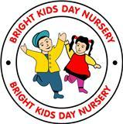

# What Pre-school/ Toddlers Learning

This months Topic is the beach.

Children will be learning about the seasons. Parents need to bring in holiday pictures. Children will also be making ice lollies and learning about sinking and floating items.

.

#### Summer Party 22nd July 2016

We would like all the children at the nursery to dress up as princess/superhero characters on the 22nd July. We would like parents to make small contribution to the party food. List will be given to each room.

# Nursery Cam

We have the Nursery Cam up and running. Please see Zeb to sign up and is 5.00 per month.

**Funded children will break up for Summer on the 22nd of July and will return on the 5th September 2016.**

# Changes of Staff

As parents are aware we are a new nursery and still in the process of building our team. Every staff joins us is on probation period. In that part of of probationary period the staff are monitored in terms of quality of practices and suitability as a practitioner. If we feel they are not suitable, as a company we will not employ them as we have a high standard of of practice. I would like to assure parents that new staff will not disrupt your child’s learning or their routine.

#### Trip Cancelled

# We have decided to cancel the nursery trip as we didn’t have enough parents to sign up.

# Nursery Picture

**We have booked a photographer to take portrait pictures on the 19th July 2016 at 10.00 clock. For children that is not their day will be able to come in for the pictures. Siblings are welcome too.**

ΩΩΩ

## :

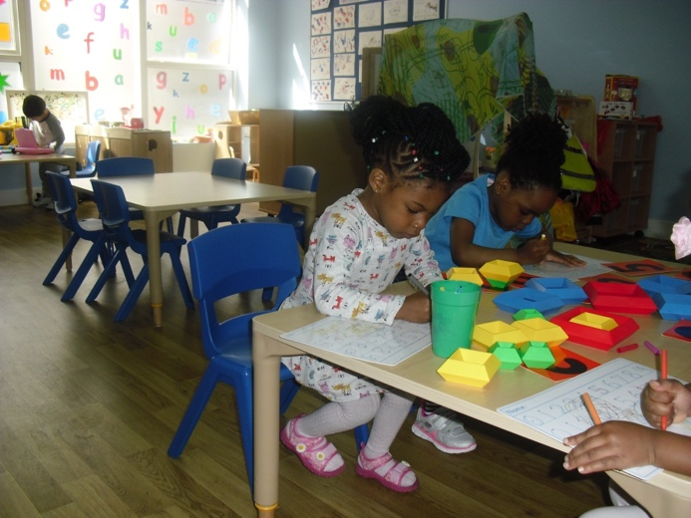

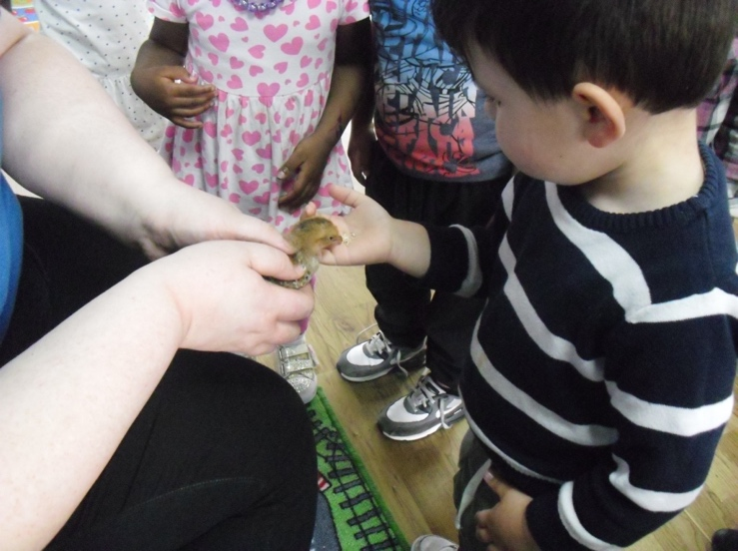

# New Website.

We have uploaded nursery children pictures engaging in activities. Please let Zeb / Carolin know if you wouldn’t like your child to take part.

Thanks

**Parents Meeting July 2016**

**We will start inviting parents over the coming weeks to inform of their child’s learning review report. We will allocate a 15min for each Parents to discuss their child’s report and to share ideas on how we can help children to move forward.**

**Flappy Bird**

Flappy Bird came to say hello at the nursery. Pre-school and toddlers had the experience to hold and feed the chick. Flappy Bird will come and visit the nursery again in the next week.