**Christmas ideas**

Rudolph Cupcakes

**Ingredients:**

*makes 24 (can easily be halved)*

225g margarine  
200g caster sugar  
50g cocoa powder  
200g self-raising flour  
4 eggs  
3-4 tablespoons of milk  
200g milk choc chips  
200g plain choc chips  
100g unsalted butter  
150g icing sugar  
Red glace cherries

**Method:**

Preheat the oven to 180C/gas mark 4.

Cream together the butter and sugar. Add the eggs one at a time.

Sift the flour and cocoa powder into the bowl and fold into the wet mix. Add a little milk if needed.

Line 2 bun tins with cupcake cases and fill each with a spoonful of cake mix.

Bake for 10-12 minutes.

Put aside 48 plain chocolate chips for decorating the cupcakes.

Melt half of the remainder of the plain chocolate in a microwave. Drizzle onto greaseproof paper into antler shapes. Repeat with the rest of the plain chocolate.

Due to the need to work quickly it is best to make the icing in two parts. Melt 100g milk chocolate and 50g of unsalted butter in the microwave. Stir in 75g icing sugar. Cover 12 of the cakes.

Carefully peel off 24 'antlers' from the greaseproof paper and stick 2 to each cake. Add two choc chips as eyes and a cherry as a nose to each cake.

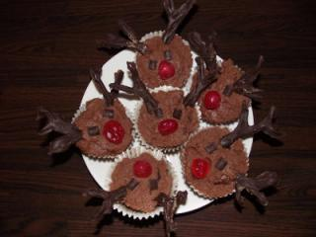

Christmas Pudding Biscuits

**You will need:**

Makes 16

175g soft unsalted butter  
175g caster sugar  
3 eggs  
400g plain flour  
75g cocoa powder  
1 teaspoon baking powder  
1 teaspoon salt  
200g white chocolate  
Green writing icing  
Glace cherries

**Instructions:**

Pre-heat the oven to 180C / Gas Mark 4.

Cream together the butter and sugar. Beat in the eggs.

Sift the flour, cocoa powder, salt and baking powder in to the bowl and mix in well to form a dough.

Wrap the dough in cling-film and pop into the fridge for at least 1 hour.

Roll out the dough to about 1/2 cm thick. Use a large circle cutter to cut 12 circles.

Place on a lined or greased baking tray and bake for 12 minutes. The biscuits should be browning slightly but still spongy to touch. They will firm up as they cool.

When the biscuits are cool, melt the white chocolate. Coat half of each biscuit in white chocolate.

Trim the glace cherries into small pieces and put them on to each biscuit to form the holly berries. Use writing icing to draw on the holly leaves.

If you don't have the time or inclination to make your own biscuits any shop bought chocolate cookies can be substituted and decorated in the same way.

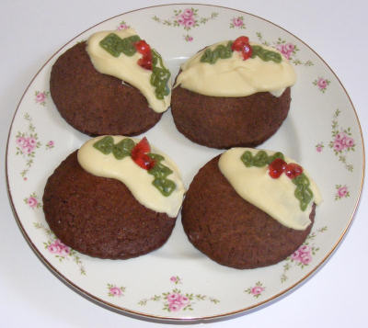

Memory Box

Make a memory box at the beginning of a New Year. It is a great way for children to think about what they have done and achieved over the previous year, and makes a super memory to pull out once a year and enjoy as a family.

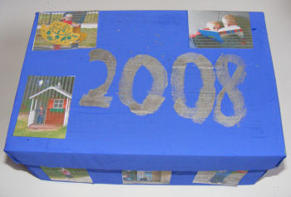

**You will need:**

A shoebox  
Paint or wrapping paper  
Small photos

**To make:**

Paint or cover a shoebox. Draw or paint the year (just passing) on to the lid. Cut out lots of small photos taken this year and glue to the box to decorate.

Fill the box with tickets, leaflets, photos, certificates and other mementos to help you remember all the things you have done this year.

Bird Cake

Make sure that the birds stay fed and happy this autumn / winter by making them this bird cake, and attract some interesting wildlife into your garden.

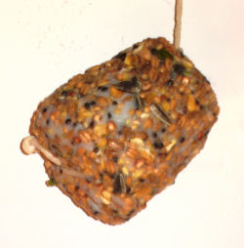

**You will need:**

Bacon fat  
Birdseed  
A heatproof drinks cup  
String

**Instructions:**

Make a small hole in the base of the drinks cup and thread through the string,  leaving a few inches either side of the cup.

Melt the fat gently and mix with the birdseed (this should be done by an adult or with close adult supervision). Leave to cool slightly, then pack it into the cup, making sure the string comes out of the middle of the cup. Leave to cool.

Remove the cup and tie the string around the cake to secure. Tie the cake in your garden for the birds to enjoy.

Handprint Snowflake Painting

Here's an idea for some messy fun to while away a long winter afternoon!

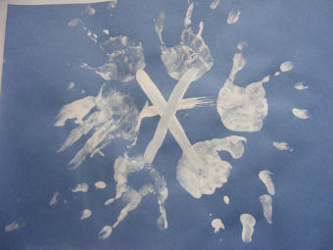

**You will need:**

Construction paper  
White paint

**Instructions:**

Paint 6 handprints in a circle but not overlapping. Make whatever shape you like with your fingers but hold the same shape for each print.

With your finger draw 3 white lines to connect the opposite prints and make a star shape

Popsicle Stick Snowflakes Craft

Have fun making this popsicle stick snowflake craft - use them to decorate the Christmas tree, your classroom or your windows in winter! Use whatever crafty decorations you have on hand...

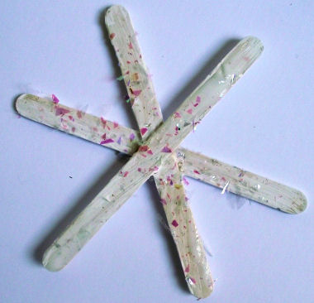  
*Popsicle stick snowflake craft - decorated with glittery flakes*

**You will need:**

P3 popsicle sticks  
PVA glue  
White paint  
Glitter glue, sequins, gems and glitter

**Instructions:**

Glue the craft sticks together in the middle so they form a star shape and leave to dry.

Paint the sticks white and leave to dry.

Decorate with glitter, sequins, gems and glitter glue.

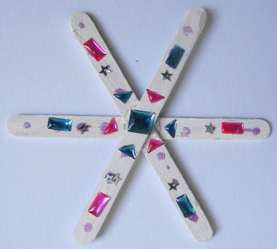  
*Popsicle stick snowflake craft - decorated with jewels and stickers*