Bright Kids Hackney

September 2016

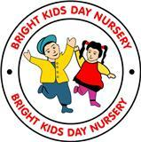

.

**Multicultural event October 19th**

Bright Kids will be celebrating Multicultural day on the Wednesday 19th October from 5.00pm. We would like parents to contribute by bringing food, it can be home made or bought. Parents are invited to celebrate this event.

# New Buggy Area

# We have a new buggy area for Toddlers and Babies. The normal buggy area will be still in use.

# 

**October Half Term**

**Children will be on half term from the 24th October to the 29th of October.**

**29th Monday will be an Inset day for funded children.**

**Jeans for Genes day 2016**

**Annual fundraising event**

We would like all the children to wear jeans on the 23rd September 2016. Please make a small donation of £1.00 to the office.

Thanks Zeb

# What Pre-school/ Toddlers Learning

Babies learning about Autumn. Winter clothes, crushing of the leaves sensory experiences and making collages.

Toddlers: Winter clothes, environment changes, colour.

Colour of the month is Green

Pre-school: Collages, leaves printing, talking about weather, and environment changes,

**New Healthy Menu.**

**We will be making slight adjustment to our menu for the babies. There will be more fruits offered. As you may have noticed our Chef prepares freshly cooked and balance meals.**

**Many new parents have requested for dessert to be given to their babies. Parents will be given an option.**

## :

## 

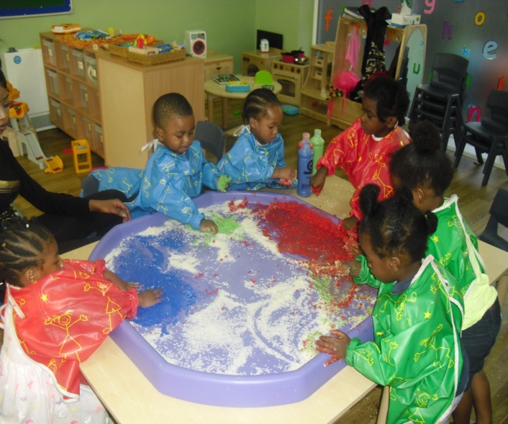

### 

# 7.30 shift

This week we have started offering the 7.30 shift. Parents who are interested will need to speak to Miss Carolin/ Zeb.

The charge is £3.00 per day.

## Parents Evening Training on the EYFS:

## We will be inviting all parents on the 6th October at 5.00pm to attend parents evening. This will be to go through the EYFS and how you can contribute towards your child’s learning and development. We will also go talk you through the new online learning journal ‘Tapestry’ . Could you please let us know how many parents will attend.

# The nursery is getting busier now with new intake of parents. Could we remind parents not to let anyone in the nursery behind you. Please ask them to wait until a member of staff sees to them.

# We are aware of the issue regarding the doors, this has now been adjusted by the company who had fitted the doors. However, we remind parents to shut the doors when they enter and leave the nursery, (safety is everybody’s responsibility)