Bright Kids Hackney March

2017

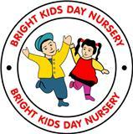

.

#### Employee of the Month.

Charlice has been awarded the Employee of the Month in February

We would like to say well done and keep up with the good work!

#### Online Safety Training

## We would like to thank parents who attended the online safety training.

## 

# 17th March St Patrick’s day

We will be celebrating St Patrick’s day on the 17th March 2017. We would like all children to wear Green. to wear Green

# What Pre-school/ Toddlers Learning



Pre-school and Toddlers will be learning about Growth, Change and decay,

Children will be looking at be planting, measuring and discussing how plant changes over time.

This will be linked into the EYFS Growth, change and Decay.

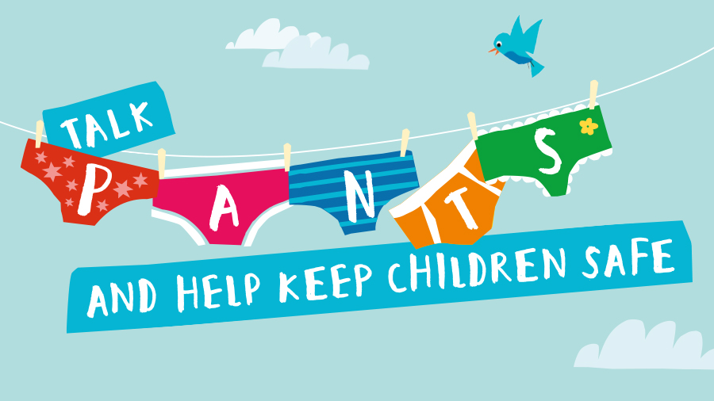

Preschool children will be learning about PANTS. This is a simple way to help keep children safe from abuse. It teaches children that their body belongs to them.

# All Fees need to be paid on- line from the 1st April

Sort Code: 60:13:12

Account Number: 42531675

Growers been Growing

# 

# 27th Month integrated Review

If your child is due for the 27month review please let your key person know, as we will book the Health Visitor for you. This progress check will be conducted in the nursery alongside the Health Visitor and and the Key Person.

## :

## 

# Healthy Body, Happy Me

We have joined Healthy Body Happy Me program which will run from 27th-31st of March.

This will include a range of activities throughout the week. For more information Visit NDNA website.

# Half term for

# Funded children only

# Easter Half term Friday the 31st March till 18th April.

#### Inset Day 17th April.

#### 

## We will be having a cake sale on Tuesday the 21st of March. Children will decorate and bake cakes for the sale. Cakes will be on sale from £25p. we would appreciate if parents could bring in some cakes.

Thank you

# Mothers Day Week

We will be celebrating Mothers Day the week commencing 20th -24th March. We would like parents to come and join us in activities for the morning or afternoon. This will include baking, arts and craft and reading stories to the children.

We would be organizing afternoon tea on Wednesday 22nd March at 3.30 pm. We would appreciate if Mothers/ aunties /grandmas would like to join us.