Bright Kids Hackney

November 2016

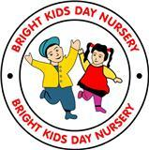

.

**Christmas Dinner:**

Children will be having Christmas dinner on the 15th December. Parents will be informed of the menu. 

# Parents meeting:

We will be conducting parent’s reviews from now and December. This will give parents a chance to speak to their child’s Key person and find out what they have been learning. If parents already had a recent review, they will not be on the list.

# 

**Harvest**

**Thank you to all the parents donated for Harvest. The donation will go to the Local food bank.**

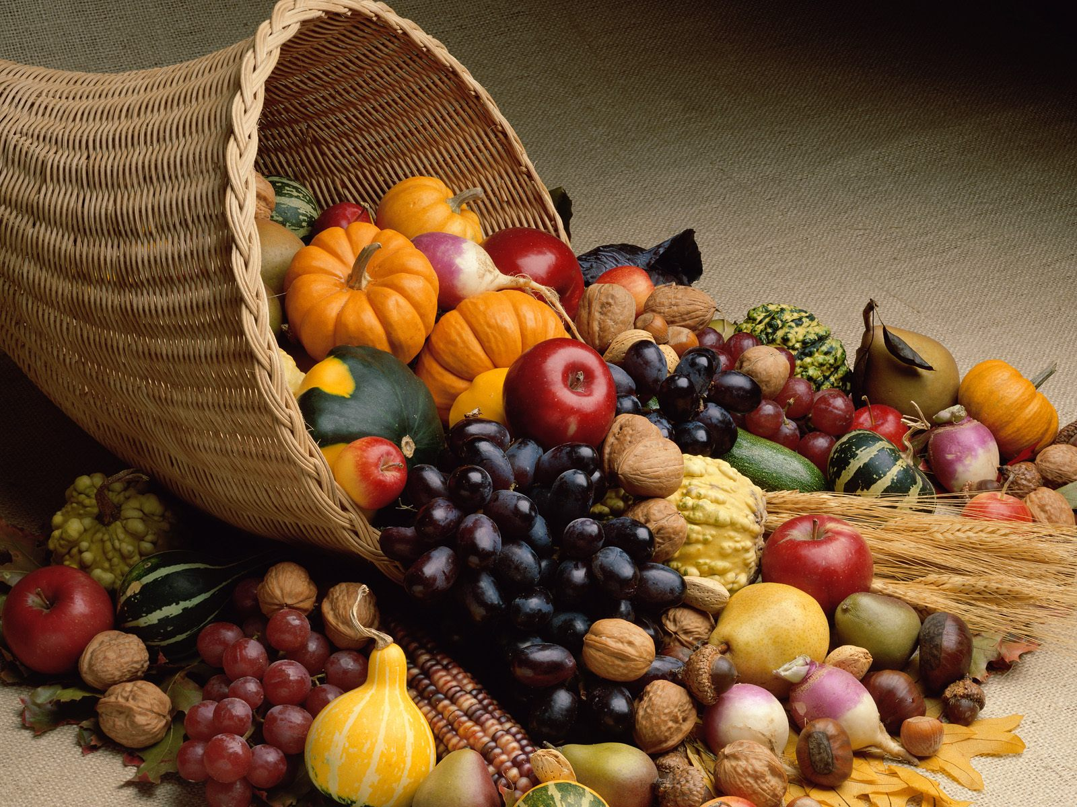

# Weather’s getting cold

We would like parents to make sure that children start’s bringing in their hats and gloves as the weather is getting colder.

Children will be excluded form outside play if appropriate clothing is not provided.

**New Staffing 2016**

**As the nursery getting busy we will be hiring new staff. The notices will be on the door.**

**We also have volunteers from colleges that attends certain days.**

# Multicultural Fantastic Turn out

**We would like to thank all parents who contributed and attended the multicultural event. This was a great turn out and would like to continue to build parents in partnership.**

## :

## 

### 

#### 7.30 Shift charged

Parents who would like the 7.30 shift, we charge £3.00 per day. We have a list of children who are already signed up to this service. Children who are not on the list will not be allowed in before 8.

## ../Pictures/Photos%20Library.photoslibrary/Thumbnails/2016/10/20/20161020-132730/6d7g5lCbSs+uUNRrQaWpPQ/thumb_CIMG7356_1024.jpg

# Pre-School Christmas Concert

#### We are inviting parents for Christmas concert on Wednesday 21st December at 3.00 clock.

# Christmas Dates:

**Funded children break up on the 21st December**

**Xmas Party**

**Tuesday 20th December at 3.00**

**(List will be on the door for parents to contribute)**

**Nursery last day: 23rd December and will re-open on the 4th January.**

**Santa to visit: Day to be confirmed**

# Children Topic

Toddlers and Pre-school are learning about the Jungle.

* Looking at different types of animal live in the jungle
* Making Animal Mask
* Naming Animals
* Animal Sounds
* “down in the Jungle song”
* Animal Colour’s

**Babies:**

Activities around Musical Songs “five little ducks”

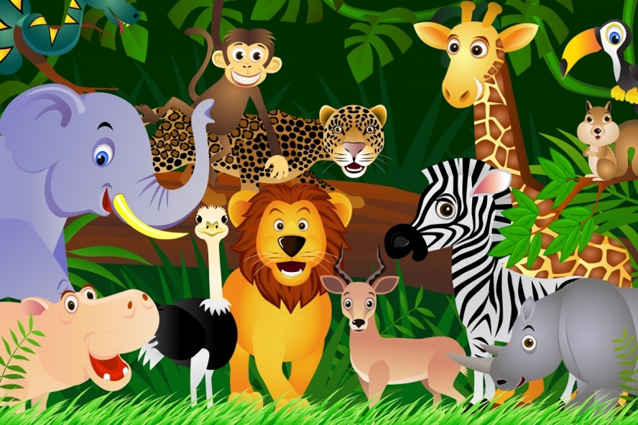



**Christmas Photo’s**

We have booked a photographer to come and take pictures for Christmas using Xmas props.

This will be on the 7th December 2016 at 9.30.

Children that is not their day can also attend.