Bright Kids Hackney

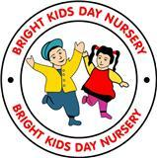 **Summer**

JUNE

2017

# Lego Land payments in 9th

# June

Deadline for Payments need to be in by Friday 9th June.

**Please pay Zeb or Shabs/Renicka**

#### 

#### Graduation Photos

#### to be taken 17th of July at 10.00. All children need to be in by 9.45.

#### Pre-school Ceremony /Leaving party

Graduation ceremony will be taking place on Friday 7th July at 3.00 clock.

# Friday 27th July Nursery will be Closed.

We will be closing the Nursery on Friday the 27th July due to staff training day that has been arranged by the Local Authority. We are allowed to close up to 3 days for staff training as we only close for one. The fees will still need to be paid for this day. We are giving enough notice for parents to arrange for childcare for this day.

# Fees

**We have noticed some parents have been in late in terms of paying fees. I would like to remind all parents, that payment is advance weekly or monthly payments. If parents fall behind in their payment’s, we will suspend the place without notice given.**

# Tapestry

# Please make sure parents activates the Tapestry log in and make comments on observation.

## :

## 

# Sunhats/Sun cream

Wee need all children to bring in sun cream and sun hat for children to take part in outside activities.

If parents fail to bring these items their children will be left out of the activity.

# We have been rated “Good” by Ofsted

# Preschool Learning

Pre-school will be learning about “The Beach” We would like parents to bring in photos of the children at the sea side or on holiday. Alongside we will be teaching children that are going to school about Transition.

# Dates to remember

**Graduation Pictures: 17th July at 9.45**

**Graduation Leaving party: 7th July at 3.00 clock**

**14th July 2017 Lego land Trip**

**Nursery Closed on 21st Friday 2017 Due to Local Authority Training.**

**Summer Half term: 21st July 2017 for Funded Children Return on the 5th/09/2017.**

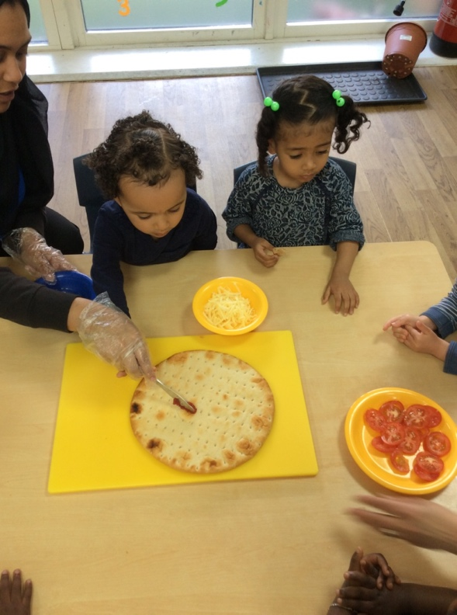

# Children illnesses

Parents are bringing children into nursery while they are sick. I would like to remind parents anything contagious parents need to make sure that illness is treated before they come into nursery. As parent can understand that if a child is unwell it is best to keep them at home because to prevent the infection from spreading.

