Bright Kids Hackney

January 2017

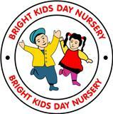

.

# Buggies

# Please ensure all parents fold their buggies so others can have space. Thank you

#### Staff Changes

Lesia and Ockeisha has left and is replaced with Miss Sevgi and Miss Saira from the baby room. Miss Reneika who is qualified level 3 will be taking over Miss Saira Key children.

# What Pre-school/ Toddlers Learning

Preschool : Transport

Learning about different types of transport. People who help us such as Police, ambulance.

Toddlers: Will be learning about colours

Parents: Please ensure that when you are dropping your child of in the nursery, you sign them in, and hand them over to staff. On few occasion parents just leave their children in the room not notifying staff and not signing them in. This is part of safeguarding policy.

# February Half Term:

**Funded children only will be on Half Term on the Monday 13th –Friday 17th 2017.**

# New Assistant Manager

We would like to welcome Miss Shabana who is the new Assistant Manager. Her role will be to ensure the smooth running of the nursery, on the day to day basis.

#### Thank you to all the parents attended Xmas concert. We appreciated your support.

#### 

## :

## 

### 

# 7.30 shift

This week we have started offering the 7.30 shift. Parents who are interested will need to speak to Miss Shabana / Zeb.

The charge is £3.00 per day.

|  |
| --- |
| **Help towards your childcare costs!**  The government has introduced a Tax free childcare scheme. For every £8.00  You pay towards your nursery fees into childcare account the government will will pay £2.00 This is a huge saving of over £3000 per year. For further information please go onto  [www.childcare-support.tax.service.gov.uk](http://www.childcare-support.tax.service.gov.uk) Emergency Contact need to be updated. Next week we will be handing out slips to parents in order to update the emergency contacts. Please ensure you fill them out and hand them into the office.  Thanks |

# Web Cam

If parents have signed up to the Web Cam Please ensure you make a payment of £5.00 per month.

TAPESTRY-ONLINE LEARNING JOURNAL

Tapestry – Parents are able to log onto online learning journal. Here you can see children’s observation , photographs and reports. Parents can also add observations and photographs of what the children have being doing at home. If you have to NOT accessed it please speak to the manager.

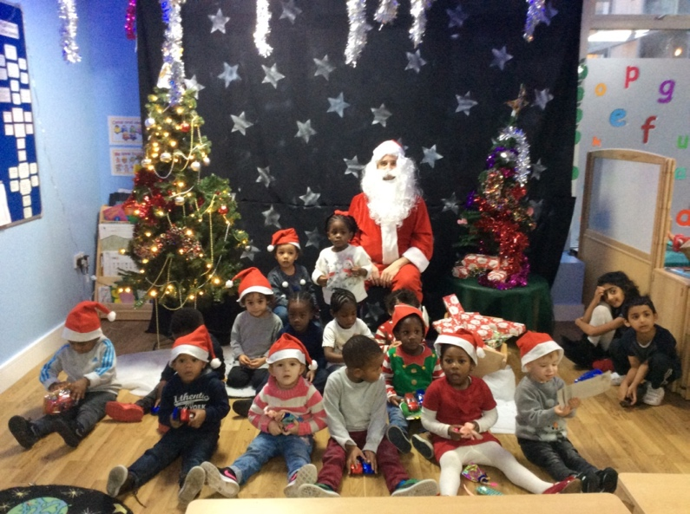

#### Chinese New Year 2017

We approaching the Chinese new year on the 28th January 2017.

In- order to celebrate this event we have arranged the chef to make Chinese menu on the Wednesday the 25th of January 2017.

