Bright Kids Hackney

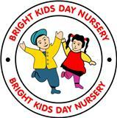

**Autumn News Letter 2017**

**Cinderella Panto**

**Christmas**

We are organizing a Pre-school trip to the local Hackney Empire to watch Cinderella on the 1ST December at 1.30 pm.

Tickets are £15.00 each. We will be sending letters home by Friday 6th October.

Many Thanks.

#### Nursery Photos on the 1st of November.

All children should be at the Nursery by 9.30 on the 1st of November for the nursery photos. Funded children also welcomed, parents should bring them in at 10.00 and stay with them until the phots have been taken.

# What the Children will be learning for this term:

* All about me
* Harvest
* Autumn
* Christmas

# Multicultural Event 2017

We had a great turn out last year for our multicultural event.

We will be organizing this again Friday 10rdof November between 5-7pm.

We would like all Parent’s to contribute by bringing in food from the cultural back ground.

List will be up on the doors for what parent can bring.

Thank you

## :

**Fees**

**Please can parents make sure that payments are set up every week. Fees need to be paid advance monthly /weekly. We have the right to refuse children in, if they haven’t paid.**

**Thanks.**

# 30hrs Educational Grant

Parents can apply for the 30hrs if your child is turning three or have turned 3. The funding will start a term after their birthday.

The validation needs to be made every 3 months in order to still receive the grant.

The Nursery is still allow to charge a top fee and in order to receive the 30hrs you have to be in employment for at least 16 hours a week.

# Babies / Toddlers

Please call the nursery if you are going to bring your child in late. Children who cannot come in before 11.30 will not be allowed in the nursery until 2.00 clock. This is because it will disrupt the nursery routine and other children.

# Buggy Area

Can parents ensure that the buggy is folded and and the door is locked. As we have noticed that the door has been left open a few times.

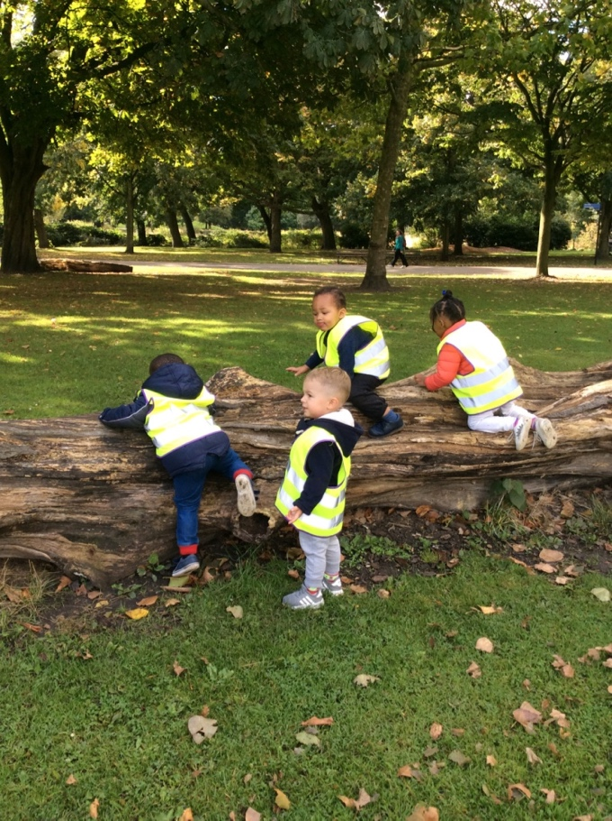

# Autumn Walk with our Pre-school children

#### Dates to remember

**October** Half Term : Monday 23rd October -27th October 2017

Funded children return on Tuesday 31st October

**November Multicultural Event Friday 10th November**

**Pre-school Trip**: 1st December at 1.30am ( pending we have children going)

**Christmas Carol** 6th December 3.30pm

**Christmas Lunch /Jumper day** 8th December

**Christmas Party**: Wednesday 13th December 3.30am

**Break up for Xmas:** Funded children break up Thursday 21st December

**Nursery closes on 22 December and re-opens on the 3rd January**