**ACTIVITIES FOR UNDER 2’S**

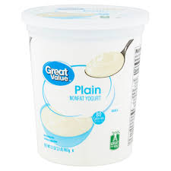**ACTIVITY 4**

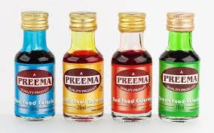

**YOGURT PAINTING**

**PLAIN YOGURT OR SOYA YOGURT**

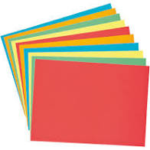**FOOD COLOURING**

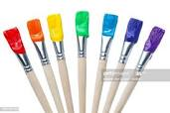**COLOURED OR WHITE CARD**

**(it may get a bit soggy if you use paper)**

**Mix the food colouring into the yogurt**

**And create different colours**

**Using your fingers or a brush use the coloured yogurt to create a colourful picture on the card or paper.**

**It is okay to lick your fingers as the “paint” is edible!**

**ACTIVITY 5**

**COLOURED RICE ACTIVITY**

**Measure a cup of rice into a bowl and add some food colouring**

**Repeat this using as many different food colours as you have**

**Simply coat the dried rice in the colouring and spread out on some baking parchment or foil and allow to dry.**

**When the rice is dry, you can either mix it to create a colourful mixture of dried rice for your child to scoop and pour. Or you can keep the colours separate and put them in different bowls to play with. You can make a rainbow effect in clear plastic cups. Or you can create shakers using clear plastic water bottles.**

