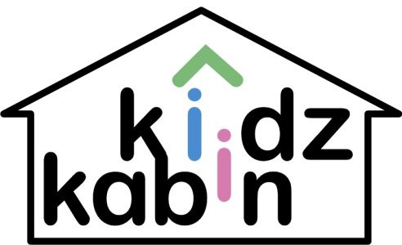

**SPRING/ SUMMER LUNCH MENU WEEK 1**

**MONDAY**

**Main:** Soya chicken with wholemeal rice and salad

**Desert:** Fresh fruit

**TUESDAY**

**Main:** Pasta and tomato sauce with broccoli; choice of grated cheese and sweetcorn

**Desert:** Banana cake

**WEDNESDAY**

**Main:** Baked Smoked fish and bulgur with fresh tomatoes and cucumber

**Desert:** Natural yogurt and fruit puree

**THURSDAY**

**Main:** Spinach and cheese omelette with sauteed potatoes, tomato sauce and salad

**Desert:** Fresh fruit salad

**FRIDAY**

**Main:** Fresh baked salmon, roasted potatoes with peas and carrots

**Desert:** Natural yogurt and fruit puree

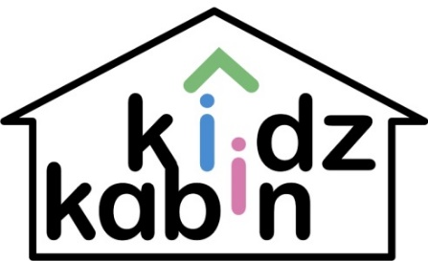

**SPRING/ SUMMER LUNCH MENU WEEK 2**

**MONDAY**

**Main:** Vegetarian spaghetti Bolognese with sweetcorn

**Desert:** Natural yogurt and fruit puree

**TUESDAY**

**Main:** Fisherman’s Pie with petits pois, sliced tomatoes

**Desert:** Fresh fruit salad

**WEDNESDAY**

**Main:** Freshly baked chef’s Pizza with sweet cucumber spears andsalad

**Desert:** Apple cake

**THURSDAY**

**Main:** Soya meatballs with mash and onion gravy, steamed broccoli and carrots

**Desert:** Fresh fruit

**FRIDAY**

**Main:** Chef’s own spinach and cheese muffins; vegetarian nuggets served with buttered rice and peas and sweetcorn

**Desert:** Natural yogurt and fruit puree



**SPRING/ SUMMER LUNCH MENU WEEK 3**

**MONDAY**

**Main:** Pasta with tomato and cheese served with tuna and sweetcorn

**Desert:** Natural yogurt and fruit puree

**TUESDAY**

**Main:** Jacket potatoes with assorted fillings (tuna, baked beans, grated or cream cheese), Salad

**Desert:** Fresh fruit salad

**WEDNESDAY**

**Main:** Vegetarian nuggets with bulgur, broccoli and sweetcorn

**Desert:** Natural yogurt and fruit puree

**THURSDAY**

**Main:** Salmon Piccata with tomato sauce and roasted potatoes served with green beans

**Desert:** Pineapple cake

**FRIDAY**

**Main:** Macaroni cheese & mixed salad **Desert:** Fresh fruit