**UNDER 2’S**

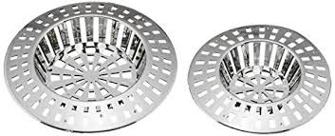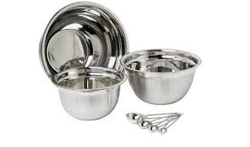**ACTIVITY 2**

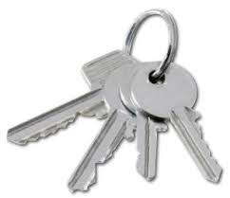**SHINY OBJECTS**

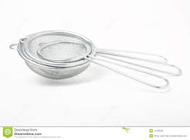**You will need:**

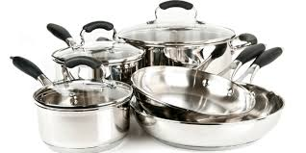**Stainless steel mixing bowls**

**Metal spoons, large and small**

**Stainless steel pots and lids**

**Other shiny cutlery such as a whisk**

**keys**

**Activity**

**Look at your reflection in the shiny objects**

**Bang the spoon on the metal saucepan lid**

**Use 2 saucepan lids to crash together as cymbals**

**Find other shiny objects to explore such as keys, sieves, etc**

**Talk About**

**Sounds**

**Actions**

**Noise**

**Reflection**

**“What can you see?”**

**“What can you hear?”**

**Count as you tap the spoon on the saucepan 1-2-3…..**

**Put the spoons or other shiny objects in the pots and put the lids on and then open them and see what is inside.**

**Use different intonation such as surprise, joy, to create a “Wow” moment**