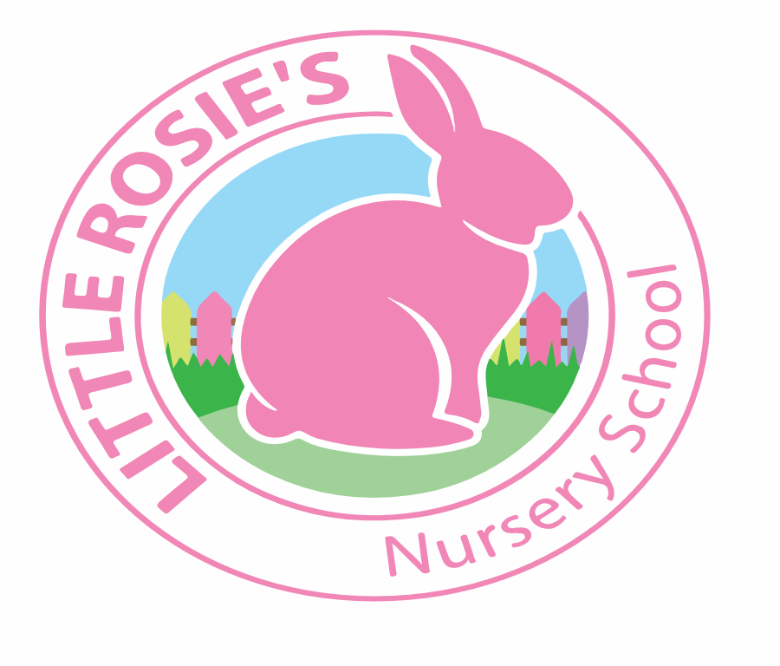



_______________________________________________________________

Little Rosie’s Nursery School Term Dates 2019 - 2020

Autumn Term 2019

Term Starts: Monday 2nd September 2019

End of Term: Friday 20th December 2019

Teaching Weeks: 16 Weeks

Spring Term 2020

Term Starts: Monday 6th January 2020  
 End of Term: Friday 3rd April 2020

Teaching Weeks: 14 Weeks

Summer Term 2020

Term Starts: Tuesday 14th April 2020  
 Bank Holidays: Monday 8th May 2020  
 Monday 25th May 2020

End of Term: Thursday 20th August 2020

 Teaching Weeks: 17 Weeks

**Total Teaching Weeks: 47 Weeks**



Little Rosie’s Nursery Limited, Our Lady of Holy Souls Church, W10 5DJ  
 020 8960 2500 | info@littlerosiesnurseryschool.co.uk | www.littlerosiesnurseryschool.co.uk