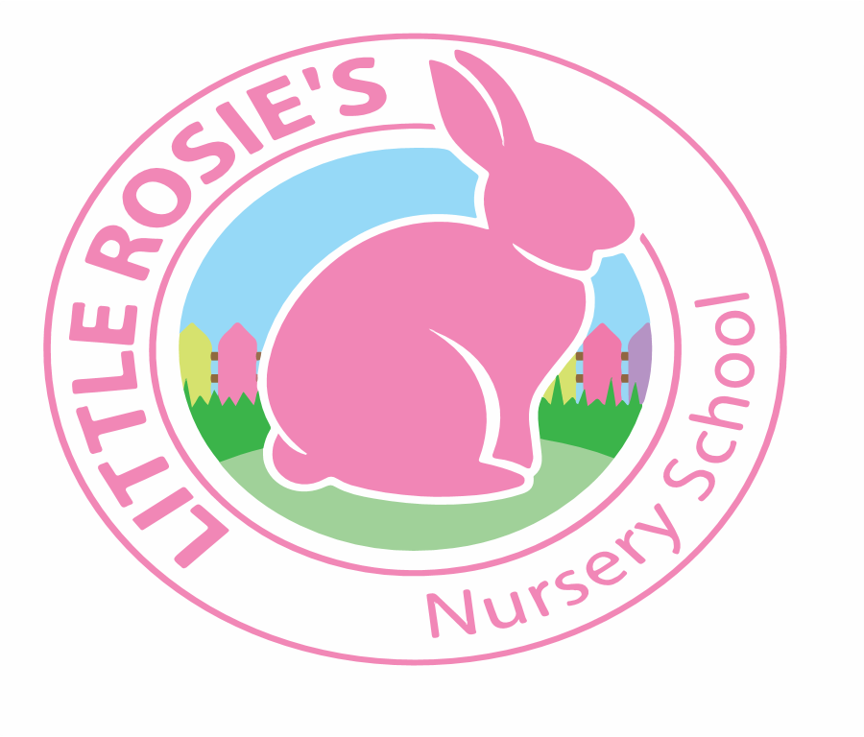

Little Rosie’s Nursery School   
Spring Term 2020 Topic List

________________________________________________________

|  |
| --- |
| **January** |
| **People Who Help Us**  Week 1: Doctors and Nurses  Week 2: The Dentist  Week 3: The Police  Week 4: The Firemen |

|  |
| --- |
| **February** |
| **Transport**  Week 5: Emergency Vehicles  Week 6: Cars and Buses   Week 7: Trains and Airplanes   Week 8: Road Safety |

|  |
| --- |
| **March** |
| **Spring Time!**  Week 9: Minibeasts  Week 10: Animal Life Cycles   Week 11: Mother’s Day   Week 12: Plant Life Cycles  Week 13: Easter |



Little Rosie’s Nursery Limited, Our Lady of Holy Souls Church, W10 5DJ  
 020 8960 2500 | info@littlerosiesnurseryschool.co.uk | www.littlerosiesnurseryschool.co.uk