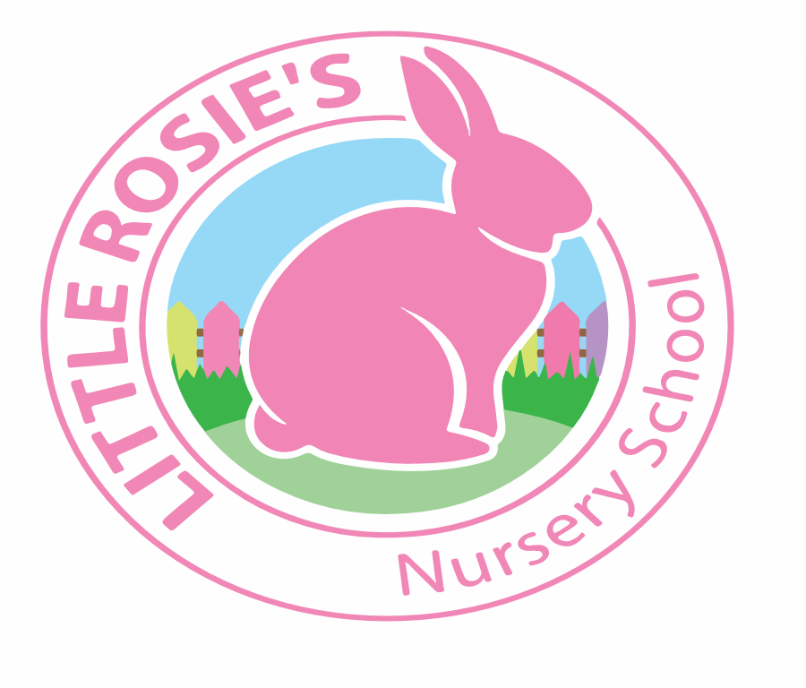



Little Rosie’s Nursery School   
NEG Term Dates 2020-2021

__________________________________________________________________

Autumn Term 2020

Term Starts: Monday 7th September 2020

Half Term: Monday 26th - Friday 30th October 2020

End of Term: Friday 11th December 2020

Teaching Weeks: 13 Weeks

Spring Term 2021

Term Starts: Monday 4th January 2021

Half Term: Monday 15th - Friday 19th February 2021  
 End of Term: Thursday 1st April 2021

Teaching Weeks: 12 Weeks

Summer Term 2021

Term Starts: Monday 19th April 2021  
 Bank Holidays: Monday 3rd May 2021  
 Monday 31st May 2021

Half Term: Tuesday 1st - Friday 4th June 2021  
 End of Term: Friday 23rd July 2021

 Teaching Weeks: 13 Weeks

**Total Teaching Weeks: 38 Weeks**



Little Rosie’s Nursery Limited, Our Lady of Holy Souls Church, W10 5DJ  
 020 8960 2500 | info@littlerosiesnurseryschool.co.uk | www.littlerosiesnurseryschool.co.uk