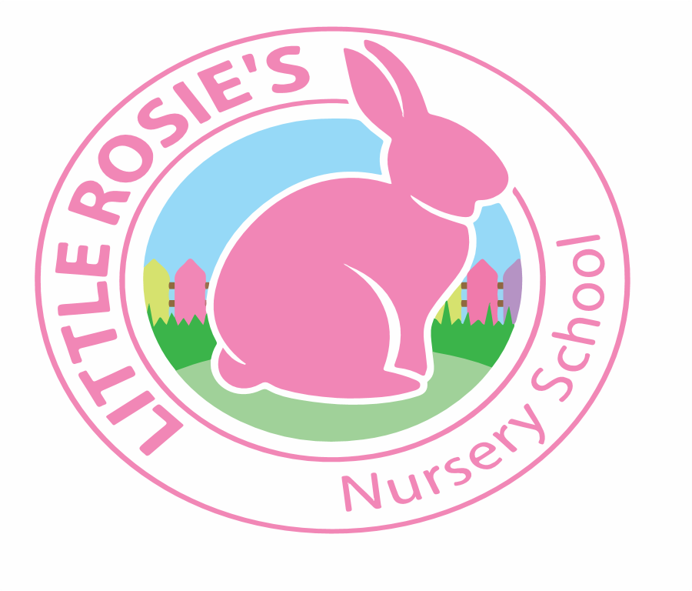

Little Rosie’s Nursery School   
AutumnTerm 2020 Topic List

________________________________________________________

|  |
| --- |
| **September** |
| **All About Me**    Week 1: Me and my Family  Week 2: Where I Come From  Week 3: My Body  Week 4: My Hobbies and Interests |

|  |
| --- |
| **October** |
| **Animals**  Week 5: Safari Animals   Week 6: Farm Animals   Week 7: Nocturnal Animals  Week 8: Sea Animals |

|  |
| --- |
| **November** |
| **Books**  Week 8: Aliens Love Underpants   Week 9: The Very Hungry Caterpillar   Week 10: Handa’s Surprise   Week 11: The Gruffalo |

|  |
| --- |
| **December** |
| **Christmas**  Week 12: The Nativity  Week 13 : Santa Claus is Coming to Town |



Little Rosie’s Nursery Limited, Our Lady of Holy Souls Church, W10 5DJ  
 020 8960 2500 | info@littlerosiesnurseryschool.co.uk | www.littlerosiesnurseryschool.co.uk