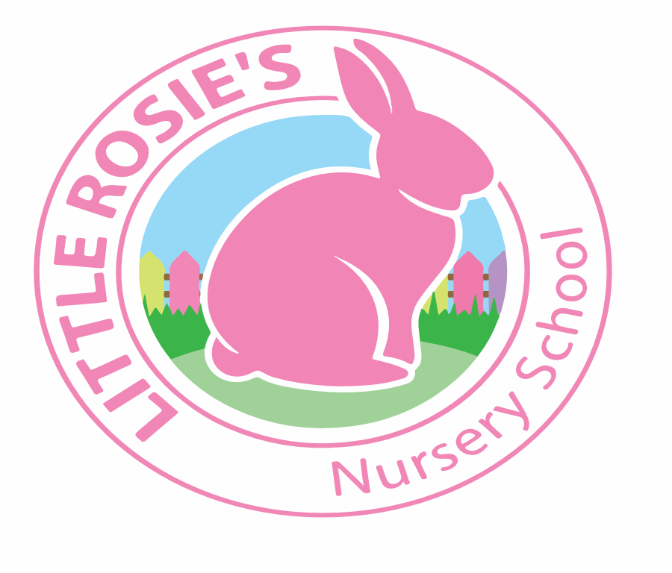

Little Rosie’s Nursery School   
Autumn 2020 Tea Menu

**______________________________________________________________________________________**

|  |  |  |
| --- | --- | --- |
|  |  | |
|  | **Main Tea** Side Dish | | | |
| Monday | **Chicken Goujons** | **Salsa Dip** | |
| Tuesday | **Scrambled Eggs** | **Wholemeal Bread Triangles** | |
| Wednesday | **Mini Tuna and Sweetcorn Sandwiches** | **Cucumber Slices** | |
| Thursday | **Baked Beans On Toast** | **Grated Cheese** | |
| Friday | **Cheese Toasties** | **Cherry Tomatoes** | |

**Week 1**

Little Rosie’s Nursery Limited, Our Lady of Holy Souls Church, W10 5DJ  
 020 8960 2500 | info@littlerosiesnurseryschool.co.uk | www.littlerosiesnurseryschool.co.uk

|  |  |  |
| --- | --- | --- |
|  |  | |
|  | **Main Tea** Side Dish | | | |
| Monday | **Vegetable Stir Fry Noodles** |  | |
| Tuesday | **Mini Cheese Sandwiches** | **Cherry Tomatoes** | |
| Wednesday | **Cod Fish Cakes** | **Salsa Dip** | |
| Thursday | **Mini Pizzas** | **Sweetcorn** | |
| Friday | **Savoury Crumpets** | **Cucumber Slices** | |

**Week 2**