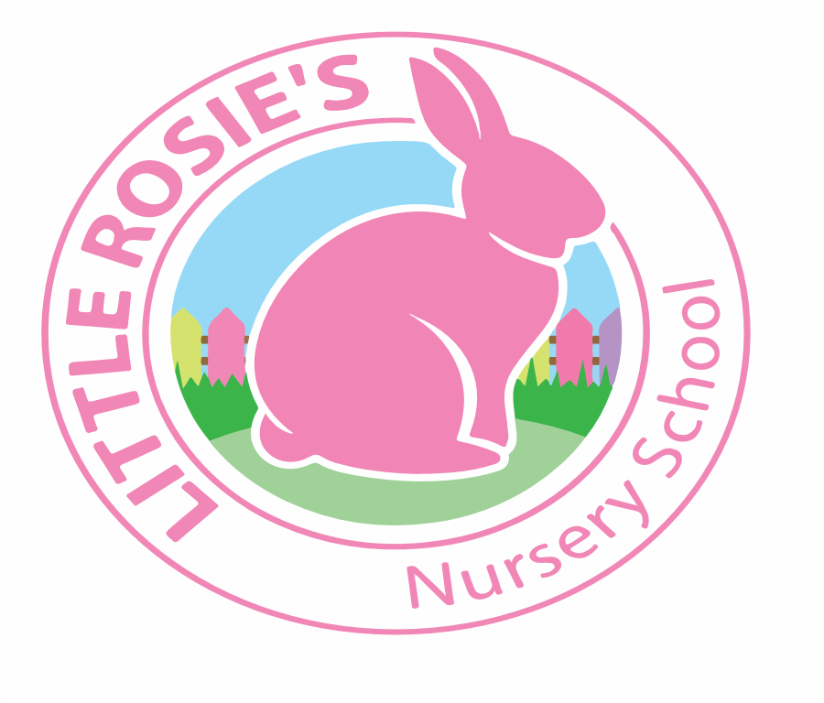

Little Rosie’s Nursery School   
Autumn 2020 Lunch Menu

**___________________________________________________________________________________**

|  |  |  |  |
| --- | --- | --- | --- |
|  | |  | |
|  | **Main Lunch** Side Dish Dessert | | | | | |
| Monday | **Chilli Con Carne** | **White Rice** | | **Seasonal Fresh Fruit** | |
| Tuesday | **Chicken Tikka Curry** | **Naan Bread** | | **Organic Yoghurt** | |
| Wednesday | **Spaghetti Bolognese** | **Grated Chedder Cheese** | | **Stawberry Jelly** | |
| Thursday | **Butternut Squash Soup** | **Wholemeal Bread** | | **Seasonal Fresh Fruit** | |
| Friday | **Baked Fish** | **Chunky Potato Fries** | | **Marble Cake with Custard** | |

**Week 1**

Little Rosie’s Nursery Limited, Our Lady of Holy Souls Church, W10 5DJ  
 020 8960 2500 | info@littlerosiesnurseryschool.co.uk | www.littlerosiesnurseryschool.co.uk

|  |  |  |  |
| --- | --- | --- | --- |
|  | |  | |
|  | **Main Lunch** Side Dish Dessert | | | | | |
| Monday | **Baked Jacket Potatoes** | **Beans and Grated Cheese** | | **Seasonal Fresh Fruit** | |
| Tuesday | **Vegetable Lasagna** | **Green Beans** | | **Marble Cake with Custard** | |
| Wednesday | **Roast Chicken Dinner** | **Mixed Seasonal Vegetables** | | **Organic Yoghurt** | |
| Thursday | **Tuna Penne Bake** | **Sweetcorn** | | **Seasonal Fresh Fruit** | |
| Friday | **Mini Burgers** | **Chunky Potato Fries** | | **Strawberry Jelly** | |

**Week 2**