|  |
| --- |
| Little Rosie’s Nursery |
| **Terms and Conditions** |
| September 2019 |

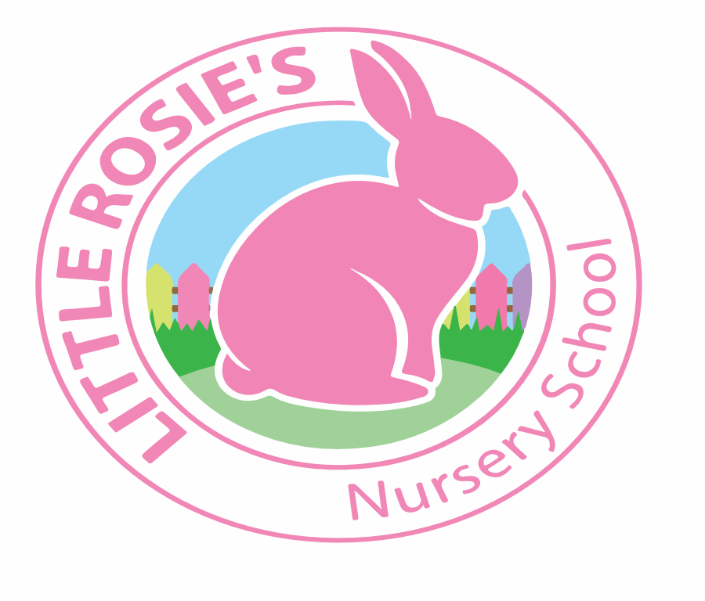



**Registration**

To register your child at Little Rosie’s, a non-refundable registration fee of **£50** is payable on acceptance of the registration form and your child’s name will be place on the waiting list. This does not guarantee that a place will be available, and the registration fee will be returned if the nursery cannot offer the place on the schedule and date required. Once a place has been offered, a two-week deposit fee is required which is refundable to you on your child’s last month at the nursery within the given notice period.

**Waiting List**

A child is placed on the waiting list in the order of the date on which a registration form and registration fee is received. The parent will then be contacted to confirm the availability of place in advance of a requested start date. Parents are responsible in ensuring that the nursery has up to date contact details to ensure that contact can be made.

**Places**

Places are subject to availability and Little Rosie’s cannot guarantee nursery places. Once a place has been offered, the parent has the right to refuse any places offered once and after this refusal, the child will have their status changed to ‘inactive’ on the waiting list. If a parent decides to defer their child’s start date, they will need to ‘re-join’ the waiting list.

**Nursery Fees**

Little Rosie’s runs from the first week of September to mid-August. The nursery is closed for two weeks at Christmas, one week at Easter and two weeks at the end of August. Nursery fees are calculated on a monthly basis for the weeks that we are open, which are payable on the 1st of every month. The initial payment of fees will be determined by the child’s start date at the nursery and will include all sessions booked from that date, up to, and including the remainder of that month. Payments can be made by bank trasnfer, standing order childcare vouchers and grants.

The nursery reserves the right to review fees at any time. In the event of there being changes to the fees, one calendar month’s written notice shall be given to all parents and carers.

**A refund will not be given where a child is absent from the nursery due to sickness or holiday.**

If fees remain outstanding for more than 5 days:

* The nursery reserves the right to charge a late payment fee of 5% on any outstanding balance.
* The nursery may serve 14 days’ notice in writing to terminate the contract. Upon termination of this contract the child shall cease forthwith to be admitted to the nursery and the nursery’s notice to terminate shall be regarded as a formal demand for all outstanding fees.

**Cancellation and Termination**

(i) After an offer of a place has been made by the nursery, but before acceptance by the parent/guardian, either party may cancel the offer by serving 7 days written notice.

(ii) After acceptance of the offer by the parent, either party may terminate this agreement by the service of one calendar months’ notice in writing. During this period, the nursery undertakes to continue to admit the child and the parent/guardian undertakes to pay all fees due. In the event of the parent/guardian failing to pay the month’s fees the child’s place shall be immediately withdrawn and the nursery shall be entitled to serve a formal demand for payment of such fees.

(iii) In the event of the parent/guardian giving notice of withdrawal of the child and immediately withdrawing the said child, there shall be due to the nursery one calendar month’s fees in lieu of notice.

Failure by the parent to provide one calendar months’ notice or any notice at all, shall render the parent liable to the nursery for one month’s fees.

(iv) Notice must be in writing.

(vi) The Nursery reserves the right to terminate any child’s enrolment, or restrict access to parent or child, at any time without notice, in consideration of the protection of other children and staff, and the well- being and smooth operation of the Nursery. Any disruption caused by a parent or child that is deemed inappropriate or not conducive to a nursery environment, or undermines the reputation of the Nursery, or its staff, will be cause for termination at the discretion of the Nursery Manager.

**Early and Late Collection Surcharge**

Parents/guardians either dropping off early or collecting beyond the booked session times will be subject to an additional surcharge of £5 for every 5 minutes. The parent is responsible in notifying the nursery if their child is going to be late or absent from the nursery. It will be at the Nursery Manager’s discretion to waive the surcharge in the following instances:

* If the child is collected late due to an emergency and the parent has notified the nursery in advance.
* If a serious transport issue has been identified and therefore many children are collected late and late collection is deemed unavoidable.
* Any other factors that the Nursery Manager deems relevant to waive the surcharge.

**Unforeseen Closure**

In the event of closure of the nursery due to extreme weather conditions, flooding, loss of utility supplies, heating failure, or other causes beyond the reasonable control of the nursery, the nursery will close, and the parent/carer accepts that no refund of fees will be made due to continued operational costs.



**Infections & Illnesses**

Children must not attend the nursery when they are unwell or suffering from a contagious illness or infection. In the event of a child becoming ill whilst at the nursery, the parent or nominated carer will be contacted to arrange to take their child home. In the case of an infectious condition the recommended exclusion time must elapse before the child can be readmitted to the nursery (the nursery can advise on this). The parent must inform the nursery staff as soon as possible if your child has an infectious illness. You must not allow your child to attend the nursery if they are suffering from a contagious disease that could be passed on to another child in the nursery. We reserve the right to refuse admission to any child on health grounds.

**General**

* You will give us full details of anything affecting your child’s health, including known allergies, conditions or additional needs.
* All children should have at least one change of clothing.
* All items of clothing and personal property should be clearly labelled.
* Our nurseries are fully equipped with a wide range of toys and resources for your  
  child and therefore we would ask that your child does not bring their own toys from home as we cannot accept any responsibility for loss or damage to personal property.
* Immediately inform us of any changes to your personal contact details.
* You must advise the nursery manager immediately if any of these emergency  
  contact details change.
* You must keep the nursery manager informed of any changes to the person(s)  
  authorised to collect your child from nursery (this will be the authorised person(s) as stated on the registration form). We will not allow a child to leave the nursery with anyone other than the authorised person. All parents/carers must comply with the nursery’s security for the collection of children policy.
* You must complete a medicine consent form if you require nursery staff to administer any prescribed medication.
* You must inform us if your child is the subject of any court order and provide us with a copy of this order.
* Discuss with your child’s key teacher or nursery manager if you have any concerns about the services we provide – if you feel your concern has not been resolved please refer to our complaints procedure.
* You will adhere to all of the terms and conditions outlined in this document.
* In-line with our safeguarding children policy we have a Duty of Care to report to the relevant authorities any circumstances where we consider a child to have been harmed or at risk of harm or neglect. We may do this with or without your consent and with or without informing you, depending upon the circumstances.
* We have a further legal duty to monitor non-noticed absence and will contact you to check on your child each time they are due at nursery and do not attend without any prior notification. Therefore, it is essential that you always advise us when your child is going to be absent from nursery.
* All of our childcare policies and procedures are available on the parent’s notice board and online via the parent portal.

**Personal Property**

Little Rosie’s Nursery cannot be held liable for the loss or damage of any item belonging to the public on the premises. This particularly applies to children’s clothing and toys as well as motor vehicles, prams and buggies.

**General Data Protection Regulation 2018**

By acceptance of the Terms & Conditions you give Little Rosie’s Nursery express consent to retain and process that information provided by the parent/guardian, which directly relates to the child, for the sole purpose of childcare. Such information will remain with Little Rosie’s Nursery for up to 6 years or be transferred to a school of your choice, once your child leaves the Nursery.