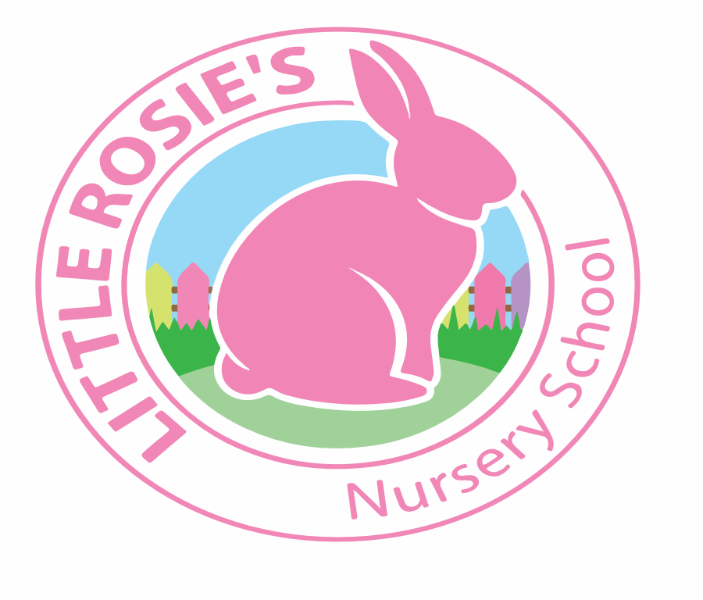



Little Rosie’s Nursery School   
NEG Term Dates 2019-2020

__________________________________________________________________

Autumn Term 2019

Term Starts: Monday 9th September 2019

Half Term: Monday 21st – Friday 25th October 2019

End of Term: Friday 13th December 2019

Teaching Weeks: 13 Weeks

Spring Term 2020

Term Starts: Monday 6th January 2020

Half Term: Monday 17th – Friday 21st February 2020  
 End of Term: Friday 3rd April 2020

Teaching Weeks: 12 Weeks

Summer Term 2020

Term Starts: Monday 20th April 2020  
 Bank Holidays: Monday 4th May 2020  
 Monday 25th May 2020

Half Term: Tuesday 26th – Friday 29th May 2020  
 End of Term: Friday 24th July 2020

 Teaching Weeks: 13 Weeks

**Total Teaching Weeks: 38 Weeks**



Little Rosie’s Nursery Limited, Our Lady of Holy Souls Church, W10 5DJ  
 020 8960 2500 | info@littlerosiesnurseryschool.co.uk | www.littlerosiesnurseryschool.co.uk