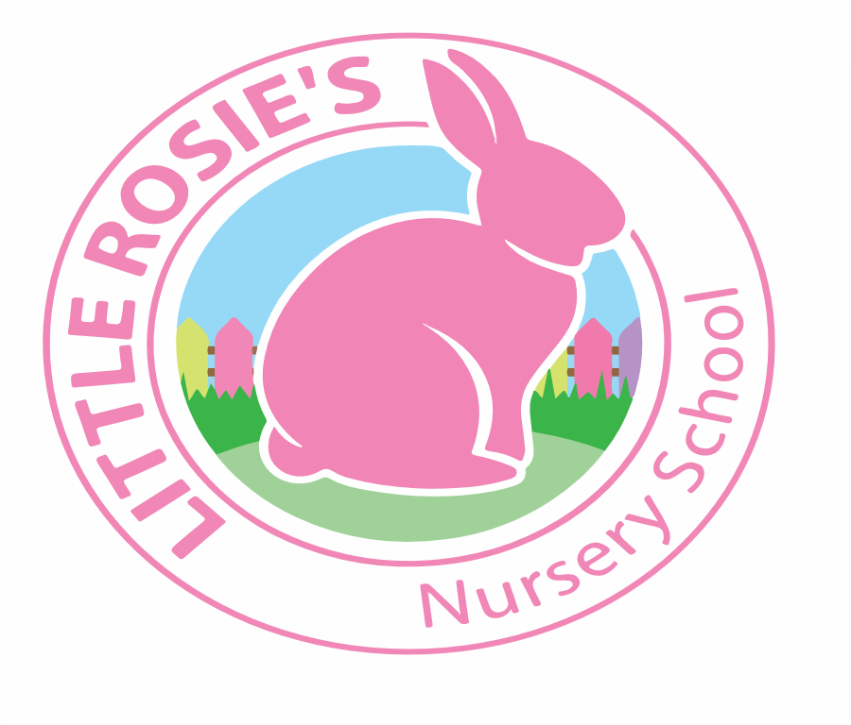

Little Rosie’s Nursery School   
Spring 2020 Lunch Menu

**________________________________________________________________________________________**

|  |  |  |  |
| --- | --- | --- | --- |
|  | |  | |
|  | **Main Lunch** Side Dish Dessert | | | | | |
| Monday | **Spaghetti Bolognese** | **Grated Cheese** | | **Organic Yoghurt** | |
| Tuesday | **Butternut Squash Soup** | **Homemade Bread** | | **Seasonal Fruit** | |
| Wednesday | **Sheperds Pie** | **Garden Peas** | | **Strawberry Jelly** | |
| Thursday | **Tuna pasta Bake** | **Mixed Vegetables** | | **Seasonal Fruit** | |
| Friday | **Mini Burgers** | **Chunky Potato Fries** | | **Marble Cake with Custard** | |

**Week 1**

Little Rosie’s Nursery Limited, Our Lady of Holy Souls Church, W10 5DJ  
 020 8960 2500 | info@littlerosiesnurseryschool.co.uk | www.littlerosiesnurseryschool.co.uk

|  |  |  |  |
| --- | --- | --- | --- |
|  | |  | |
|  | **Main Lunch** Side Dish Dessert | | | | | |
| Monday | **Mediterranean Vegetable Pasta** | **Grated Cheese** | | **Chocolate Cake with Custard** | |
| Tuesday | **Beef Lasagne** | **Mixed Vegetables** | | **Organic Yoghurt** | |
| Wednesday | **Chicken Tikka Masala** | **Naan Bread** | | **Seasonal Fresh Fruit** | |
| Thursday | **Jacket potatoes** | **Baked Beans** | | **Organic Yoghurt** | |
| Friday | **Fish Fingers** | **Chunky Potato Fries** | | **Orange Jelly** | |

**Week 2**