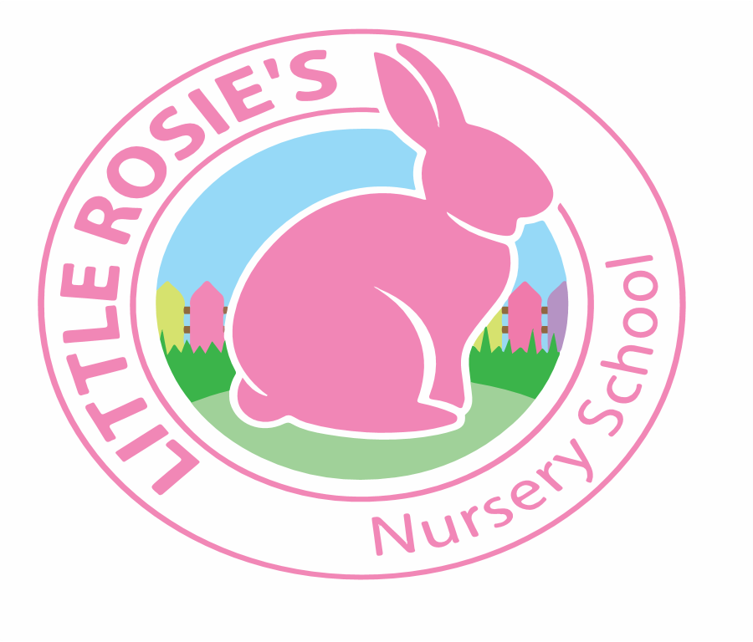



Little Rosie’s Nursery School   
Daily Schedule

|  |  |
| --- | --- |
| **Time** | **Daily Routine** |
| 8:00am-  9:30am | **Arrival Time:** The children and parents are welcomed into the nursery to start their day. The children engage in free choice play during this period. |
| 9:30am-  9:45am | **Circle Time:** The children participate in group discussions regarding the weekly topic, as well as in listening to stories and singing songs. |
| 9:45am-  10:15am | **Snack Time** |
| 10:15am-  10:45am | **Free Choice/Adult Led/Groups:** The children explore free choice play as well  as adult led activities (one-to-one or as a group). |
| 10:45am-  11:45am | **Outdoor/Indoor Play:** Depending on the weather, the children explore an outing to the park or explore free choice/adult led/large group activities  indoors. |
| 11:45am- 12:30pm | **Lunch Time (Full Day Session Only)**  11:45am-12:00pm : The morning session children engage in small group activities such as  puzzles, stories, drawing etc. before home time.  12:00pm-12:30pm : Arrival time for the afternoon session and the children engage in small  group activities during this period. |
| 12:30pm-  12:45pm | **Circle Time:** The children participate in group discussions regarding the weekly topic, as well as in listening to stories and singing songs. |
| 12:45pm-  1:45pm | **Outdoor/Indoor Play:** Depending on the weather, the children explore an outing to the park or explore free choice/adult led activities indoors. |
| 1:45pm-  2:30pm | **Free Choice/Adult Led/Groups:** The children explore free choice play as well  as adult led activities (one-to-one or as a group). |
| 2:30pm-  3:00pm | **Large Group Play:** The children participate in large group activities, such as physical movement, singing, dancing, stories and circle games. |
| 3:00pm-  3:30pm | **Snack Time** |
| 3:30pm -  4:00pm | **Free Flow and Home Time** |

___________________________________________________________****

Little Rosie’s Nursery Limited, Our Lady of Holy Souls Church, W10 5DJ  
 020 8960 2500 | info@littlerosiesnurseryschool.co.uk | www.littlerosiesnurseryschool.co.uk

The daily schedule establishes a nurturing home from home environment here at Little Rosie’s Nursery for each child in providing a wide variety of stimulating activities and effective practice and planning aimed at promoting and broadening the key aspects of a child’s development.