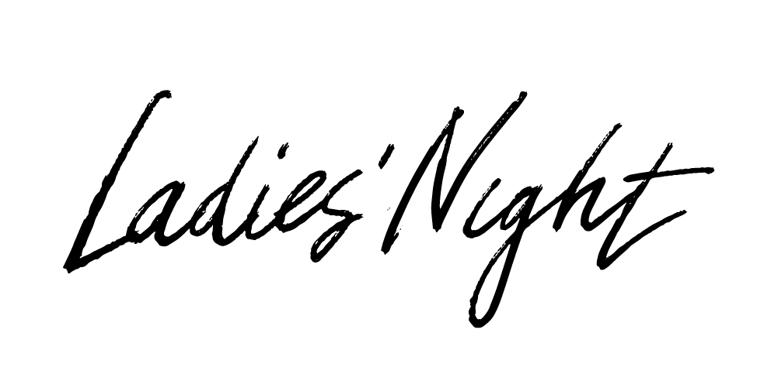

Friday 18th November 2016 6.45pm till late

Pavenham Village Hall

Tickets are priced at £15 each.

Entry includes a Fish and Chip Supper, a choice of pudding and a glass of Prosecco

Tickets available from
Pinchmill Preschool
01234 781770
admin@pinchmillpreschool.co.uk

