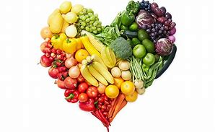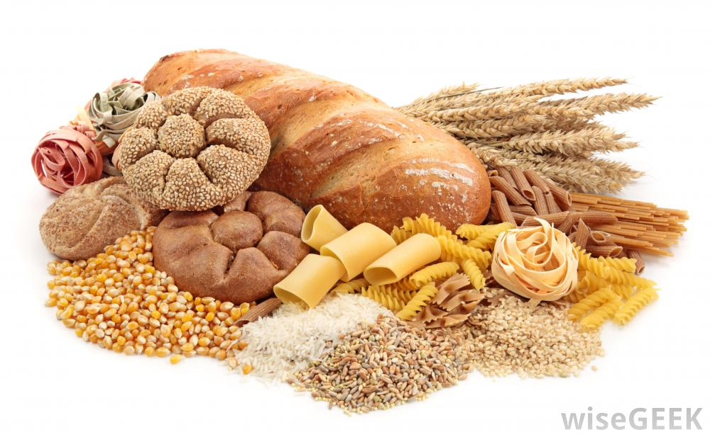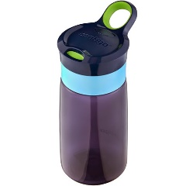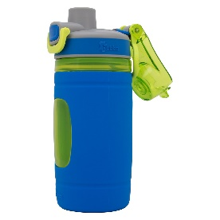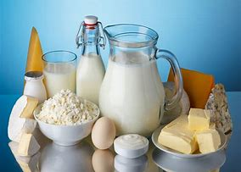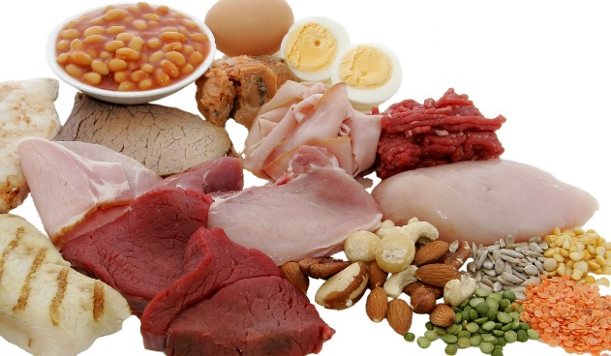  
  
  
  
  
  
  
  
  
  
  
  
  
  
  
  
  
  
  
  
  
  
  
  
  
  
  
  
  
  
  
  
  
  
  
  
  
  
  
  
  
  
  
Carbohydrates Fruits  
Sandwiches – on bagels, bread or bun Strawberries  
Crackers Raspberries  
Tortillas – make wraps or quesadillas Blueberries  
Waffles Blackberries  
Mini rice cakes Cherries   
Mini muffins Watermelon  
Cold pasta Pineapple  
 Kiwi   
Dairy Grapes  
Cheese Oranges  
Cream Cheese sandwiches Bananas  
Cheesestrings Apples  
Yogurt tubes / drinks Pears   
Yogurt Plums  
 Raisins  
 Dried fruit  
Meats / Protein Vegetables  
Meat sandwiches Peas  
Chicken Baby Carrots  
Hard boiled eggs Baby tomatoes   
Peanut butter Cucumber  
Chicken or Beef quesadillas Celery  
Hummus with vegetable dippers Sweetcorn  
Tuna sandwiches Steamed broccoli   
Salmon sandwiches Steamed green beans  
Mackerel sandwiches

As part of our Early Years Foundation Stage curriculum we always encourage healthy eating and a healthy lifestyle. We hope that we can support you in doing the same with your child’s packed lunch. Below is an example of what needs to be included in your child’s packed lunch to ensure they are getting everything they need. Unbalanced packed lunch can result in higher intakes of fat, salt, sugar and as a result, can affect learning, growth, development and long-term health.

**Did you know?**

**Fruit & Vegetables**

**Starchy / Carbohydrates**

**Drinks**It is important your child is hydrated. Water is always best. Please ensure your child has a drink.

**Remember**

Always make sure grapes are cut lengthways.

**Protein**

* Eating a bag of crisp everyday can have the same amount of fat as drinking one cup full of oil!
* Some fruit juices contain up to 8 teaspoons of sugar!

**Dairy**

We have the use of a microwave and cooker. If your child would like for example beans and toast, you need to provide the beans and bread but we would make it for them. We WILL NOT re-heat food such as rice, meat or noodles. We also don’t have a freezer to store food. Please provide a drink for lunch time. We ask that you don’t provide fizzy drinks ie:- coke, lemonade or sweets.