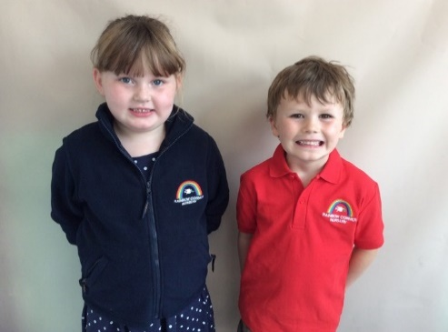 Uniform Order Form  
   
Polo shirt - £7.50 Sizes 1-2yrs 3-4yrs   
  
Fleece - £12.50 Sizes 2yrs 3-4yrs   
  
Please circle the size above.   
  
Polo shirt quantity ………………………………………….  
Fleece quantity …………………………………………..  
  
Please place money into an envelope with the child’s name on. Cheques made payable to Rainbow Corner Playgroup LTD