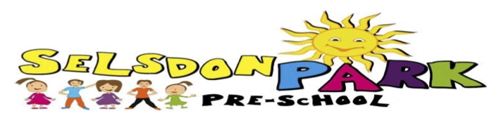

**EAL Policy (English as an Additional Language)**

**Rationale**

**At Selsdon Park Pre-School we value the different language and cultures of children and parents who use the Pre-School and will promote a positive attitude towards bilingualism.**

**The Pre-School will provide a wealth of opportunities to aid the development of the child’s home language in order to help EAL Learners to achieve more.**

**Implementation of Policy**

We understand that bilingual learners must be allowed time to observe and experiment with their new language.

At Selsdon Park Pre-school we will ensure that;

* Learners have access to a range of books and stories that cover a range of cultures and beliefs and support the development of language.
* Pre-School staff will plan high quality activities with practical focus on key vocabulary and phrases EAL Learners require.
* The Pre-School will form a partnership with the parents of EAL Learners to ensure that the child’s language development is supported at home and builds on the work in the Pre-School.
* We will try to get language support team from early years to assist staff to learn key words which make the child fell welcome and comfortable.
* Different posters and props will be used to support EAL children.

Signed on behalf of the setting:

Date:

Date written 5/10/16

To be reviewed 5/10/17