**A peek to what we have been learning**!

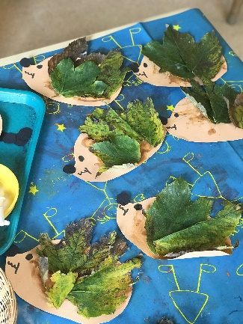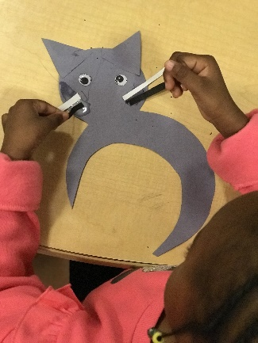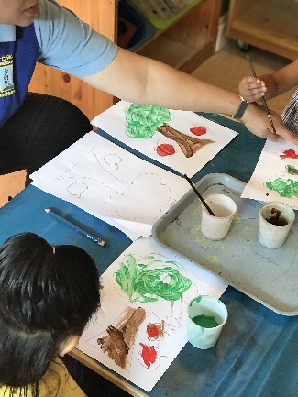Over the past few weeks in Jupiter & Neptune room we have been very busy enjoying both outdoors and indoors learning environment. We took part in Autumn Nature projects; we learnt that Autumn is a time for slowing down and preparation for the long winter ahead. We also learnt about leaves, why are the leaves not all green? Why do leaves fall off the trees? Will the trees grow more leaves? Where do the animals go? And much more! We have also enjoyed exploring with sticks which enhanced our mathematical development through counting the sticks, lining them up and exploring the patterns, ordering them by size. We have also enjoyed learning about apples, mushrooms, Spiders and Hedgehogs, we read stories related to those themes such as “The Stick man”, “How do apples grow?”” The very helpful hedgehogs” and “The forgetful spider”. We have also enjoyed celebrating “Multicultural day” where we tried out new food from different parts of the world and we made lots of arts and crafts related to “Halloween” which we have used to decorate the nursery! Here are some of the activities we had enjoyed:

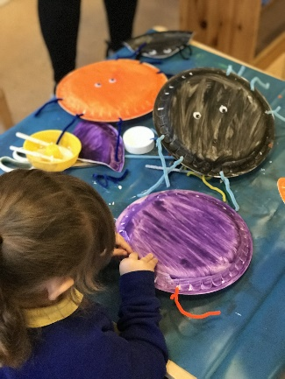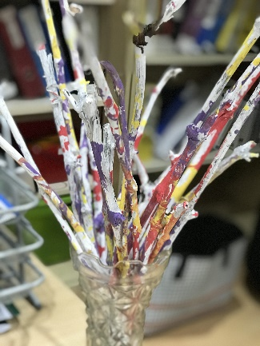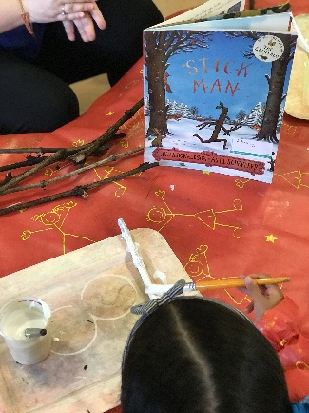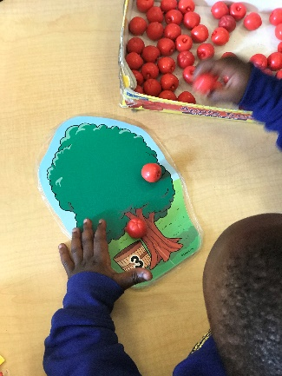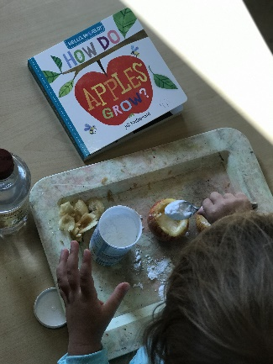

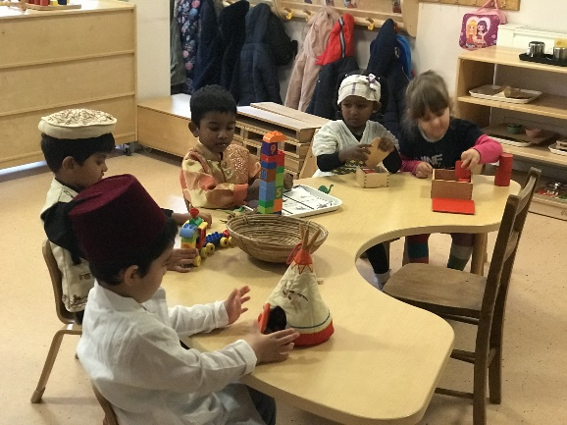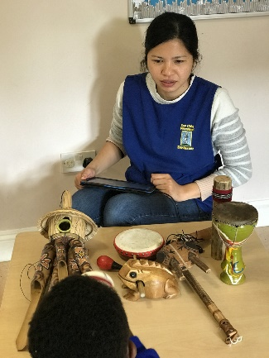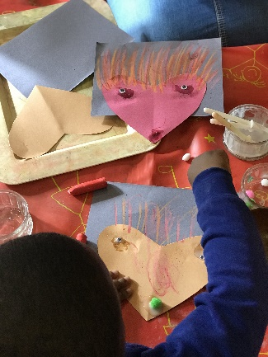

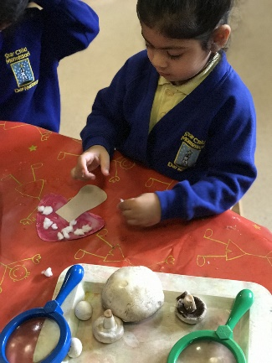***Link to characteristics of effective learning*** - Playing and exploring - Finding out and exploring - Engaging in open-ended activity.

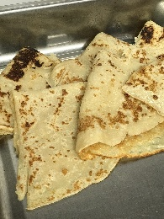***Link to the Early Years Foundation Stage*** - Understanding the World - The World - Shows care and concern for living things and the environment. (30-50 Months).