**A peek to what we have been learning**!

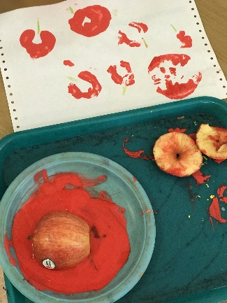Over the past few weeks in Venus room we have been very busy enjoying both outdoors and indoors learning environment. We have learnt about “All about Me”, “My Body”, “5 senses” and “Fruits and vegetables” We have read stories related to those themes such as: “Super senses”, “Look”, “The very hungry caterpillar”, “One potato”, “My meal time”.Taste testing, comparing foods by sight and feel, and group games were just amongst the few activities we have enjoyed! The “All about Me” theme help us learn about each other and each other’s families as we have had the opportunity to look at family pictures at circle time! It has also helped us understand that every person is unique and special and each of us have thoughts, ideas and interests that make us unique and are important and no one person is more or less important than another! We have also enjoyed celebrating “Multicultural day” where we tried out new food from different parts of the world and we made lots of arts and crafts related to “Halloween” which we have used to decorate the room! Here are some of the activities we had enjoyed:

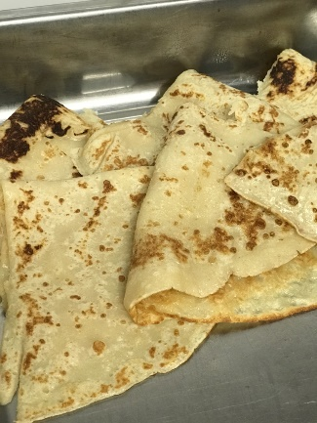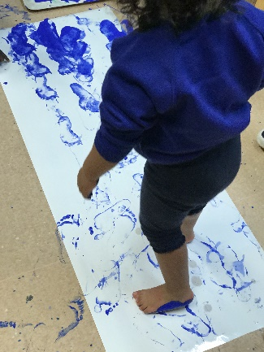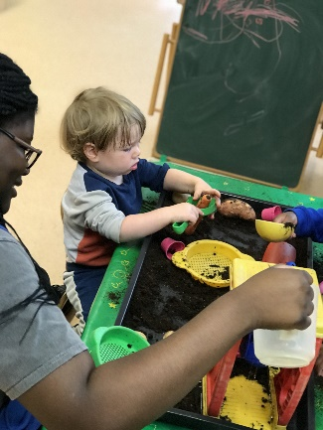

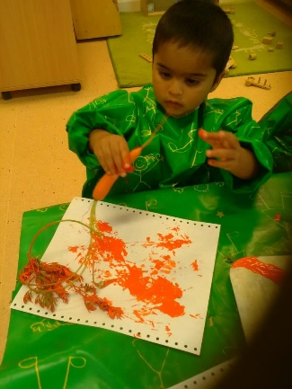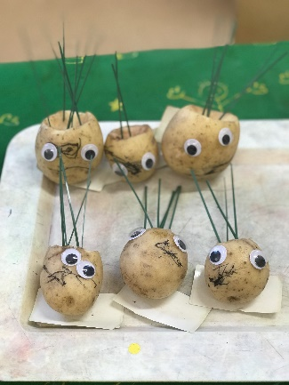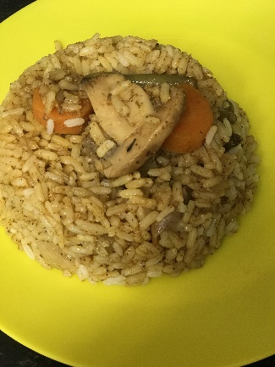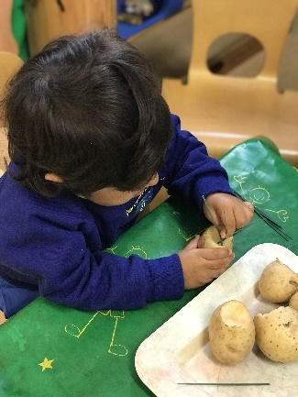

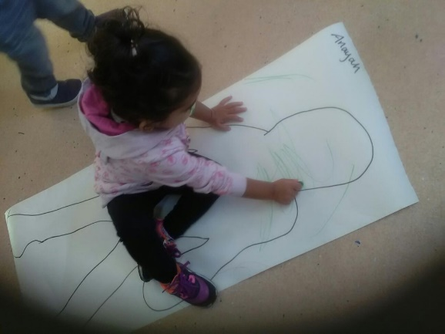

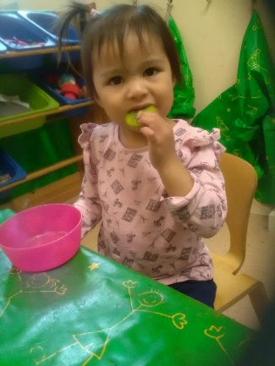***Link to characteristics of effective learning*** - Playing and exploring - Finding out and exploring - Engaging in open-ended activity.

***Link to the Early Years Foundation Stage*** –

Personal, Social and Emotional development (self-confidence and self-awareness; Make independent choices 22-36Months).

Physical Development, Health and self-care: eat a range of healthy food.

My body Tracing Test tasting