My Body poem (circle time/ Monday to Friday)

Doctors’surgery role play

Bean bag body balance (following instructions)

This the way…(circle time)

Moving your body

(driving cars on zig zag and straight line)

Body / Funny feet/Funny Bones (Story time)

Hokey Pokey game outdoors (Monday to Friday)

Jumping bean song (T.K )confidence)

Yoga movements (managing feelings and beaviour)

every day /before going upstairs for lunch

water play; washing babies

**C&L**

**Week 13/09 & 20/09/21**

**My Body**

**Venus Room**

**PSED**

Foot and toes printing (Monday1)

Body tracing (Tuesday 1)

Ear pods bone painting (Wednesday 1)

Playdough with body cutters (ginger man) (Thursday 1,2)

Shower art (Monday 2)

Multicultural hand prints (all in one arts and crafts)Tuesday 2

Shaving foam fun (Wednesday 2)

Junk modelling (Friday 1,2)

**PD**

**Foot and Toe Painting**

**Implement**: Materials needed:  newspaper, paint, pieces of paper; shallow trays for paint, bin with warm soapy water and towels.

Place newspaper all over the floor in the area you will do this.  Put large sheets of paper and have the children, 2 or 3 at a time, dip their feet in fingerpaint and make a group footprint picture!

**Body Tracing**

Help each child trace their body!  They lay down on a large piece of paper.  You trace their outline and print their name on the paper.

The child then decorates it.

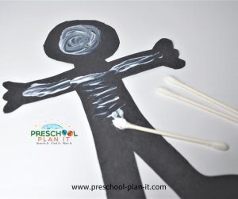

**Ear pod "Bone" Painting**

**Implement**: In advance, cut out body shapes out of black paper. Provide ear pods and white paint. Encourage the children to paint bones on the bodies.

**Bean Bag Body Balance**

Implement: Provide one bean bag for each child. Name a body part and tell them to walk around with the bean bag on that part (elbow, head, foot, belly, back!).

|  |  |
| --- | --- |
| **My Body poem**  Here Are My Ears  Here are my ears.  Here is my nose.  Here are my fingers.  Here are my toes.  Here are my eyes,  Both open wide.  Here is my mouth  With white teeth inside.  Here is my tongue  That helps me speak.  Here is my chin,  And here are my cheeks.  Here are my hands  That help me play.  Here are my feet for walking today.! | **This Is The Way***sung to the tune of The Mulberry Bush*  Act it out as you sing!  This is the way we wash our hands, wash our hands, wash our hands.  This is the way we wash our hands so early in the morning.  This is the way we wash our face, wash our face, wash our face.  This is the way we wash our face so early in the morning.  Add additional verses such as:  This is the way we wash our elbows....  This is the way we wash our stomachs.... |

Shower art painting

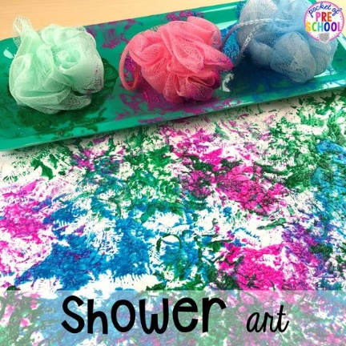

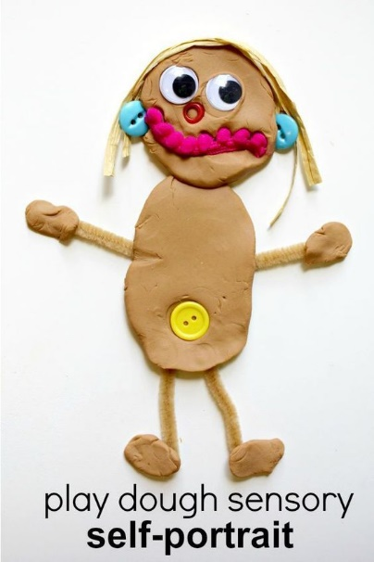 Ginger man playdough

**Moving your body:**

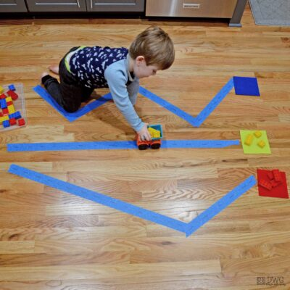**Intent: Prewriting with colours can help with writing!** child is moving left to right, along with seeing lines like straights, zigzags, and curves, just like we form lines and letters. When we prewrite with colours and movement, we help our children make connections to the letters of the alphabet.

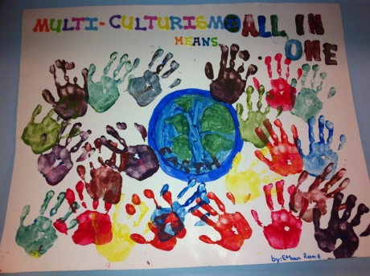

**Shaving Cream Fun** (Black history month/Multicultural) Mr. Carver, as stated above, also invented adhesives.  Adhesives make things sticky!  Let's make our shaving cream sticky!

**Implement:** Mix equal amounts of shaving cream and white glue.  If you want to color it, add paint or food colouring to the shaving cream and mix.  THEN add to the glue. Place the concoction in bowls and let the children paint on paper with it. It dries hard and somewhat shiny!

