For specific information regarding daily/weekly nutritional content please speak to your Nursery Chef or Nursery Manager
We always do our best to accommodate any specific dietary requirements and work closely with our parents to ensure every child is getting 100% of the nutrition they need whilst in our care. We take care not to provide food containing nuts or nut products and are vigilant where we have a child who has a known allergy.
Seasonal fruit served after Lunch and Tea
Week 1 | Monday | Tuesday | Wednesday | Thursday | Friday
Breakfast : A selection of cereals with warm or cold milk toast with butter; also a selection of fruit available.CG, M
Lunch | Mixed Beans chili corn carne served with rice  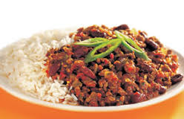 | Greek Lamb and Macaroni bake  CG M E  Greek Chickpeas and Vegetable with Macaroni bake |   Fisherman pie served with broccoli and sweetcorn F M E    Creamy fishless pie with green peas | Chicken pie served with sautéed green beans CG M  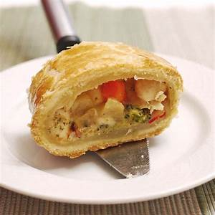  Green beans and selection of vegetables pie |  | Vegetable Pasta Bake served with garlic bread M CG  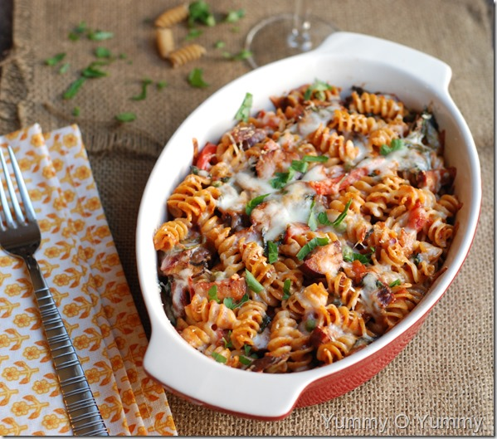
Desert |   Pineapple upside down cake served with custard E CG M |   Yogurt M | 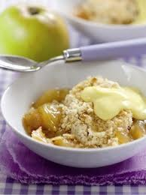  Apple crumble served with custard M E CG | Jelly and Ice cream M   |  | Chocolate rice Krispie cake
Tea | Cheese pancakes E, M, CG   | Couscous and vegetabes stew M | Selection of Cheese, jam and lemon curd Venus and Neptune  Beans on toast for Pluto room CG, M,E   | Leek and spinach spaghetti stir fry CG |  | Margherita Pizza CG, M
P: Peanuts | SY: Soya | F: Fish | E: Egg | M: Milk | Mo: molluscs | L: lupin
C: Celery | CG: Cereal and Gluten | CR: crustacean shellfish | SS: Sesame Seeds | SD: Sulphur Dioxide | Mu: Mustard | N: nuts

