For specific information regarding daily/weekly nutritional content please speak to your Nursery Chef or Nursery Manager
Week 2 | Monday | Tuesday | Wednesday | Thursday | Friday
Breakfast: A selection of cereals with warm or cold milk; toast with butter; also a selection of fruit available CG M
Lunch | Homemade pineapple cheese pizza served with cucumber and sweetcorn salad CG M   | Lamb and vegetables lasagne served with garlic bread  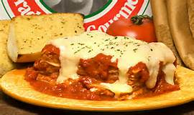  CG M E  Red lentils and vegetables lasagne | Chicken and Butternut Squash Curry with Rice    Chickpea and butternut Squash Curry with Rice | Broccoi and cauliflower Cheese M |   Fish fingers, chips and peas  F CG  Fishless fingers, chips and peas.
Desert | Semolina and raisin pudding CG M SD  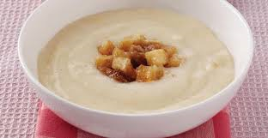 | Yogurt M   | Jelly and Ice cream  CG M E | Chocolate Brownies | Banana Loaf and custard  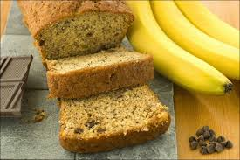  CG M E
Tea | Jollof Rice CG | Turkish red Lentil soup with cheesy homemade Scones CG M    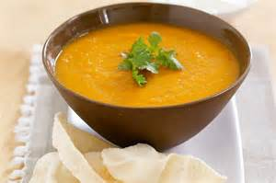 | 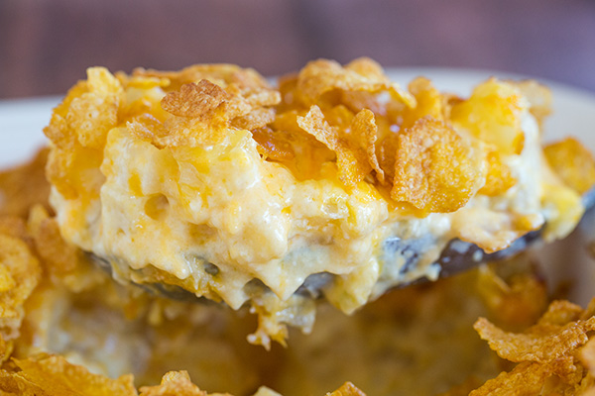  Potato ad sweetcorn bake M |   Cheese on toast CG M | 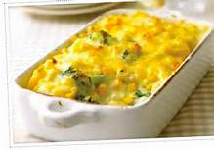  Macaroni and sweet corn bake. CG M
We always do our best to accommodate any specific dietary requirements and work closely with our parents to ensure every child is getting 100% of the nutrition they need whilst in our care.
We take care not to provide food containing nuts or nut products and are vigilant where we have a child who has a known allergy.

Seasonal fruit served after Lunch and Tea
P: Peanuts | SY: Soya | F: Fish | E: Egg | M: Milk | Mo: molluscs | L: lupin
C: Celery | CG: Cereal and Gluten | CR: crustacean shellfish | SS: Sesame Seeds | SD: Sulphur Dioxide | Mu: Mustard | N: nuts

