For specific information regarding daily/weekly nutritional content please speak to your Nursery Chef or Nursery Manager
We always do our best to accommodate any specific dietary requirements and work closely with our parents to ensure every child is getting 100% of the nutrition they need whilst in our care. We take care not to provide food containing nuts or nut products and are vigilant where we have a child who has a known allergy.
Week 3 | Monday | Tuesday | Wednesday | Thursday | Friday
A selection of cereals with warm or cold milk; toast with butter; also a selection of fruit available

Lunch | Vegetarian Spanish Paella  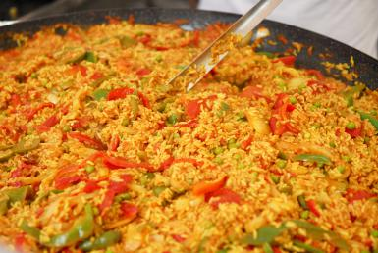 | Spaghetti Bolognese  CG M  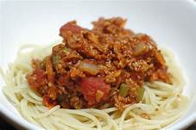  Lentil Bolognese | sweet and sour chicken with egg fried rice CG    Sweet and sour mushrooms with egg fried rice | . Homemade fish cake with baked beans F    Fishless cake with baked beans | Pasta bake with garlic bread CG M  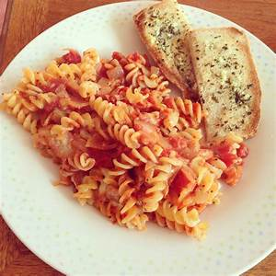
Desert | Chocolate sponge and Custard | Yoghurt  CG M E SD | Apricot sponge cake and custard M | 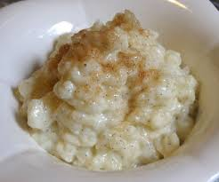  Rice pudding M | 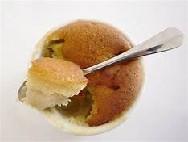  Eve’s pudding and custard  CG M E
Tea | Egg noodles stir fry  CG | Couscous and Spinach stew CG | Assorted sandwiches /  Butternutsquash soup M  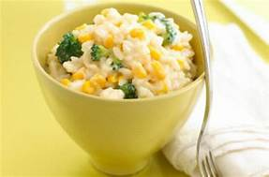 | Selection of Jam/ lemon curd/ Tuna and cucumber sandwiches CG E   | Spaghetti on toast CG  

Seasonal fruit served after Lunch and Tea
P: Peanuts | SY: Soya | F: Fish | E: Egg | M: Milk | Mo: molluscs | L: lupin
C: Celery | CG: Cereal and Gluten | CR: crustacean shellfish | SS: Sesame Seeds | SD: Sulphur Dioxide | Mu: Mustard | N: nuts

