**A peek to what we have been learning**!

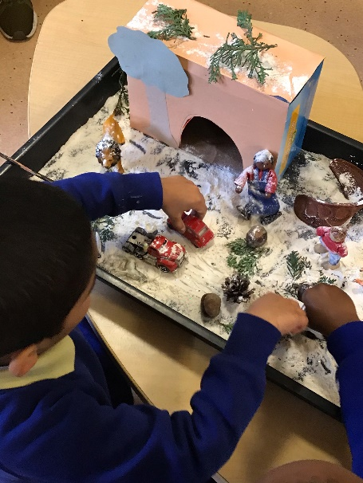Over the past few weeks in Jupiter & Neptune room we have been very busy enjoying both outdoors and indoors learning environment. We learnt about Winter, Winter trees, hibernation, Snow, Mountains and Snowflakes.

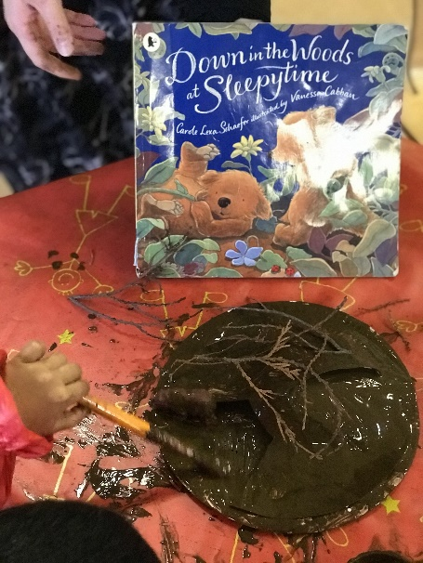It was very interesting to learn about what animals go in deep, deep sleep in winter; we found out that a hibernating animal's body temperature drops very low and their breathing slows too! We also learnt that in summer they eat extra food to help them get through the winter. The most amazing fact was that during their winter sleep, we can tickle, move or touch them but they will not even be aware of it!

Some animals that hibernate are spikey little hedgehogs, buzzy bumble bees, sleepy little dormouse and slithering grass snakes!

Now, here's something you may not have known: Bears do **NOT** hibernate! They actually go into what is called **torpor**; when they sleep soundly for weeks! so shhhhhhh.... don’t wake the bears!

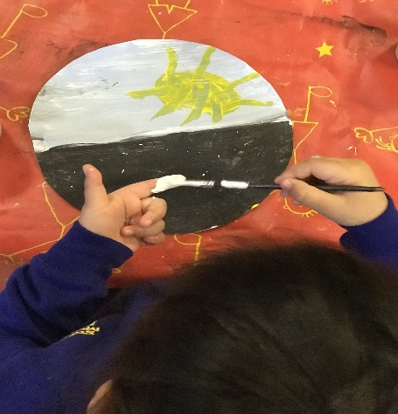

For the Winter theme, we learnt that **winter season** includes all kinds of weather! Not only is it windy but there is ice and.......SNOW! The days are shorter, and we have longer night and time of darkness!

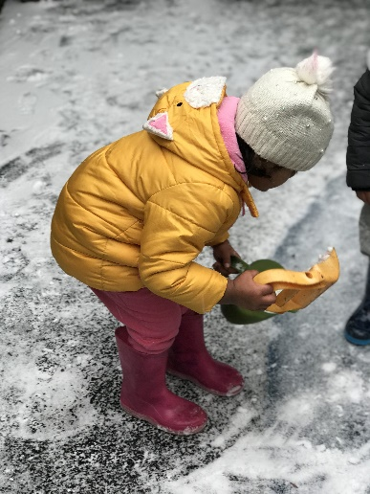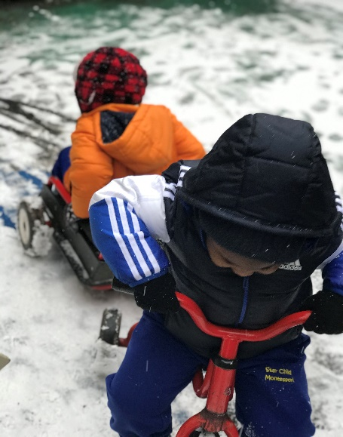We were very fortunate this year to see LOTS of snow! And we all enjoyed going outside and play in it.  We even brough the snow and ice inside when it was too cold to go outside! It was a great fun catching snowflakes on our mitten and try to draw them before they melt.

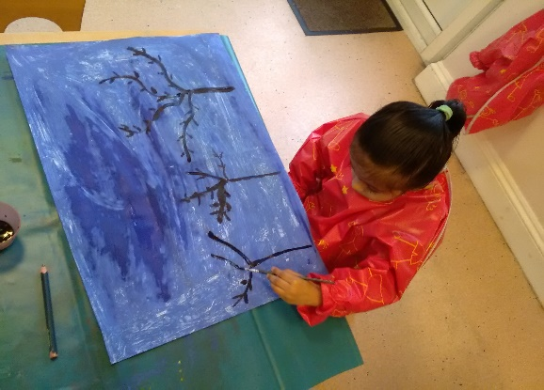In winter, the trees take a rest, to get ready to share their goods when the weather warms again.

We also learnt about mountains and how they look like a big rock! Did you know if you go over the mountain, to see what you 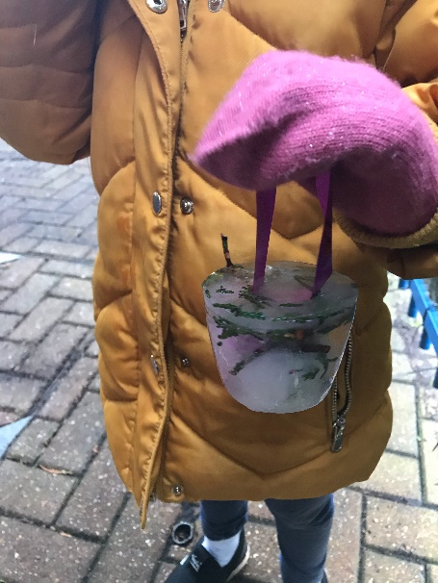could see? You will only see the other side of the mountain!

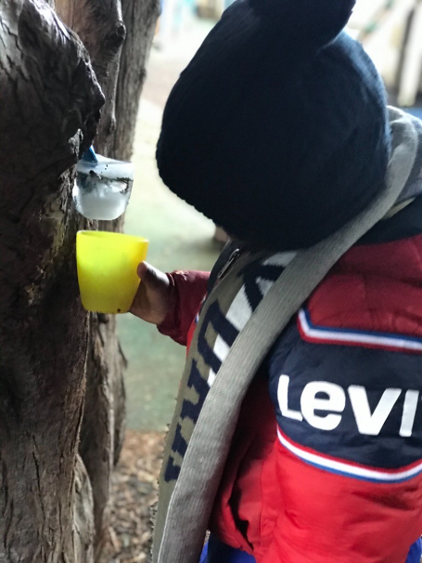

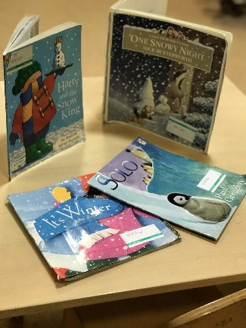

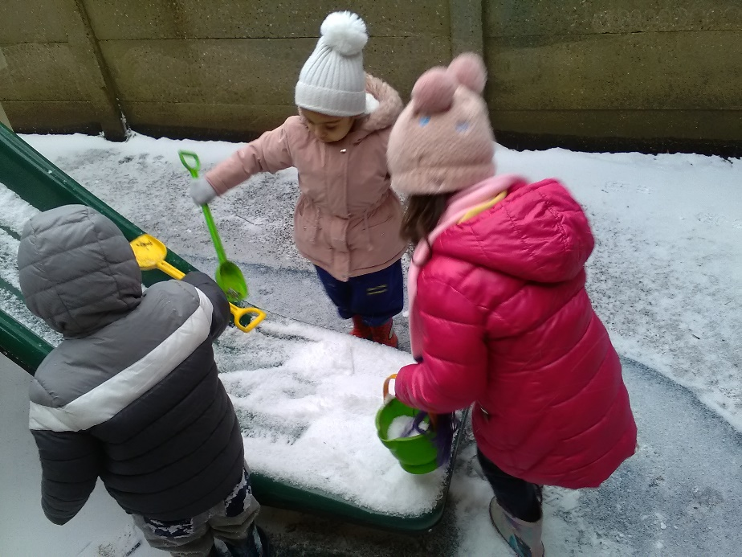

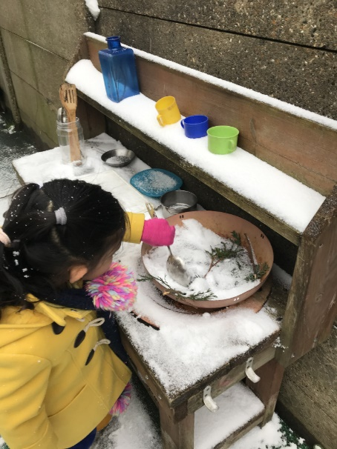

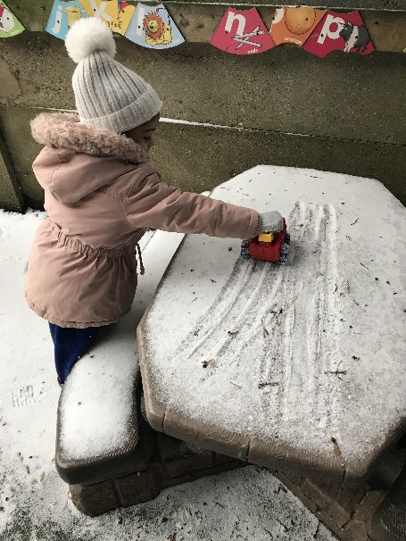

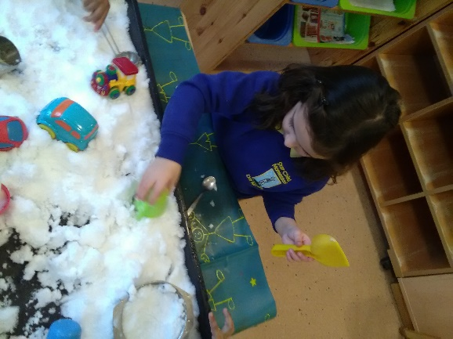

***Link to characteristics of effective learning*** – Taking a risk, engaging in new experiences and learning by trial and error e.g slippery surfaces!

***Link to the Early Years Foundation Stage*** – Look closely at similarities, patterns and change.

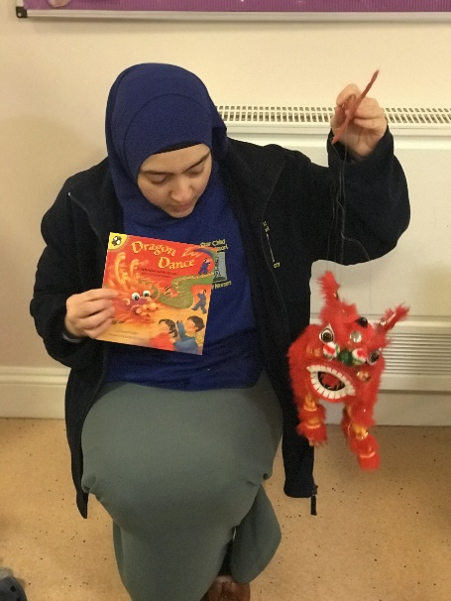In addition to the above, We have also enjoyed celebrating “Chinese New Year” where we tried out a sweet and sour dish from China and explored traditional items e.g. chopsticks and we made lots of arts and crafts related to the theme and to “Valentine”.

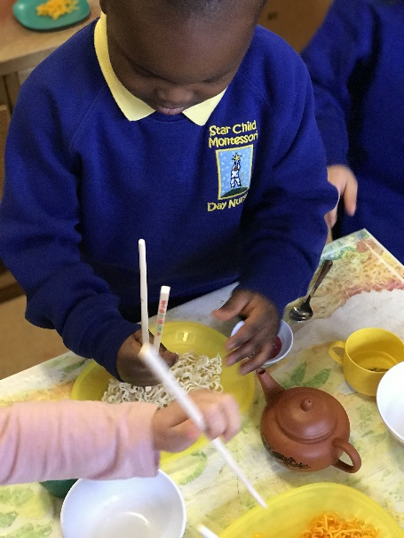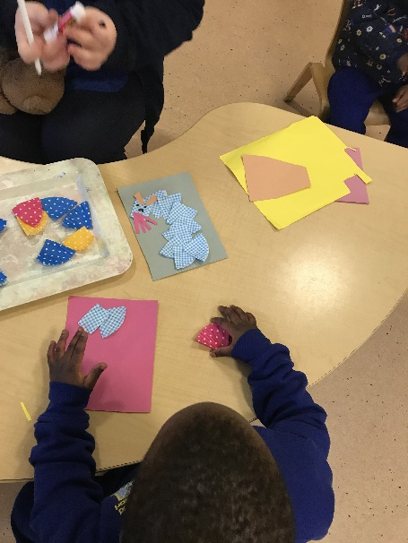

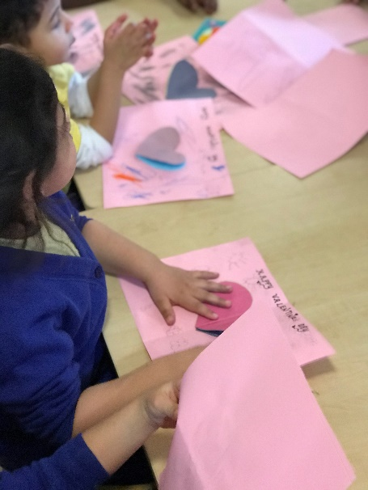

***L******ink to characteristics of effective learning***

’Playing and exploring; Representing their experiences in Play

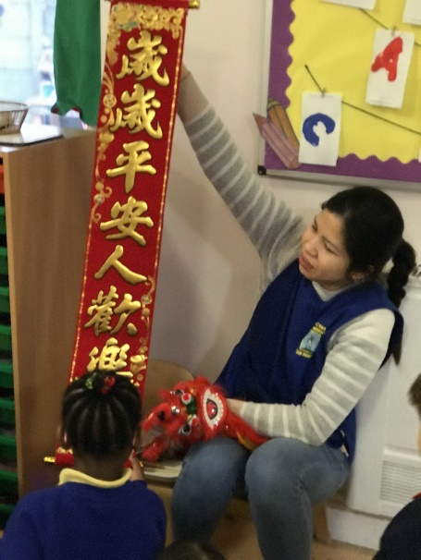***Link to the Early Years Foundation Stage*** – Know some of the things that make them unique and can talk about some of them similarities and differences in relation to friends and family.

