‘ Next steps:

Rain rhymes; listening and attention

The rainstorm

Listening to rain and thunder on you tube/ just listening

Pancake making role play (Eric Carl pancake, pancakes)

Puddle jumping

Puddle tossing

Rain rhymes (being confident to take part in group )

**PSED**

**C&L**

Child interest: books/water play/Group games

Next step:

Get on your rain gear

The rainstorm

Rain table (water play)

**Week**

**21 02/2022**

**28/02/2022**

**Rain, dinosaurs**

**World book (Eric Carl) day/Pancake day**

**Jupiter/ Neptune**

Rainbow blocks

Puddle jumping

Puddle tossing

Making orange Juice

Water play: pouring and transferring

Making snips on paper

Healthy and non-healthy food bingo

kk

**KDW**

Collage Art (Monday 1)

The Grounchy ladybug craft (Tuesday 1)

Pancake craft (Wednesday 1)

Cloud making (Thursday 1)

(Friday 1,2) Moon Art playdough 1/dinosaurs

Rain forest flower painting (Monday 2)

Paper plate dinosaurs (Tuesday 2)

Mothers’ day card (Wednesday 2)

Salt dough dinosaurs fossils (Thursday 2)

P letter box

Rain Rhymes

Pink box series “o””a”

”e”and “I”

Pancakes, pnacakes

(Eric Carl)

5 ferocious herbivors

Trace and count

Broad stairs

Pink tower

3D solid shapes box

**Literacy**

**EAD**

**Rainbow Coloured Rain Drops**

Materials needed:  coffee filters, pipettes, many cups with water coloured with food colouring.

Implement: The children squeeze drops of coloured rain onto the filters for a great effect!

Encourage them to count the drops as the squeeze!

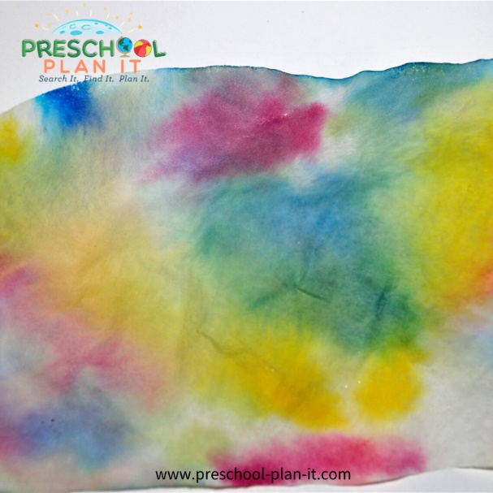

**Rainbow Blocks**

Add rainbow coloured blocks to your block area.

The children can use the blocks to build many rainbows.  Discuss rainbows and when they see them, sing the Rainbow song (Red and orange, green and blue!).

**Rain Rhymes**  : circle time/ Impact: for children to learn the social skills of being together as a large group AND to learn more about the theme! Learning from more able peers.

Materials needed:  A large piece of paper/ white board and a marker

Implement: Say the word rain with them several times.  Ask them if they can think of any words that SOUND like the word "Rain".  List all the ideas on the chart with the children's names.

List words even if they do not rhyme. For example, the child may not understand the activity.  They may say thunder.  Write that on the side of the chart paper and comment, something like:

"Well, that is something that happens sometimes when it rains!  The word "thunder" does not sound like "rain".  Let's say them:  Thunder. Rain.  So we'll put that word over here, because we DO hear thunder when it rains sometimes.

This results of this type of activity can help you in many ways (point of reflection):

1.  Are you using words or descriptions of activities that are understood by the children?

2.  Is the child understanding what is being asked?

3.  Are there processing delays happening?

**Get on Your Rain Gear!**

Provide rain coats, hats, rubber boots and small, safe umbrellas!

They children dress to "go outside" and then count and jump the puddles!

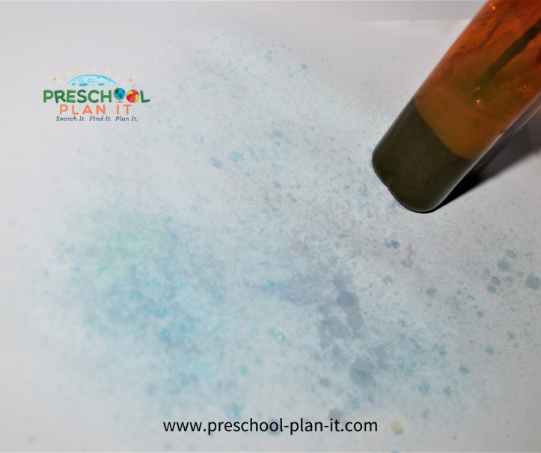**Rain Painting**

Provide small water bottles filled with water and some paint mixed in.

The children spray their designs

**Mud Painting**

In advance, make a large bowl of mud.  Place mud in paint cups.  Provide large paint brushes for the children to paint with.

**Puddle Jumping**

Make a large puddle shape out of paper!  Or, we have used a jump rope to make a large circle.

Tell the children they have to figure out how to get over the puddle without "getting wet"...aka jumping in the puddle.

Every once in a while, yell "FREEZE!  PUDDLE JUMPING TIME" And let them jump in the puddle!  You KNOW they want to!

VARIATION:  C'mon.....be brave......actually jump in puddles outside!  No rain?  Make puddles!  Ask parents to bring in a change of clothing for Puddle Jumping Day!!  ;)

**Puddle Tossing**

Materials needed:  A hula hoop or a large bin, basket or box and bean bags.

The hoop, bin, basket or box is the puddle.  The children practice tossing the beans into the puddle!

EXTENSION:  Add packing peanuts into the "puddle" for a big splash when the bean bag hits them!

**The Rainstorm**

Have the children act out a rainstorm from beginning to end!

Oh Look!  It's getting cloudy (put hands up and sway like clouds).

What's that?  Was it a drip of rain?  (squat down, pause, then up pause, repeat)

Oh, now it's very misty!  (rub hands together to make a misting noise as you move around together....listen to the mist!)

Oh No!  It's pouring out!  (Slap your hands against your legs as you move around to make rain noise!)

Is that thunder I hear?  (Stomp around in the circle).

The storm is leaving.... (now do the actions in reverse). Phew, it's nice out again!  Now we can play outside!  (Jump up and down!!)

**Rain Table ( water play)**

In your water table this week, add water wheels, colanders and/or sand sifters, small plastic bottles, salt and pepper shakers--anything with holes to create rain!!

**FLOWERS OF RAIN FOREST LAYERS**

Provide liquid watercolor paints for Rain Forest flowers! The children paint their own flowers.

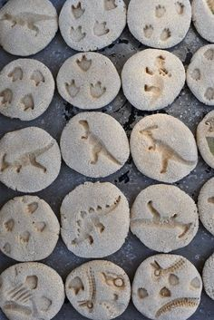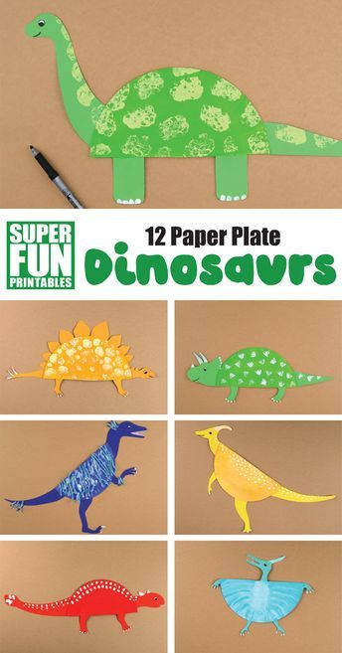

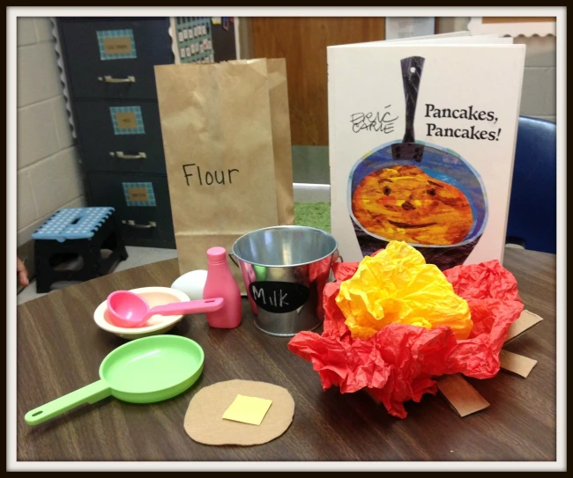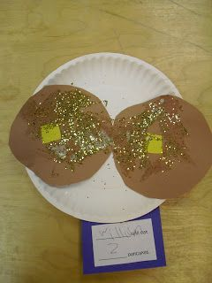 World book day (Eric Carl) and Pancake day pancake craft

**Collage Art**

Eric Carle's use of water colour and collage are pretty amazing!  Get creative and see what items your pre-schoolers’ can use to create with!

Materials Needed: tissue paper, watered-down white glue, white construction paper.

The children create their own collage with the tissue paper.  I find it easier if the children "paint" the glue on their paper first and then place the tissue paper.

VARIATION:  Place small pieces of tissue paper into a tray, bin cover or cookie sheet.

The children "paint" their paper with glue.  They then flip the paper over and press into the tray of tissue paper (or other collage materials).When providing different mediums to paint with, provide a variety of tools to paint with such as:

* [**Plastic forks**](https://amzn.to/3c9xCoI) [**Playdough tool sets**](https://amzn.to/3c0fz4e) [**Craft sticks**](https://amzn.to/3b0rKhk)
* 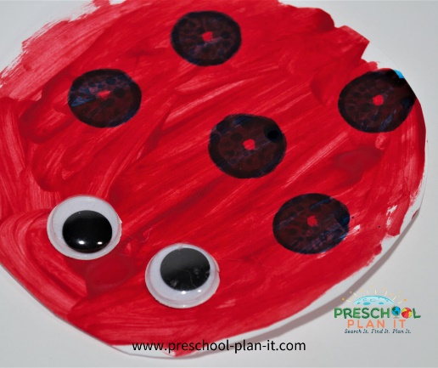**Ladybugs**
* After reading [**The Grouchy Ladybug**](https://amzn.to/2RqQXKb) book, let the children make their own Ladybugs!
* Materials Needed: White paper (either pre-cut into circles or encourage the children to cut their own circle as best they can!) or paper plates; googly eyes, bingo daubers.
* The children cut their circle and then paint it with red paint.  They use the daubers to put black dots on the lady bug and then glue on googly eyes.

**Cloud Making!**

After reading [**Little Cloud**](https://amzn.to/2Rsgp1O), follow up with these fun ideas for cloud art!

* ***Coloured Clouds***

This is a variation on the puffy paint.  Place shaving cream and glue in many bowls.  Add a different colour to each bowl and mix.

The children create different colours of clouds to represent sunsets or sunrises!

**Moon Art**

After reading [**Papa, Please Get the Moon for Me (This one is the book and CD!)**](https://amzn.to/2JRFaAp), provide materials for the children to make their own moons!

* ***Playdough***

Provide playdough in different colors for the children to create the moon and create ladders or other scenes from the story.

You can also provide playdough tools to use including moon and star shaped cookie cutters!

|  |  |  |  |
| --- | --- | --- | --- |
| 5 ferocious herbivores playing in the swamp.  Eating yummy plants, chomp, chomp, chomp.  Along came a carnivore as LOUD as could be and.....gulp! (move one herbivore aside)  Continue backwards to 0! | Which One? (sung to the Muffin Man)  Which dinosaur had a tooth like a banana, tooth like a banana, tooth like a banana?  Which dinosaur had a tooth like a banana? Which one do you think? (T-Rex)  Which dinosaur had a horn on its nose?........ (Triceratops)  Which dinosaur had plates on its back?........ (Stegosaurus)  Which dinosaur ran really fast................ (T-Rex) | Tyrannosaurus Rex sung to Mary Had a Little Lamb  Dinosaurs walked on this earth, on this earth, on this earth.  Dinosaurs walked on this earth...a very long time ago.  Tyrannosaurus Rex was the king, was the kink....a very long time ago.  Add facts about other prehistoric reptiles you've learned about! | **Thunderstorm poem**  Boom. Bang. Boom. Bang  Rumpety, lumpety, bump.  Zoom. Zam. Zoom. Zam.  Clipperty, clapperty, clump.  Rustles and bustles, and swishes and zings.  What wonderful noises a thunderstorm brings. |