Seashell cup game .

Transition “bear dressing up”

**PSED**

Beach theme what’s missing game

Light box: Picture stories

Hermit crab, Hermit crab where are you?

**C&L**

Child interest: A.P Shadows

**Numeracy**

**Literacy**

**PD**

Next step:

At the bay water play ;

At the beach sand play

**Week**

**02/ 08/2021**

**09/08/2021**

**The beach**

Wooden blocks and torches play

Beach volley ball game

Gafrden jobs; Check plants

daily and water them

shadow tag!

Water tray; pouring and

transferring using

container

**KDW**

Sand art (Monday 1)

Sand paper rubbing (Tuesday 1)

Sand castles (Tuesday 2)

Beach towel craft (Wednesday 1)

Foil fish craft (Wednesday 2)

Sea shell craft (Monday 2)

Junk modeling (Friday 1,2)

Paper case crab craft (Thursday 1

Playdough (Thursday 2)

Light box;

Shapes and patterns

3 D shapes shadow

5 little sand castles poem

Sand paper numerlas

Shell sorting

Hermit crab, hermit

crab where are you?

Tree bark rubbings

B sound box

Beach scene colouring

b is for beach tracing

sheet

**EAD**

**Sand Art**

Materials Needed: Sand/glue

**Implement:**

There are 2 ways to do this!

1. The children squeeze glue all over their paper and then sprinkle the sand over it (use a shallow tray to catch the extra sand!)
2. The children brush their entire paper with clue and then use a spoon to sprinkle the sand to make a beach scene!

**Sandpaper Rubbings**

Materials needed:  variety of different "grit" or roughness's of sandpaper cut into different sizes, paper, peeled crayons.

**Implement**:

The children place pieces of sandpaper under their paper.

They rub crayons over their papers to reveal the texture (using the sides of the crayons, not the tips).

**VARIATION:**  Let the children colour ON the sandpaper!

**Beach Theme What's Missing Game**

Using the items related to the beach (sand, bucket, spade, seashell, hat, flip flop) , place them all out in the open.

**Implement:** Cover all the items with a blanket.

Remove one item without the children seeing what it is. Can they remember what items is missing?

**Intent**: listening and attention/ develop concentration/

**Hermit Crab! Hermit Crab! Where are you?**

Implement: For this game, make a set of cards about 3" X 3" all with a seashell on it.

Make a hermit crab body that will fit under the cards without being seen. Laminate the cards.

Using a dry erase marker, program the cards with letters or numbers.

Place the hermit crab under one of the cards without the children seeing.

Say, "Hermit Crab!  Hermit Crab!  Where are you?" Invite ONE child to take a turn guessing (they choose a shell and before lifting it up, they say the letter or number.  If they don't know what it is, ask the rest of the children to help their friend identify the number or letter).

The child lifts up the card.

Is the hermit crab there?  If yes, "Hooray!  You found it!"  If no, "Not here today!"  Place the card back on the floor.

Repeat until every child has had a turn.

This type of game is always a favourite!  You might want to place it at your math or library area for use during centre time!

VARIATION:  If you are working on colours, print off the seashell cards on coloured paper!

**Beach Towels**

Materials needed:  paint, brushes, large white construction paper, scissors, pen/marker.

The children print their name on one side of the paper.

Flip paper over and the children design their own beach towel with paint.  Encourage the use of mixing colours, patterns, dots, etc.

When dry, the children use scissors to "fringe" the shorter edges!

**Sea Shell Cup Game**

 Provide hard plastic drinking cups and a seashell.

The children place a shell under one cup and move the cups around.

Another child tries to guess which cup it is under!

**Beach Volley Ball**

Use a beach ball to play volley ball!

Don't have a net?  It's okay.... make a line in the grass or sand using wooden blocks!

**Sand Castles**

Provide sand and spray bottles in your sand table.

Add sand pails and sand moulds for the children to build with.

**Shell Sorting** Provide a sand pail full of seashells for the children to investigate.  Provide plates or bowls for them to sort by size, colour, type, etc. VARIATION:  If you don't have seashells, make a matching game with pictures of seashells!

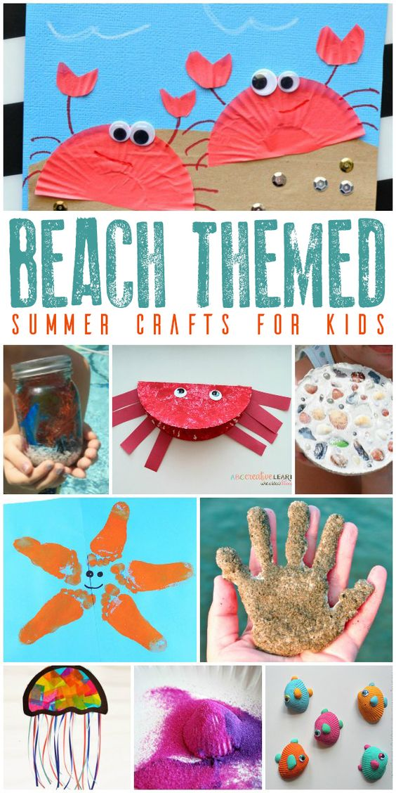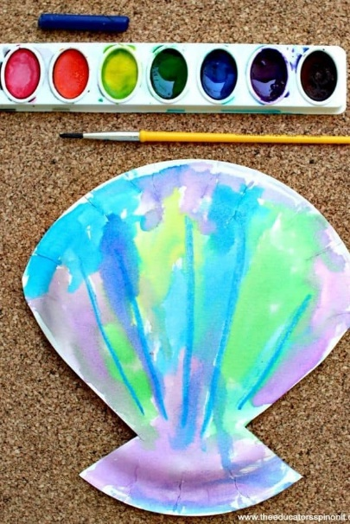

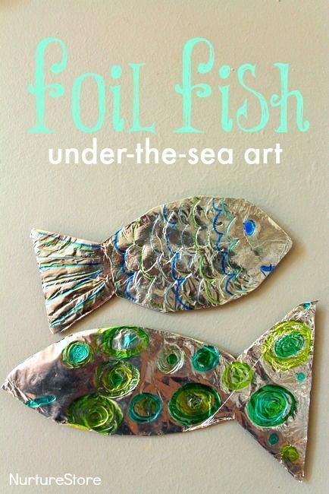

**Light box**

**Picture stories**: **(intent)** Foster children’s enjoyment of spoken language by providing interesting and stimulating play opportunities (Communication **and Language/Literacy**

**What you need (implement):** Transparent tangrams. Linking people, Transparent fraction squares, coloured acetate, skeleton leaves and small weaker balls (all in the light box)

**What to do: (implement)**

* Display the “playing with light” resources next to your light box.
* Encourage te children to create pictures with the resources, listen to them and note the words they use as they build up their pictures introducing new vocabulary for the children to experiment with.
* Take photographs of the picture on the light box and use them to stimulate conversations.
* Talk to the children about the pictures they have created and the stories which could be told.
* Show the children how to create a background for their role play (shadows) by using the resources e.g. use the green acetate, the skeleton leaves and tiles from the transparent fraction squares to create a forest scene on the wall.

**Vocabulary to introduce:**

Picture story words tell

First last next before

After all some soon

Light shine big project/shadow.

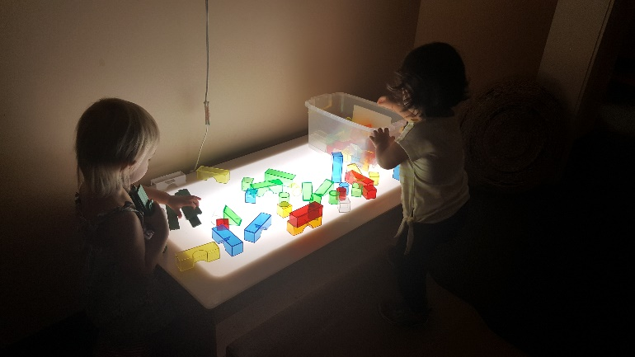**Light box**

**Shape and Pattern**: **(intent)** show an interest in shape and space by playing with shapes and making arrangements with objects/ (Mathematics)

**What you need (implement):** Transparent tangrams, Square transparent Counters, Round Transparent counters, Transparent fraction squares, coloured acetate, small weaker balls (all in the light box)

**What to do: (implement)**

* ASK the children to make patterns on the light box using the round transparent counters. Encourage younger children to make patterns by modelling the activity yourself alongside them.
* Add the square counters to the resources for making patterns, introduce a game for two children where one child make a pattern with the counters and the other one repeats the pattern.
* Add the other resources gradually (depending on child’s age) to make the patterns more complex and challenging.

**Vocabulary to introduce:**

Shape colour pattern counter

Round square circle triangle

Same different join

Big little near far

Top of Form

|  |  |  |
| --- | --- | --- |
| **5 Little Sand Castles**  This is a fun poem to act out and use flannel pieces with!  Have a child remove one flannel sandcastle at the end of each verse.  5 little sandcastles sitting on a beach.  Watching the boats go by.   (hand over eyes as though watching boats)  5 little sandcastles sitting on a beach  Watching the seagulls fly  (flap arms like a seagull and make the gull noises, too!).  5 little sandcastles sitting on a beach  Watching the clouds so high (look up and point)  When along came a wave  (roll hands or make large wave movements with arms)  and washed one away  (hold up 1 finger).   (Remove one sand castle from flannel board)  Now this is what the other ones say:  Now we are 4 little sandcastles sitting on the beach.......  Repeat the poem and movements down to the last one.  After the last one is washed away:  ...When along came a wave  and washed it away.  Now there is nothing to say. | Down By The Bay (down the jungle tune)  Down by the bay  Where the watermelons grow  Back to my home  I dare not go  For if I do  My mother will say  "Have you ever seen a bear  Combing his hair?"  Down by the bay  Where the watermelons grow  Back to my home  I dare not go  For if I do  My mother will say  "Have you ever seen a goose Kissing a moose"  Down by the bay?  Where the watermelons grow  Back to my home  I dare not go  For if I do  My mother will say  "Have you ever seen a whale With a polka dot tail?"  Down by the bay  Where the watermelons grow  Back to my home  I dare not go  For if I do  My mother will say  "Have you ever seen a fly  Wearing a tie?"  Down by the bay  Where the watermelons grow  Back to my home  I dare not go  For if I do  My mother will say  "Have you ever seen a snake  Baking a cake?"  Down by the bay  Down by the bay  Where the watermelons grow  Back to my home  I dare not go  For if I do  My mother will say  "Have you ever seen an orange  Eating a blouse? | **Books**  At the Beach  Beach Boy  Day by the Sea  Let’s visit the sea-side |

|  |  |  |
| --- | --- | --- |
|  |  |  |
|  |  |  |

|  |  |  |
| --- | --- | --- |
|  |  |  |

Bottom of Form