Tour the classroom

Ground rules

Role Play; home corner (getting to know each other)

Families

**PSED**

Find the item.

Why do we come to Nursery discussuion?

House building (block play)

**C&L**

Child interest:

**Numeracy**

**Literacy**

**PD**

Next step:

**Week**

**19/ 09/2022**

**26/09/2022**

**All About Me/Back to Nursery**

**Jupiter**

Petting the bunnies

Garden jobs; Check plants

daily and water them

Whose shoes

Moving and grooving

(Kids in action music and movements )

Water tray; pouring and

transferring using

container

Simon Says?

**KDW**

Chalk and Water (Monday 1)

We are a sharp bunch (Tuesday 1)

An apple to take home (Wednesday 1)

Just Painting (easel) (Thursday 1)

My portrait (Monday 2)

I like… (Tuesday 2)

Junk modeling (Friday 1,2)

My family;shaving

foam play (Wednesday 2

Playdough (Thursday 2)

Counting and sorting

bears in sand tray

Sand paper numerlas

Shell sorting

Name tag rhyme

School day sequesncing

M sound box

Writing workshop

**EAD**

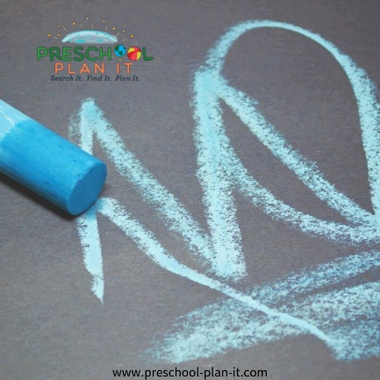**Chalk and Water**

Materials Needed: Coloured sidewalk chalk, construction paper (looks great on black paper, but let each child choose their own colour) and shallow trays of water. Chalk looks great on paper when they have dipped the chalk into water first

**Intent**: This is a great way to find out what their favourite colour is (by the colour of paper they choose) and to assess their motor and drawing skills.

**We Are A Sharp Bunch!**

Implement:

In advance, cut out large pencil shaped white papers; provide sponges and yellow paint. The children sponge paint their papers. When dry, encourage them to paint the erase side pink. Hang when dry as a bulletin board or wall display.

**An Apple To Take Home**

Materials Needed: Pre-cut apple shapes; pieces of red, yellow and green paper, glue

**Implement:** Have the children use their small hand muscles to tear the red, yellow and/or green paper into little pieces and glue onto their apple shape.

Add this poem:

This apple that you see here,

Was made just for you in my preschool year.

You'll never see another like it in the great, big land,

Because to make this apple, I used my own little hands.

**Tour the Classroom**

Take the children on a tour of the classroom. Walk to each area of your room and talk about what we can do here.

Example: Here is the easel. We can paint and use what is in this tray. We wear a paint apron to stop the paint from getting on us.

This is the Block Center. Here we build with blocks, etc.

Encourage the children to name what they see in each area and make suggestions about what they can do with those materials.

**Classroom Rules (Ground rules)**

Choose only 3 so that they can remember. Always state rules in the positive (what they can do rather than what they can't do)

Basic rules are:

We use kind words. (No yelling)

Our hands stay on our own body. (No hitting)

Our feet walk inside and run outside.

**Find the Item**

Name an item in the classroom and have one child find it and bring it to circle. Let each child have a turn.

This will help them to become familiar with what is in the classroom.

Give clues as to where the item is for the child:

Suzy, would you please bring a paintbrush to circle? The paintbrushes are in the art centre. The art centre is over there.

**Why Do We Come To Nursery?**

Ask the children why they come to school. Write their answers down on a chart paper. Accept all answers.

Discuss what they will do and learn at school.

**Just Painting**

Although paint, brushes and white paper may seem boring to you, remember that this may be the children's first time in school so painting while standing up and on such large paper will be novel to them!

**Whose Shoes?**

Have the children take off one shoe and put it in a pile.

Have the children take turns going to the pile and choosing one.....they can NOT choose their own!

They need to find whose shoe they have and find out that child's name while returning the shoe!

**School Day Sequencing**

Materials: Laminated pictures of activities at school

Encourage the children to put the pictures in the order that activities happen at school. We usually have:

Arrival (picture of a bus and cars)

Circle Time

Activity Time

Snack Time/Outdoor Time/ Departure Time (children with their families).

Preschoolers tell time based on activities-not by a clock!  
  
Help your pre-schoolers to answer the following questions by having a visual schedule posted for them to see:  
  
"What time is it?"   
  
"What do we do next?"  
  
"When is snack time?"  
  
"Is it time to go home yet?"

**Writing Tools Introduction (workshop)**

Provide many writing tools and a wide variety of paper.

Include coloured pencils, markers (thin and fat), crayons and different sizes and colours of paper.

Add a collection of stickers!

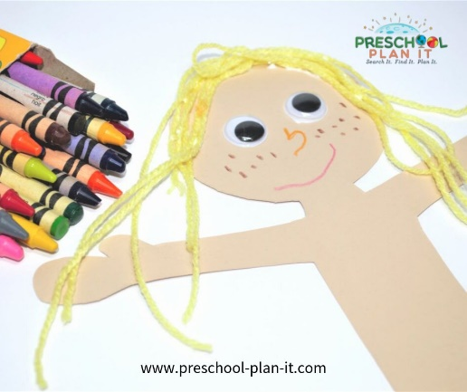**My Portrait**

Materials Needed: Pre-cut people shapes (like paper dolls) on heavy tag board or cardboard; hand mirrors; markers; crayons, variety of yarn (for hair); scissors; glue

The children use the mirrors to draw themselves onto the cut-out. This is best done is small groups (4 or under) so that you have time to talk with the small group about their eye colour, hair colour, etc.

You can hang them throughout your room and have parents try to find their child!

**I Like...**

Materials Needed: magazines, scissors, glue, crayons, construction paper

The children cut out items from magazines of things that they like such as: dogs, cats, flowers, family pictures, etc.

**Me and My Family**

Materials Needed: shaving cream and a table!

Encourage the children to smooth the shaving cream onto the table. They can draw a circle and add eyes, nose, mouth hair, etc. They can add their family members, pets, etc.

**House Building**

Encourage the children to build their house out of the blocks you have available during this theme. Talk about type of houses and buildings maisonette, house, flat, Victorian…etc

**Our Families**

Tell the children to listen to what you are saying and stand up if what you say is true about them!

Stand up if you have a brother.

Stand up if you have a pet.

Have the children standing name them (brother, pet, etc.)

Be sure to help children who aren't sure of the answers (Dee-Dee, you have a baby sister! Stand up! What is your baby sister's name?)

|  |  |  |  |
| --- | --- | --- | --- |
| **Name Tag Rhyme**  Make a name tag for each child for your flannel board (you can use Velcro or a dryer sheet for the back to make it stick. If you don't have a flannel board, simply place the name tags in the middle of your circle area).  Down around the corner in the preschool that's the best.  There were (number of children) little name tags on the teacher's desk.  Along came (name a child) one day. He/she took his/her name tag away. (Have that child come and get their name tag and sit back down).  Continue until all the name tags are gone. | **School Safety Poem**  STOP, Look and Listen  Before you cross the street.  Use your eyes. Use your ears.  And then use your feet | **Important Rules**  *sung to the tune of Twinkle, Twinkle Little Star*  Here are rules for you and me,  See how important they can be.  Always be honest, kind and fair.  Always be good and willing to share.  These are rules that we should know,  And follow these rules wherever we go. | **Books**  Grace and Family  One big Family  Mae’s First day of school  Me |

Top of Form

|  |  |  |
| --- | --- | --- |
|  |  |  |
|  |  |  |

|  |  |  |
| --- | --- | --- |
|  |  |  |

Bottom of Form