Next steps:

Parachute game; catch the animal

Puppet Show

What Am I guessing game; being confident to take part in group game

Valentine Day house role play

Puppet show.

What am I guessing game; listening and attention

“If you give a pig a pancake” you tube story.

**PSED**

**C&L**

Child interest: books/water play/Group games

Next step:

If you give a pig a pancake

Local walk;Just take a walk!

Look for winter changes: no

more leaves on trees.

abandoned birds

' nests; snow.

ice; animal tracks!

Snow flakes move

**Week**

**07/ 02/2022**

**14/02/2022**

**Winter Animals/Valentine**

**Jupiter/ Neptune**

Making orange Juice

Water play: pouring and transferring

Making snips on paper

Healthy and non-healthy food bingo

kk

Penguin craft (Monday 1)

Valentine Craft (Tuesday 1)

Winter rabbit craft (Wednesday 1)

Snow my home (Thursday 1)

(Friday 1,2) Free colouring and drawing

Fork painter polar bear (Monday 2)

Arctic Fox craft (Tuesday 2)

Hand Print robins (Wednesday 2)

Playdough (Thursday 2)

**KDW**

P letter box

Tracing Winter animals sheet

Pancake poem/Birds poem

Pink box series “o””a”

”e”and “I”

The missing

heart game

Number stacking pancake

Trace and count

Broad stairs

Pink tower

3D solid shapes box

**Literacy**

**EAD**

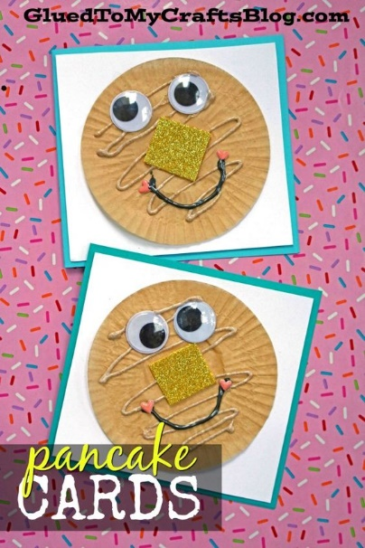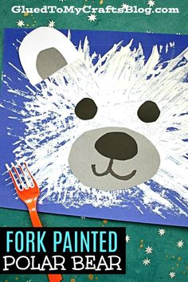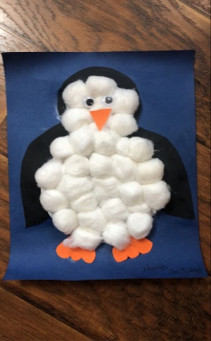Penguin craft

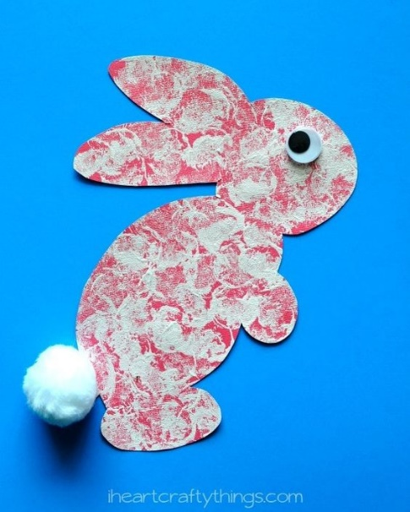

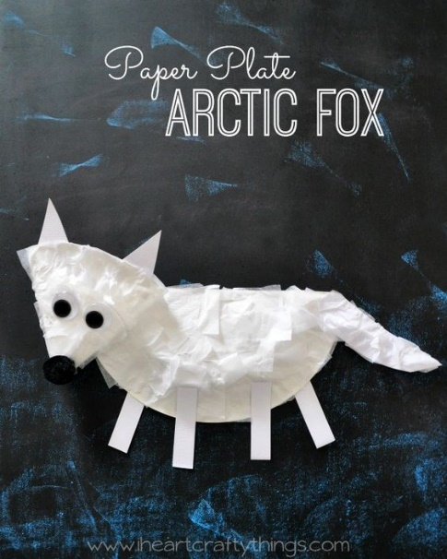

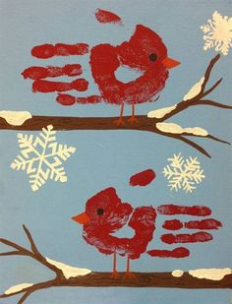

**Puppet Show!**

Materials Needed: A winter animals puppet!

Introduce the puppet to the children. "Hi everyone! I'd like you to meet my friend___!" Give the children time to introduce themselves or just say "Hi" to each child with your puppet!

Puppet: Shivers a lot and looks around at the children.

You: _______, you're shaking. Are you scared?

Puppet: "No, I'm not scared. I'm FREEZING! Why am I so cold today?

You: Perhaps because of the season it is. Boys and girls, do you remember what season it is, the one that comes after fall?

Puppet: OH! Is it REALLY winter already? That's why it's cold outside! You know, a lot of my friends have to get ready for the cold. Boys and girls, what do you do to get ready for the cold?

Encourage the children for winter clothing answers such as "What do you put on your hands in winter so that they don't get too cold? What else do you wear in winter (coats, scarves, boots, etc.).

Puppet: Those are great ways to stay warm! My animal friends do different things to get ready. Want to know what they do?

Puppet: Let's listen! Our teacher is going to read us a story about winter animals!

Have the puppet sit on your lap, or near you. We sometimes have to put the puppet away at story time if it becomes too much of a distraction! You can tell them that the puppet will be in the library for them to play with later on in the morning!

A great story to follow up this puppet show with is When Winter Comes by Nancy Van Laan. However, any winter animal story will do!

**What Am I?**

Play this guessing game with the children relating to Winter Animals.

I am small. I am white. I have long ears. I hop. What Am I?

Ask similar questions for each animal that you have talked about this winter.

**Snow on My Home**

Provide sidewalk chalk, cups of water and black and brown paper.

The children can color with the wet chalk to cover the paper as an animal's den would look after a snowstorm! The appearance of the wet chalk is always exciting to the children!

**Parachute--Catch the Animal**

Materials Needed: Parachute (or large sheet to use as one) and winter stuffed animals.

With children holding handles or ends of parachute, show them how to raise the chute from their waist to over their head while all counting together to 4 (1,2,3,4..hold it up a little more---poem to use!).

Then count to 4 slowly as you all lower the chute to your waists. Practice a few more times.

Instruct them to do it again, counting slowly, so you can put toys under the parachute..but they should NOT let go of the parachute.

When done, tell them that when they count to 4 and the chute is up high, you will call one of their names and that person and ONLY that person, should run UNDER the parachute, grab a stuffed animal and come back out. Remind them that they need to do this QUICKLY!

Give each child a turn.

**Love Bugs (Valentine craft)**Materials Needed: egg cartons, paint, pipe cleaners

* Cut the egg cartons into 3-piece sections.
* The children paint their 3-piece section.
* Encourage them to paint on eyes, nose and mouth on their Love Bugs.
* Encourage them to stick pipe cleaners into the top of the head for antenna.
* If you have metallic hearts (or paper hearts), the children might want to add them to the antenna.

**Valentines Day House**

Place red, pink and other stuffed animals in your block area. Wrap some blocks in themed wrapping or tissue paper to allow for houses to be built with patterns!

**The Missing Heart**

Materials Needed: Programmed paper hearts with a concept you are working with written on them. For example, if you are working on specific letters, print one letter on each heart. You could also print numbers, the children's names or just have different color hearts.

Place the hearts on the floor at circle. Tell the children you are going to remove one and they have to guess which heart is missing.

Tell them to close their eyes and NO PEAKING! Remove one heart. Tell them to open their eyes and guess which is missing!

If it becomes very easy for them, remove 2 or more hearts and have them guess which 2 or 3 are missing!

EXTENSION: Place pieces of dryer sheets or felt behind the hearts and place them in the library area with a felt board for them to continue the guessing!

|  |  |  |  |
| --- | --- | --- | --- |
| **I Love You Song**  OK, OK, I know! Don't sing this one if you're sick of Barney!  Sung to the tune of This Old Man:  I love you.  You love me.  We're as happy as can be.  With a great big hug and a kiss from me to you.  Won't you say you love me, too?  I love you,  You love me.  We're best friends like friends should be.  With a great big hug and a kiss from me to you.  Won't you say you love me, too? | Hungry Birdies (poem)  I have built a little nest, look inside, look inside.  Hungry birdies with their beaks, open wide, open wide.  And the little birdies grow, day by day by day.  ‘Till they spread their wings and fly, far away, far away. | **Penguin Songs!**  To the tune of Mary Had a Little Lamb:  The penguin has a coat of black, Coat of black, coat of black.  The penguin has a coat of black, Watch her waddle up and back.  The penguin has a body of white, Body of white, body of white.  The penguin has a body of white, Watch her waddle out of sight.  To the tune of Twinkle, Twinkle, Little Star:  Penguins, penguins having fun,  Waddling in the winter sun.  Waddling fast and waddling slow,  Waddling to and waddling from.  Penguins, penguins having fun,  Waddling in the winter sun. | **Love My Friends Exercise and Song**  Sung to: Row, Row, Row Your Boat  Love, love, love our friends,  Yes, we really do.  Valentines, Valentines, Valentines, Valentines,  Sent from me to you!  Do some healthy exercises with the children each time you sing it such as:  Running in place.  Jumping Jacks  Touch your toes and reach for the sky.  Hopping |

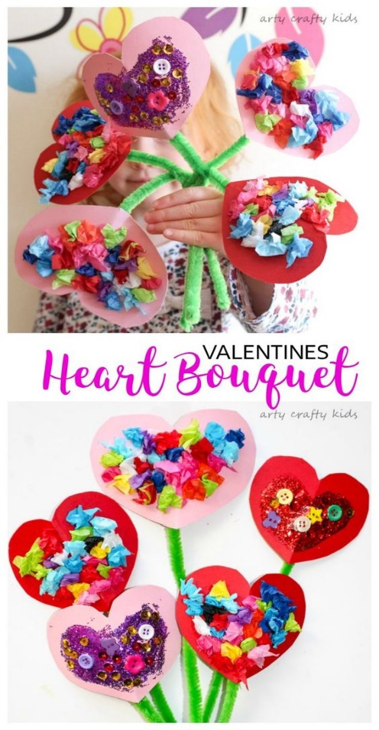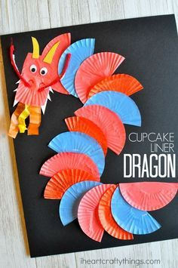For the week 8th, we will focus on valentine and Chinese new year (Chinese new year 12/02/2021/ Valentine 14/02/2021)

