Harvest song, I am a strawberry song

Fruit or vegetable; circle time

The very hungry caterpillarstory book.

One potato story book.

My meal time story book.

Ring, ring a roses (Listening and attention)

**C&L**

What do I feel? Wednesday 1

Fruity water play (Monda to Friday).

Taste testing!

Pre-school gardening area visit.

Jumping bean song (T.K )confidence)

**Week 27/09 & 04/10/21**

**Fruits and Vegetables/**

**Harvest**

**PSED**

Apple and potatoes printing (Monday1)

Fruits and vegetables collage (Tuesday 1)

Carrot top painting (Monday 2)

Garden Harvest sensory play (Wednesday 1)

Mr Potato head craft (Tuesday 2)

Carrot sticking craft (Wednesday 2)

Playdough with vegetables and fruits

cutters (Thursday 1,2)

**PD**

Apple and potato Printing

**Intent:** cut the potatoes and apples in half to provide different "stamp" shapes for the children to use with paint! For best results, only provide a very shallow amount of paint in the tray so that the paint does not go on the produce too thickly.

**Fruits and vegetables collage**:

**Implement**: Materials Needed: Provide advertisement flyers from local supermarkets, glue sticks, scissors and construction paper. The children cut out and glue their favourites veg or fruit on the construction paper.

**Fruit or Vegetable? Circle time**

**Implement**: bring some real produce and ask the children to name what each is and then ask them to determine which it is.

**Carrot top painting Carrot sticking craft idea for display board**

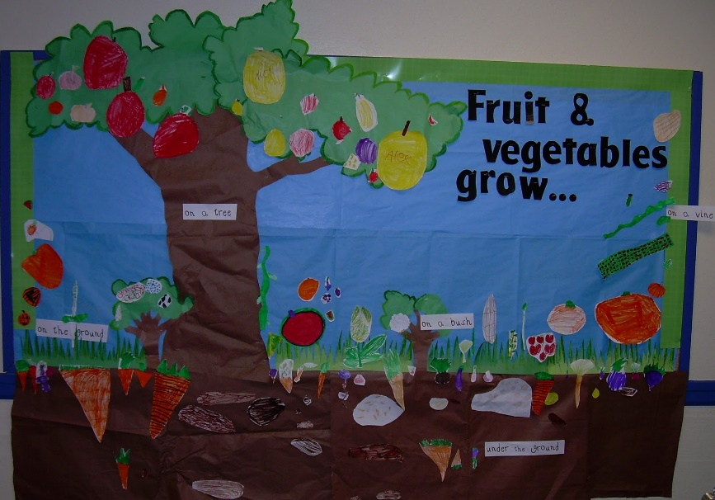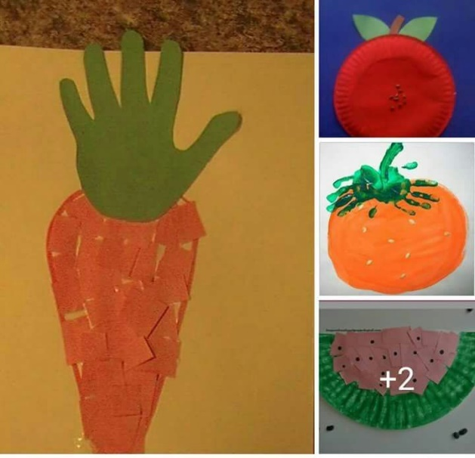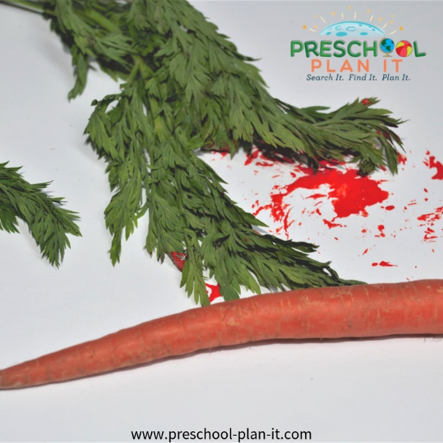

**What Do I Feel?**

Encourage the children to feel into a bag or box and guess which piece of produce you have placed in it!

You can show them all first and help them to name them and then see if they can remember based on how they feel.

**Fruity Water Play**

Add a fruit scent to your water tray (use strawberry extract, lemon extract, orange, etc.). You could also color the water to match the scent!

**Garden Harvest**

Place whole vegetables in your sensory table with soil, scoops, and sifters. (beets and carrots with the ferns still on them), potatoes, celery, etc.

**Make Your Own Mr. Potato Head!**

Materials: One white potato per child, googly eyes, craft glue, grass seed and a spray bottle of water.

In advance, cut about 1/4 inch off the top of each potato. Scoop out a little of the potato.

The children glue eyes (and you can add items for a nose, mouth, etc.) on the front of the potato.

They then sprinkle grass seed on the top part that you cut out and spray with water.  
  
They should sprout pretty quickly if you keep them moist

**Taste Testing!**

**Implement**: one day for fruits and another day for vegetables. Try different types of each, some familiar to the children and some not. I suggest, if you haven't already, star fruit, kiwi and any veggies with ranch dip!

**Preschool gardening area visit**

Visit the pre-school gardening area, lets the children explore and water the plants.

|  |
| --- |
| Harvest song  Sung to "Twinkle, Twinkle, Little Star")  Pick the corn and pick the beans;  Pick the squash and other greens.  It is harvest time you see;  Come and share a feast with me.  Bring your friends; come out to play;  We will call this Harvest Day! |

