Child interest:

I am driving my car car song

Drive and drop (card boxes game)

Musical instruments (Learning to listen)

The car is going down the slide Ready, Steady, Go

Fast, slow

(pushing cars down the slide)

Build a tower up,up,up (Blocks play)

Colorful Cars book

Twinkle, twinkle chocolate bar song.

Next step:

**C&L**

Car Name game

Ball pit (Monday to Friday)

Train trucks play

Obstacle courses( playing and exploring;

be willing to have ago)

home corner play

pushchairs / baby walkers

Baby's First Cars and Trucks book

**PSED**

**Week**

**31/10 and 07 /11/2022**

**Things that go /Halloween /Bonfire**

Bubble wrap road (Monday to Friday )

Car wash (Monday 1 )

Muddy truck painting (Tuesday 1)

Shaving foam car printing (Monday 2)

Dish brush fireworks craft (Wednesday 1)

Glitter Paydough (Tuesday 2)

Remembrance day; poppy potato craft (Wednesday 2)

Painting with cars Thursday 1

Chalk mark making on Easel (Friday 1,2)

**PD**

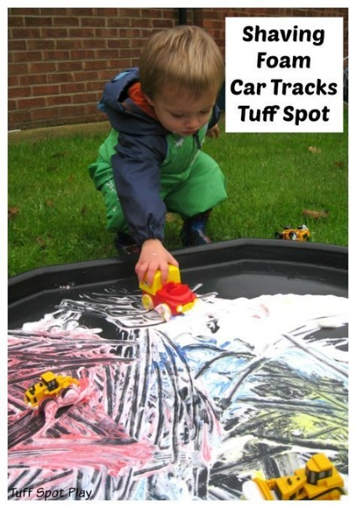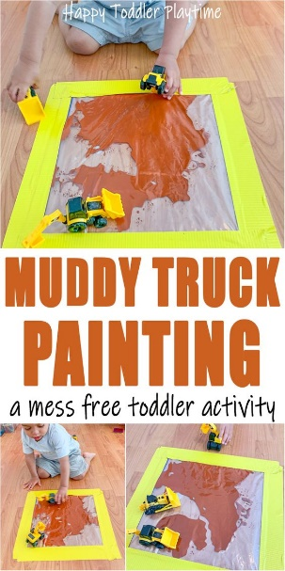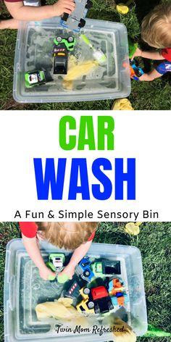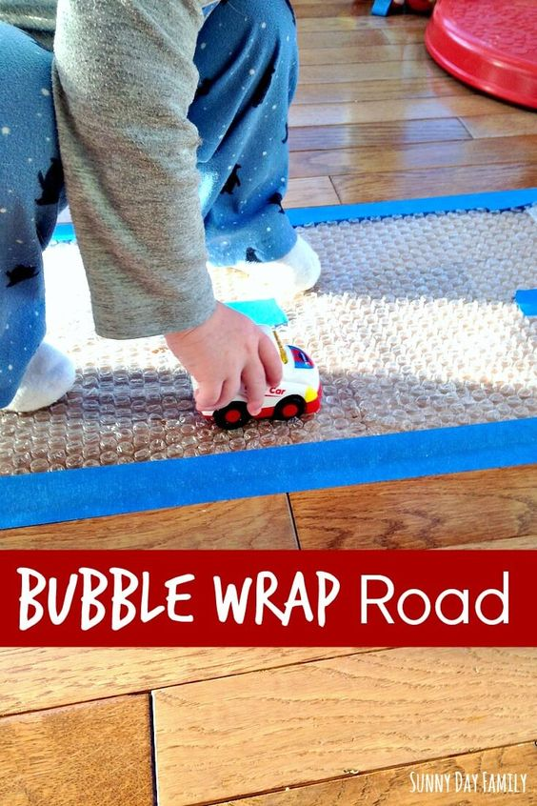

**Transporting Ball**

**Implement**: Provide trucks/balls that fit in the trucks. The children will figure out how to transport the balls to the different parts of the room!

**Car Name Game**

**Intent:** small group games/ Circle Time is such a great time for children to learn the social skills of being together and form friendships.

**Implement:** Sit in a circle.  Name a child's name and push the car to that child.  Only that child should reach for the ball, then names a friend's name and rolls the ball to them.

**Obstacle Course (if child crawling e.g Jonas)**

**Implement:** For This Obstacle Course You Will Need:

* cushions and or pillows/soft steps
* [balls](https://www.amazon.com/KONIG-KIDS-BPA-Free-Textured-Multi-Shape/dp/B07BR72D7N/ref=sxin_7?ascsubtag=amzn1.osa.2dea0622-caef-438c-ac35-1efd91b4187c.ATVPDKIKX0DER.en_US&creativeASIN=B07BR72D7N&crid=34NJST86R0QXY&cv_ct_cx=infant+balls+toys&cv_ct_id=amzn1.osa.2dea0622-caef-438c-ac35-1efd91b4187c.ATVPDKIKX0DER.en_US&cv_ct_pg=search&cv_ct_wn=osp-single-source&dchild=1&keywords=infant+balls+toys&linkCode=oas&pd_rd_i=B07BR72D7N&pd_rd_r=96b341b0-6cbf-406c-b293-9ff507f56626&pd_rd_w=zAphC&pd_rd_wg=1OFFB&pf_rd_p=08a788f8-ae54-4b96-9e48-f1e694ec6c4f&pf_rd_r=ZPQXHT38RXFYC2JECVTM&qid=1596684251&sprefix=infant+balls%2Caps%2C174&sr=1-3-72d6bf18-a4db-4490-a794-9cd9552ac58d&tag=scripps-spellingbee-20) (small enough for child to lift)

**intent: create a physical challenge/ create a level of risk and children can learn by trial and error the quickest and easiest Way to go through the obstacle**

musical instruments (Learning to listen)

**implement:**

1 face the child with some musical instruments between you.

2.Play one gently.

3. describe the noises “Ding-a-ling-a-ling” or “That’s a good noise”

4.watch the child-which did they like best? Play it again.

5. Try different noise makers (bells, rattles, drums, shakers, saucepans, and wooden spoons)

6.Comment “Wow, that’s loud”, “That’s a nice noise”

**Twinkle, twinkle, chocolate bar**  
My dad drives a rusty car  
Start the engine, pull the choke  
Off we go in a cloud of smoke  
Twinkle, twinkle, chocolate bar  
My dad drives a rusty car

