Next step: - Place objects in, on and under on request.( CL, Understanding) ZC/YL

- Point to picture of common objects described by it use ( CL, Understanding)

(circle time/ Monday to Friday)

The very hungry caterpillar (Listening and attention)

One to one reading (Listening and attention )

Fuzzy little caterpillar parachute game.

Caterpillars and butterfly role play

Fuzzy little caterpillar

parachute game (Being willing to have a go)

Musical instruments (Playing and exploring)

Yummy; taste test (trying out new food and textures )

**C&L**

**PSED**

**Week 21/02 & 28/03/22**

**Caterpillars, caterpillars, butterflies/The mixed-up Chameleon/Pancake day**

**Venus**

**(** (Monday1) C caterpillar pompom craft

(Tuesday 1) cupcake cases butterfly

(Wednesday 1) can you make a caterpillar (paint)

(Thursday 1) Playdough

(Monday 2) colourful Chameleons

**(**Tuesday 2) The Chameleons fork art

(Wednesday 2) pancake cards

(Thursday 2) playdough

Junk modelling (Friday 1,2)

**PD**

**Fuzzy Little Caterpillar (Parachute game)**

Fuzzy little caterpillar crawling on the ground (make a finger crawl on the floor).

Spin yourself a blanket and then go fast asleep (Twirl on finger around and around in circles then tuck that finger into your other hand).

Fuzzy little caterpillar wakes up by and by

Now you have two pretty wings. You're a butterfly! (Make butterfly fly away!)

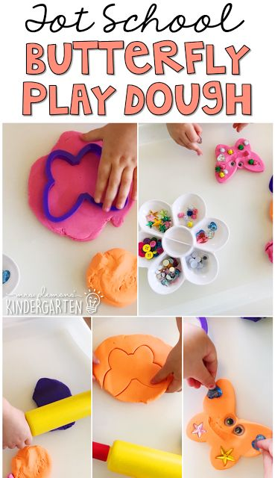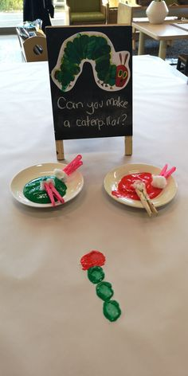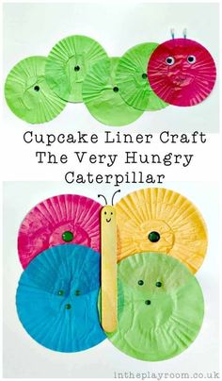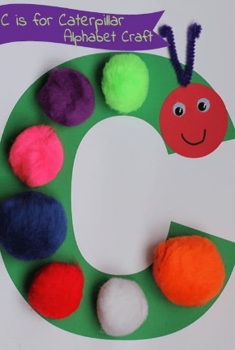

**Yummy!**

Have a taste test of all the foods in the Very Hungry Caterpillar book.

Make a chart with each food listed in a column on the left side. Make two more columns next to that one- one that says YES and one that says NO. Label the chart: Do we like what the Very Hungry Caterpillar Ate?

As each child tries each food, ask if they like it.

Review the chart over the next few days to discuss:

Which food did most children like? Dislike?

**Caterpillars and Butterflies role play,**

**Materials** , The very hungry butterfly book A small white sheet (for the egg stage); Striped fabric (for the caterpillar); green fabric for the chrysalis stage and butterfly wings.

**Implement**: Let the children explore the materials . Ask "what happens next" etc (age appropriate). Have extra butterfly wings available so that the children can pretend to fly away together to have adventures!

**Impact**: being imaginative; making believe by pretending.

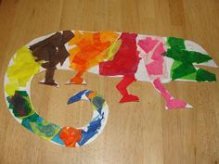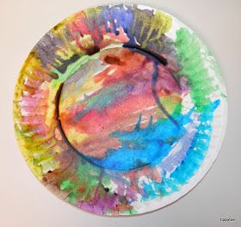Colourful Chameleons Chameleons sticking The Chamelons fork art pancake cards

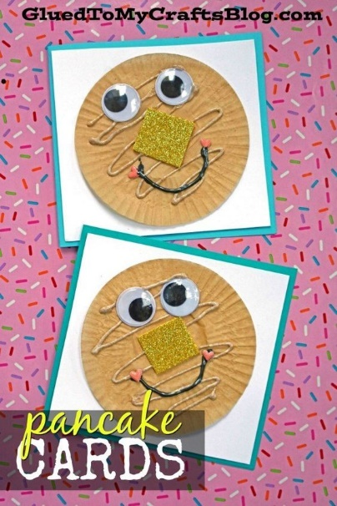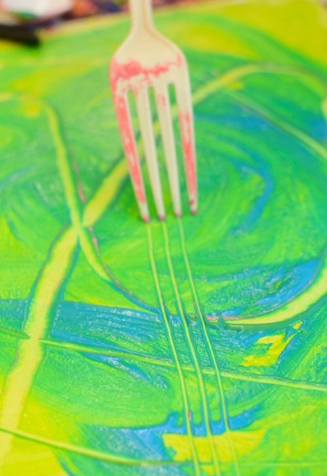

|  |  |  |
| --- | --- | --- |
| .  **Fuzzy Little Caterpillar**  Fuzzy little caterpillar crawling on the ground (make a finger crawl on the floor).  Spin yourself a blanket and then go fast asleep (Twirl on finger around and around in circles then tuck that finger into your other hand).  Fuzzy little caterpillar wakes up by and by  Now you have two pretty wings. You're a butterfly! (Make butterfly fly away!) | There’s a tiny caterpillar on a leaf (wiggle, wiggle) There’s a tiny caterpillar on a leaf (wiggle, wiggle) There’s a tiny caterpillar, tiny caterpillar, There’s a tiny caterpillar on a leaf (wiggle, wiggle)  He will eat the leaves around him ‘til he’s full (munch, munch) He will eat the leaves around him ‘til he’s full (munch, munch) He will eat the leaves around, eat the leaves around He will eat the leaves around him ‘til he’s full (munch, munch)  A cocoon is what he’s spinning for his home (spin, spin) A cocoon is what he’s spinning for his home (spin, spin) A cocoon is what he’s spinning, cocoon is what he’s spinning, A cocoon is what he’s spinning for his home (spin, spin)  Then he’ll be a butterfly and flap away (flap, flap) Then he’ll be a butterfly and fly away (flap, flap) Then he’ll be a butterfly, be a butterfly, Then he’ll be a butterfly and fly away (flap, flap) |  |

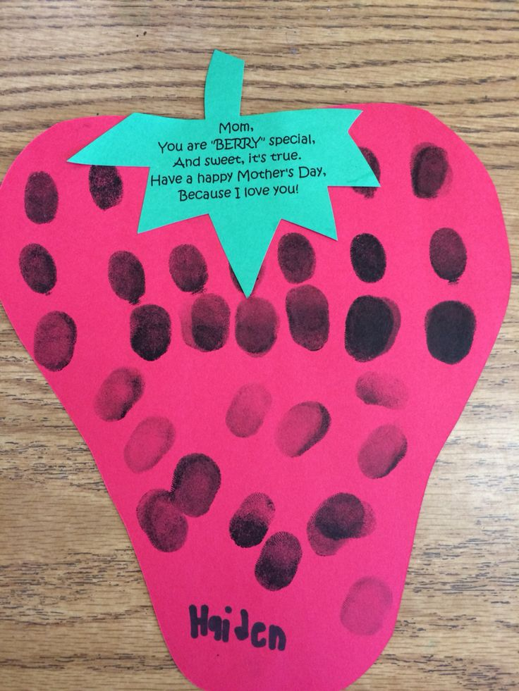Mothers day card (stay in the theme)

.