Next steps:

Parachute game

Shovel the snow

Snow flakes move

Little mouse, where is your mouse? (circle time)

How cold is it today? (circle time)

Where do I sleep?

Over the Mountain poem

.

**PSED**

**C&L**

Child interest: books/water play/Group games

Next step:

Local walk;Just take a walk!

Look for winter changes: no

more leaves on trees.

abandoned birds

' nests; snow.

ice; animal tracks!

Snow flakes move

Build a bed (wooden blocks play)

Making orange Juice

Water play: pouring and transferring

Making snips on paper

Healthy and non-healthy food bingo

Driving in the snow (moving and handling)

**Week**

**17/ 01/2022**

**24/02/2022**

**Hibernation/Snow/Mountains**

**Jupiter/ Neptune**

kk

What Kind of bed (Monday 1)

Recycled homes (Tuesday 1)

Cotton wool hybernation craft (Wednesday 1)

Day and night paper plate craft(Thursday 1)

(Friday 1,2) Free colouring and drawing

Card box mountain craft (Monday 2)

Cotton snow people (Tuesday 2)

Driving in the snow (Wednesday 2)

Wriiting in the snow (Thursday 2)

**KDW**

Winter snow ball counting

Trace and count

Broad stairs

Pink tower

3D solid shapes box

Driving in the snow

S letter box

Tracing winter sheet

January’s cold poem

Pink box series “o””a”

”e”and “I”

**Literacy**

**EAD**

**WHAT KIND OF BED?**

Materials Needed: Pictures of animals that hibernate (from magazines, online, etc.); glue sticks; construction paper; markers

Look at the pictures with the children. Ask them where they think each animal would make its bed in the winter when it hibernates (in a tree trunk, a log, a cave, in the mud-for snakes!).

Have the children choose just 1 animal picture.

Encourage the children to write their name on their paper. Then instruct them to draw a bed and/or home for the winter for their animal and then, using the glue stick, place their animal in its home.

As the children are making their pictures, be sure to ask each of them (individually) where their animal will sleep and write it down.

When done, write what they told you on their papers and hang to display.

*You do not need to just write "My snake sleeps in the mud." Write down EVERYTHING they say....it could be come quite the story!

EXTENSION: After the pages have been on display for a couple of days, make them into a class book by stapling them and add it to your classroom's library for the children to read!

They love to see their own work in print! Also, read this book at story time to the group!

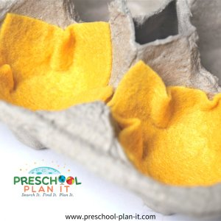**RECYCLED HOMES**

Materials Needed: Empty boxes, cans, egg cartons, etc.; paint

Ask the children where animals might sleep during the winter. Discuss the many different places-snakes in mud pits, turtles under mud, frogs in logs, bees in the ground, animals in holes in the ground or in tree trunks, in caves, etc.

Tell them they are going to create some animal homes! Let them choose from the items to come up with a home they'd like to paint.

EXTENSION: When dry, use their homes at interest learning centers throughout your classroom.

Place them on a table or on the floor with beanie babies, in the block area with some small, toy animals and reptiles and bees!

**BUILD A BED**

If possible, suspend a dark colored sheet or piece of fabric over the block area to make it a bit dark. Add smaller stuffed or other toy animals, snakes, frogs and bees in the block area and encourage the children to make winter homes for them to sleep in.

#### **LITTLE MOUSE, WHERE IS YOUR HOUSE?**

In advance draw out and laminate 1 small mouse and 1 house shape (each of different color). Make sure your mouse is SMALLER than the house shape!

Tell the children they are going to help find the hibernating mouse! Tell the children to close and cover their eyes! You hide the mouse under one of the houses.

Tell the children to look now. Ask them to join with you in saying "Little Mouse, Little Mouse, where is your house?" Ask one child which house you should look under. (Encourage them to NAME the color, not just point, to reinforce color recognition*).

"Little Mouse, are you under the orange house?" Have the child lift up the orange house. "NO! Where could she be?"

Continue with each child until found. Keep playing until every child has had a turn.

* Program the houses to work on the skill you are working on in the classroom such as letters, numbers, shapes, etc. (Little Mouse, are you in the "A" house? Are you in the "2" house? Are you in the "star" house").

#### **WHERE DO I SLEEP?**

Materials Needed: Pictures of animals and pictures of the homes they sleep in. Frog--log Snake--lake and mud Turtle--mud Ground Hog--the ground (of course!)--his burrow Squirrel--tree trunk Bat--Cave

Show the homes and ask the children if they can tell what they are.

Show the animals and ask the children to identify them.

Hand out the animals to the children. Place the home animals on the floor in the circle. Ask the children, one at a time, where an animal would live. This is a group activity, so don't put any one child on the spot (i.e. Where does YOUR animal sleep in winter?". Instead, say "Cheryl, which animal do you have? Children, where do you suppose a snake would sleep?" Have the child place the animal on the home.

[**Return to Top**](https://www.preschool-plan-it.com/hibernation.html#top)

**PARACHUTE PLAY**

Materials Needed: Parachute

Children seem to innately want to shake a parachute as soon as they touch it! Do some crazy shaking to allow them the time to get the excitement of using the parachute out of their system!

Tell them they are going to move the parachute up and down the way an animal would go. Name and animal and ask if it moves fast or slow. Then move (or shake) the parachute accordingly. Examples; snake, skunk, bear, sloth, elephant, bird, frog, etc.

EXTENSION: Have soft, stuffed animals ready. When done with above parachute game, tell the children that it is winter and the animals need to go back to their homes to sleep. Tell them to wait until you say go before they shake and that you need their help counting the animals.

--I also recommend that before you place the animals on the parachute, decide ahead of time WHO will get the animals once they are ALL off the parachute. I can't tell you how many times children just left the parachute and went running after the animals! We assigned several "zookeepers" to get 2 animals only after ALL of the animals are off. Then we assigned new zookeepers for the next round!

Have them count together with you as you toss each animal on the parachute.

Once they are all there, say "GO HIBERNATE" and start shaking. When the animals are all off the parachute, one person, or the zookeepers, collect them and you play again!

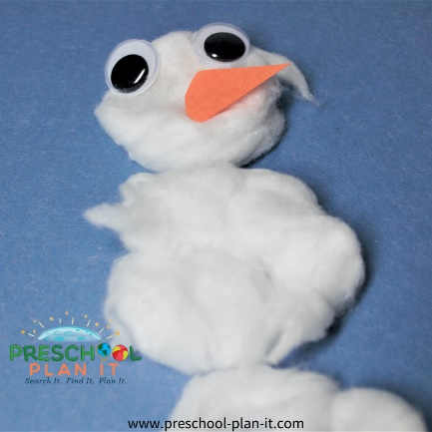**Cotton Snow People**

Provide blue paper and lots of cotton balls and glue.

The children dip the balls in glue and place on their papers to make a snowman!

If they gently pull on the cotton, it will get fluffier.

Add googly eyes and scraps of black and orange paper for eyes, mouth and nose!

**Driving In the Snow**

Materials needed:  black or blue paper, white paint, toy cars

Drop paint on the paper and let the kids drive in the snow.  The shapes and textures the wheels make are great!

The children can drive for fun or drive to make shapes, numbers or even letters!

**Shovel the Snow!**

Provide lots scraps of white paper.

Show the children how to crumple the paper.

Let them have a snowstorm!

Provide child sized shovels or dustpans for them to shovel the area clean!

**Snowflake Moves**

After talking about snowflakes, act it out!

How does the snow fall when there are only a few flakes falling from the sky?

How about when a LOT of snow falls?

What about a BLIZZARD!!!

**Writing in the Snow**

Provide cookie sheets and place some shaving cream on it.

The children use their hands to cover the tray and print their names and other letters on it!

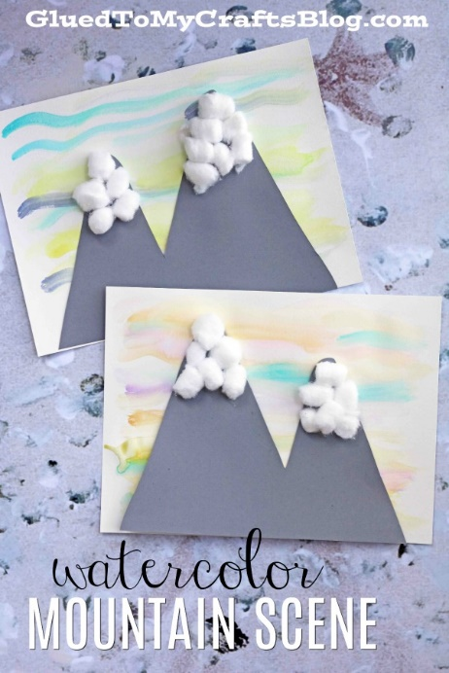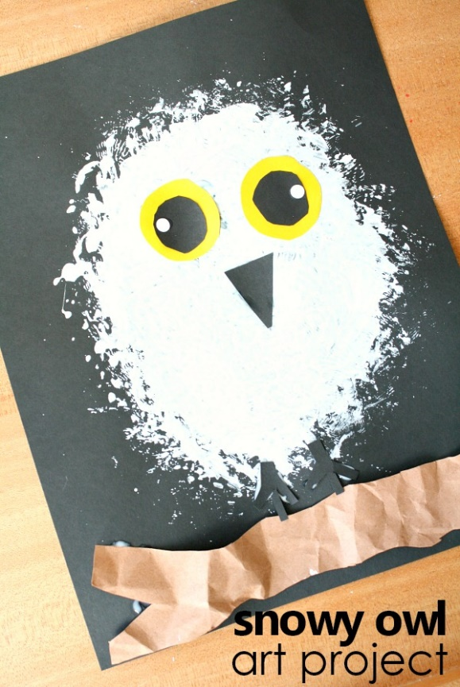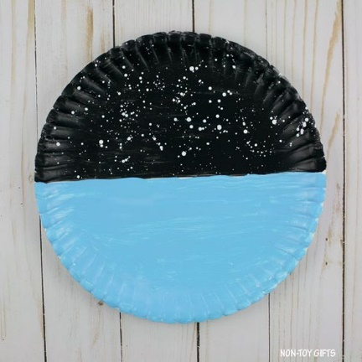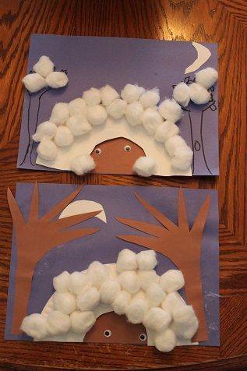

|  |  |  |
| --- | --- | --- |
| **Snowflake Song**  Snowflakes, snowflakes  Falling to the ground  Each one rests so gently  They never make a sound  Snowflakes, snowflakes  Are so pure and white  The special thing about them is  No two are alike! | Over the Mountain  Oh the bear went over the mountain,  To see what he could see.  But all that he could see,  Was the other side of the mountain,  The other side of the mountain,  Was all that he could see.  So he went back over the mountain,  To see what he could see.  But all that he could see,  Was the other side of the mountain,  Was all that he could see! | **How are snow flakes formed?**  **Every snowflake that you see on the ground started its life up in**  **a cloud as a single tiny droplet of water in the air. ... Then, other**  **water droplets stick to the ice droplet, and the other droplets**  **freeze. Because of the way they stick together, the frozen droplets**  **make a shape with six sides.** |

Facts about mountains: Show the children a picture of a mountain and let them describe what you can see;

Here is some facts:

A mountain is something that is taller & steeper than a hill.

A mountain is a big and massive piece of rock

These massive pices of rock didn’t come from nowhere, it was formed many, many years ago.

Mountains are so cool to look at

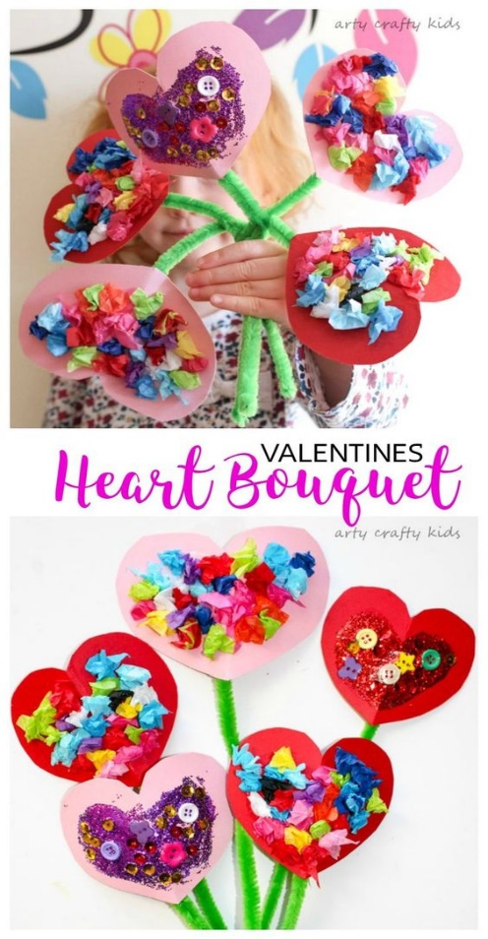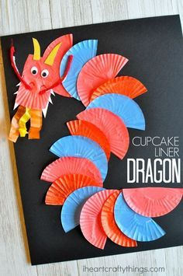For the week 8th, we will focus on valentine and Chinese new year (Chinese new year 12/02/2021/ Valentine 14/02/2021)

