**A peek to what have been learning**!

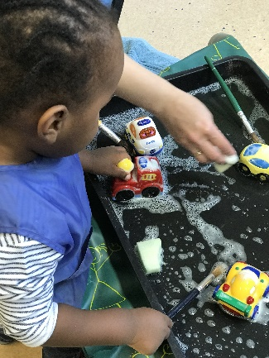Over the past few weeks we have been very busy enjoying great learning themes; fun with balls, fun with bubbles and fun with things that go! We loved all kinds of balls especially the super-duper bouncy balls!  We also learnt that Bubbles are everywhere!  In our toys, games, food, bath time and more!  We have had lots of fun with things that go theme which is a topic part of our everyday lives; we engaged in activities that included playing with all types of transportation theme items including vehicles such as cars, trucks, trains and more. All these themes have been an opportunity to learn about making sounds and music in various environment, Mark making experiences, Look and feel activities,

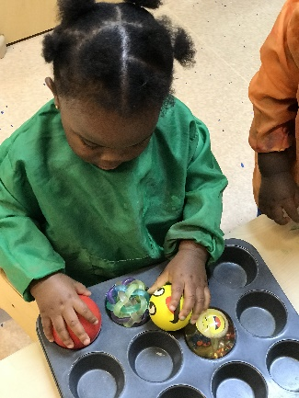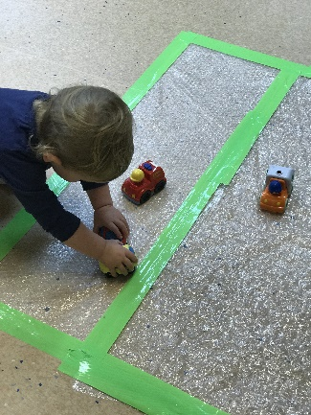

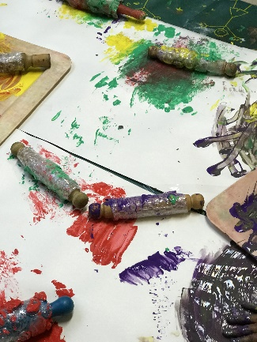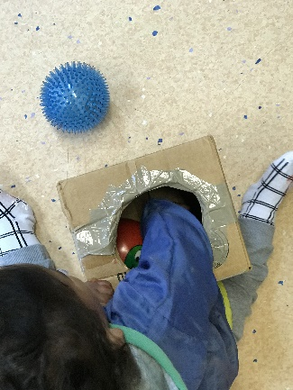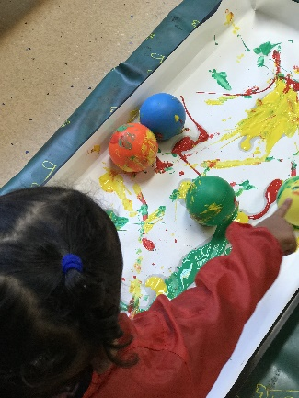

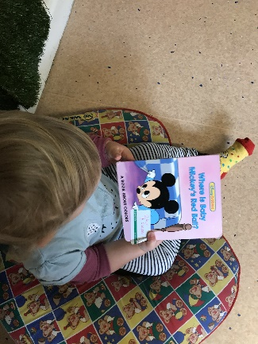

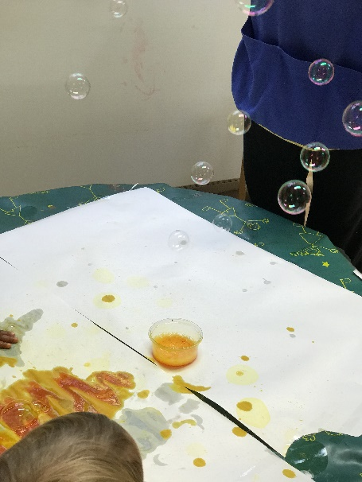***Link to characteristics of effective learning*** - Playing and exploring - Finding out and exploring – Using senses to explore the world around them.

***Link to the Early Years Foundation Stage*** – Physical Development - Moving and handling – Make connections between their movements and the marks they make (16-26 Months).

