Next step: - Place objects in, on and under on request.( CL, Understanding) ZC/YL

- Point to picture of common objects described by it use ( CL, Understanding)

(circle time/ Monday to Friday)

5 scary dinosaurs box game

Whats missing !(Being involved and concentrating)

( ZC/JL)

Move like they did (Listening and attention)

One to one reading (Listening and attention )

Harry and the dinosaurs story books

Prehrestoric homes role play

(Being willing to have a go)

Dino Hokey pokey

Jump and wash dinosaurs sensory play

Musical instruments (Playing and exploring)

Wake up pets group game

**C&L**

**PSED**

**Week 24/01 & 21/01/21**

**Dinosaus**

**Venus Room**

**Paleontologis (** (Monday1)

Painting with dinosaurs tuff spot (Tuesday 1)

Dino Playdough (Wednesday 1)

Muddy dinosaurs prints (Thursday 1)

Dino playdough (Monday 2)

**Paper plates dinosaurs craft (**Tuesday 2)

Dinosaur skin (painting) (Wednesday 2)

Painting with dinosaurs (Thursday 2)

Junk modelling (Friday 1,2)

**PD**

**5 scary dinosaurs**

5 scary dinosaurs playing in the swamp.

Eating yummy plants, chomp, chomp, chomp.

Along came a dinosaur as LOUD as could be and.....gulp! (move one herbivore aside)

Continue backwards to 0!

Place in a box for the children to use during the day.

**Prehistoric Home (role play)**

Make a cave by hanging a sheet over the dramatic play area or by adding a tent. Provide dinosaurs , blankets, artificial flowers and bushes. Hang crepe paper from the ceiling. Place a blue sheet on the floor for the water they would drink or bathe in. Provide plastic eggs with baby dinos in them.

**Move Like they Did!**

Materials: different dinos. Talk about how they moved (fly, walk on 2 legs, on 4 legs, little steps, big steps?

As you discuss each one, have the children move to the other side of the room like that dino!

**Dino Hokey Pokey**

Sing and do the movements to this traditional dance but insert dino items instead!

You put your front paws in, you put your front paws out, you put your front paws in and you shake them all about!

You do the dino hokey and you turn yourself around, that's what it's all about!

You put your tail in.......

You put your head plates in....

You put your back plates in....

**Paleontologists**

Materials needed: shaving cream, dino sorters and paint brushes.

Cover dino sorters with shaving cream. Provide spoons and paint brushes for the children to "discover" the dinos!

VARIATION: Do this same activity at the art table! Cover a dino sorter with shaving cream. Provide each child with a paint brush to find the dino! You can add paint to the shaving cream and also encourage the children to mark make in the shaving cream.

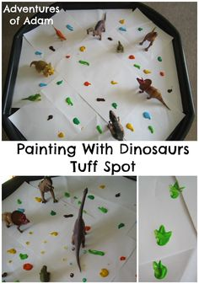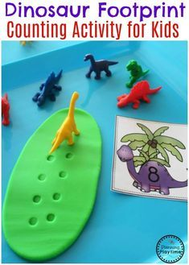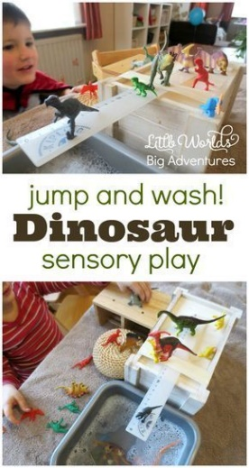

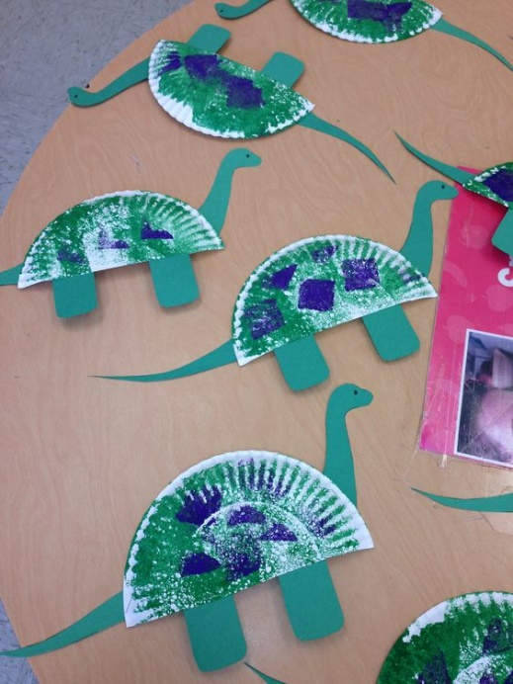

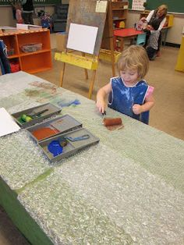 Dinosaur skin

|  |  |  |
| --- | --- | --- |
| 5 scary dinosaurs playing in the swamp.  Eating yummy plants, chomp, chomp, chomp.  Along came a dinosaur as LOUD as could be and.....gulp! (move one dinosaur aside)  Continue backwards to 0! | Around the Prehistoric Swamp (sung to Wheels on the Bus)  The dinosaurs 's wings went  flap, flap, flap...flap, flap, flap...flap, flap, flap  The dinosaurs 's wings went flap, flap, flap around the muddy swamp!  The dino Rex went grr, grr, grr....  The dino horns went poke, poke, poke  The dino ate leaves and went crunch, crunch, crunch....  The dino tail went spike, spike, spike.... | Turn Around sung to Teddy Bear, Teddy Bear  Dinosaurs, dinosaurs, stomped around.  Dinosaurs, dinosaurs, shook the ground.  Dinosaurs, dinosaurs, gave some fear.  Dinosaurs, dinosaurs, are no longer here! |

.