‘ Next steps:

Parts of the flour (circle time)

Flower shop role play

Hide and seek flowers game

Growing flowers song

Parts of the flower (Being patient / taking turn)

Hide and seek flowers game

Bunny hooky pokey

**PSED**

**C&L**

Child interest: books/water play/Group games

Next step:

Flower shop role play

Gowing flowers sand play

Will it grow?

Flower shop/nursery trip

**Week**

**04/04/2022**

**11/04/2022**

**Spring flowers/Easter**

**Jupiter/ Neptune**

**Planet Bean Bag Toss**

**Get fit obstacle course**

Making orange Juice

Water play: pouring and transferring

Making snips on paper

Healthy and non-healthy food bingo

kk

**KDW**

Finger painted flowers (Monday 1)

Magazines collage (Tuesday 1)

Muffin cups craft (Wednesday 1)

Leaf faces (Thursday 1)

(Friday 1,2) Free colouring and drawing

Leaf brushes art (Monday 2)

Playdough (Tuesday 2)

Flower painting (Wednesday 2)

Junk modelling (Thursday 2)

Free colouring (Easel painting)

Flower Sorting

And counting

Trace and count

Broad stairs

Pink tower

3D solid shapes box

F letter box

Pink box series “o””a”

”e”and “I”

F is for astronaut

Leaf and stem

rubbing

**Literacy**

**EAD**

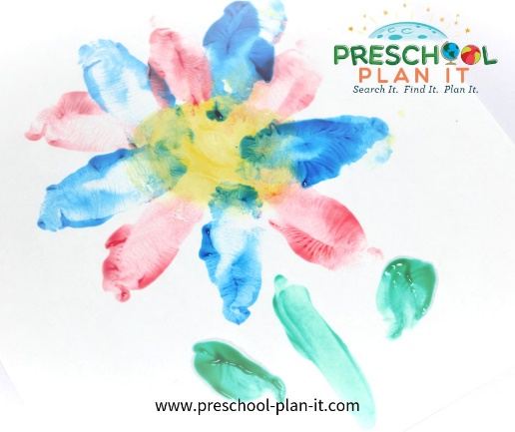

**Finger Painted Flowers**

Materials Needed: Finger paint paper, variety of finger paint colours.

Children can make flowers by using the sides of their fists and use their open hands to make leaves!

**Magazine Collage**

Materials Needed: Flower magazines, glue, paper

The children choose the flowers from the magazines that they like, cut them out and work together to make a large, group flower collage!

**Muffin Cups craft**

Materials Needed: Colourful muffin cup papers, white paper, crayons and miscellaneous art and craft supplies.

Talk about what growing flowers have (stem, leaves, roots, flower) and what they need (soil, sun, water, air).

Encourage them to create their own, unique flower that has ALL the 4 parts of a flower using the materials provided. They can also use crayons or markers to make leaves and stems, or they can use collage materials.

**Leaf Faces**

Materials: Leaves from outside, glue and markers

The children use the leaves to create a leaf face or leaf creature and add to it with markers.

Write down the stories they tell about their creations and tape the description onto the bottom of their paper when they are done and display!

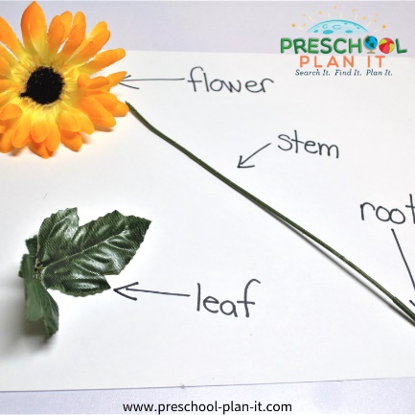**Parts of a Flower**

Materials Needed: 1 fresh flower, strips of paper and a marker, 4 pieces of construction paper, artificial flowers--dissected (take apart many artificial flowers so that you have enough pieces for each child to have one for the circle activity below).

Show the fresh flower to the children at circle time to introduce your Growing Flowers theme.

Pass the flower around for the children to touch and smell and discuss what they notice about the flower.

Ask if they know what a flower needs to grow? (Water, air, soil, sun).

Now, point to each part of the flower and ask if they know what it is called. Let them know the name and then print the name on a label and show it to them. Draw a basic picture of that part on the strip of paper and repeat the name.

Do this for each part of the flower: Flower, leaf, stem, root

Place these labels on different pieces of paper in the middle of circle.

Now pass out pieces of the artificial flowers.

Ask each child to identify which part of a growing flower they have and place it on the proper labeled paper.

EXTENSION: Use these items as a sorting/math activity for your math and manipulatives center (See Parts of a Flower math/manipulative activity below).

**Leaf Brushes art!**

Materials Needed: Leaves that are still on small branches. Use these to paint with instead of brushes!

**Hide And Seek**

Materials: Hide several flowers (artificial) in the classroom or playground. Have the children look for a specific flower! Tell them, you'll find many flowers, but right now we are ONLY looking for purple flowers, or red flowers, etc.

**Growing Flowers**

And sand, shovels, buckets, water, silk flowers, small branches from trees, watering cans and water

The children can dig a long trench and plant a beautiful garden. then allow the children to water the plants. Talk about how to care for our gardens, what plants need to survive,etc.

**Will It Grow?**

Bring in 2 plants of the same type.

Ask the children if they think the plants will grow if you don't water them?

Label one plant "WATER" Label the other "NO WATER"

Ask the children who thinks the one with water will grow? Write down how many children on that plants label.

Do the same with the plant that says NO WATER.

Place the plants on a table and watch what happens over a week by watering one and not the other.

**Leaf and Stem Rubbings**

Materials Needed: Crayons with the papers peeled off, leaves, white paper

Show the children how to place leaves under the paper and then use different crayons to rub (on the sides of the crayons, not the tips) to show the leaf prints!

**Pastel Sand Collage (egg decorating )**

Materials needed:  coloured sand, glue, card stock

The children brush glue on their paper.

They sprinkle different colours of sand for a beautiful Easter coloured collage.

We have used salt and pepper shakers for the sand.

**Bunny Hokey Pokey**

Do the Hokey Pokey but use rabbit terms!

Put your right ear in....

Put your cotton tail in...

We hop our whole selves in...

...We do the bunny pokey and we hop ourselves around

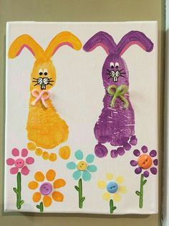

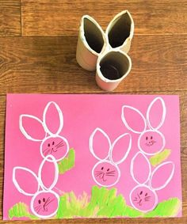 **Easter crafts:**

**Pastel Sand Collage**

Materials needed:  coloured sand, glue, card stock

The children brush glue on their paper.

They sprinkle different colours of sand for a beautiful Easter coloured collage.

We have used salt and pepper shakers for the sand.

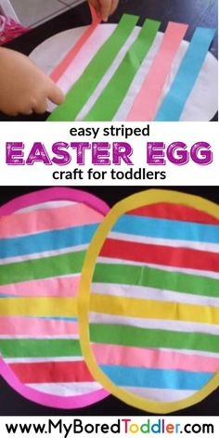

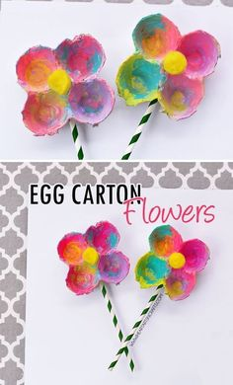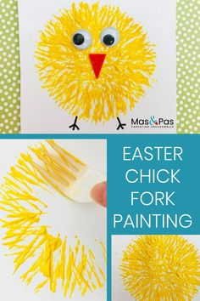

|  |  |
| --- | --- |
| **Growing Flowers Song**  sung to Frere Jacques  Use this song as one to act out!  Flowers are growing, flowers are growing (move hands from your sides to up over your head)  All around! All around! (point around the room)  So many pretty colours! So many pretty colours! (hand over eyes to look)  Fill the ground, fill the ground! (point to floor around the room)  Let's go see them, let's go see them! (hand over eyes to look again)  Growing bright, growing bright!  We'll use our noses to smell them, (bend over and pretend to smell)  and use our eyes to see them, (bend over and pretend to look at a flower)  What a sight, what a sight! (clap hands and display a very happy smile!) | .  **Did You Ever See a Rabbit?**   sung to Did You Ever See a Lassie?  Did you ever see a rabbit, a rabbit, a rabbit.  Did you ever see a rabbit on Easter morn?  He hops around so quickly..  And hides all the eggs.  Did you ever see a rabbit on Easter morn? |