This is me story book

I love my family poem

Whos’s in the bag (naming friends )

Simon says: (touch your nose !)

**C&L**

My portrait (Art and craft) Monday 1

My house (Block building/ week 1)

People Puzzle

Clean up clean up; water

play 9washing dishes )

Playdough with people

cutters (Thursday 1,2)

**PSED**

**Week 30/08 & 06/09/21**

**All about me/ Venus**

Me and My family painting print portrait (Tuesday 1)

Blow your hair What colour is your hair (Wednesday1)

Playdough (Thursday 1 and 1)

Junk modelling (Friday 1,2)

Me Book (Monday 2)

Hand printing (Tuesday 2)

Mirror craft (Wednesday 2)

**PD**

**Intent:** All About Me topic is to help children learn about each other and to realize that every person is unique and special. They also learn that every child's thoughts and ideas are important and no one person is important than another!

**What colour is your hair (straw blowing activity)**

**Implement**: Materials Needed: Pre-drawn faces, brown, yellow, black paint and straws! Encourage the children to can add their family members, pets, etc. blow the paint through the straw to make the hair .

**My Family**

Implement: Materials Needed: Sponges in the shapes of people, shallow trays of paint and paper. Encourage the children to sponge or print on the number of people in their family and then print below each one the name of the family member.

**Show and Tell Day**

**Implement**: Have a Show and Tell Day where children bring a family picture.

After show and tell, You could set up a "display table" on show and tell day where the children place their items. The only rule is that it is a looking and talking table--they do not take the items off the table to play with. Talk with the children about who is in their family? Who lives in their house? Remind the children that family is not ONLY who lives with them. It includes grandparents, a Mom or Dad who may live in a different house, etc.

**House Building**

Intent: Encourage the children to build their house out of the blocks you have available during this theme, don't feel the block building needs to have a focus. The children are learning about the items in their new environment and about their own abilities as well.

**Clean Up, Clean Up!**

Add soapy water to your tray along with your dramatic play dishes, pots and pans, etc. Include sponges and towels!

Circle time song: 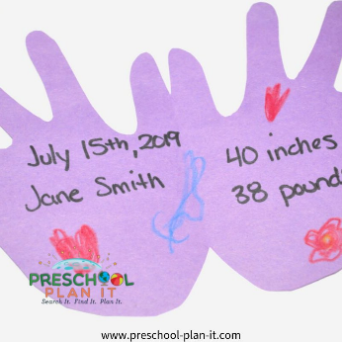**Me Book**

Fold a piece of construction paper in half. Have the child trace his/her hand and then help them cut out their hand (do not cut the folded side). When done, the hand print should open like a book.

Let the children write/ make marks on the front and decorate the front.

On the inside, write the date, the child's name, their height and weight.

**Play "Simon Says"** or other listening/following instruction games to help develop listening skills. Make sure requests are simple (i.e., "touch your nose").

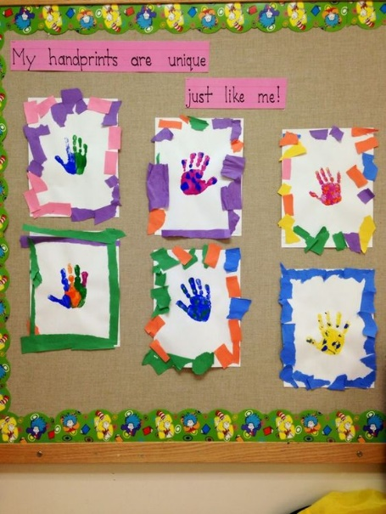

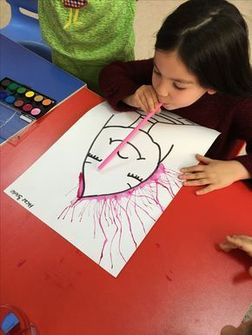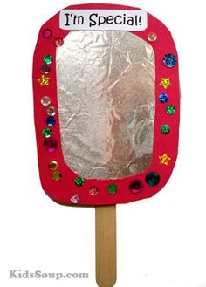

|  |  |  |
| --- | --- | --- |
| Everybody do this, do this, do this,  (leader demonstrates a body movement)  Everybody do this, just like me (everyone copies it)  Everybody do this, do this, do this,  Everybody do this, just like me | Higgledy, piggeldy, bumblebee,  Who can say their name for me? (Child says name)  Let's all say it (name)  Let's clap and say it (name)  Let's whisper it (name) | **I Love My Family**  Some families are big (spread arms wide)  Some families are small (bring arms closer together)  But I love my family (cross arms over chest)  Best of all! |