Child interest: animal/water /book

Home croner play;picnic

story book (Being involved and concentrating) Old Mc Donal had a farm

Musical Instruments (Playing and exploring/ Listening nd attention)

Surprise bag (learning and undersanding new wrds)

Puzzles

Next step:

**PSED**

**Week**

**04 and 11 /04/2022**

**Under the sea Easter**

**Pluto room**

Hide and seek Parachute game !

Ball pit (Monday to Friday)

Buble, buble blowing

Outdoor playing /taking risks ( playing and exploring;

be willing to have ago)

home corner play

pushchairs / baby walkers

Paper plate Whale (Monday 1 )

Sea anmals sensory tub (Tuesday 1)

Bouncy ball pufferfish (Monday 2)

Celery stick stamping fish (Wednesday 1)

Soapy sea foam (Tuesday 2)

Playdough (Wednesday 2)

Easle water painting Thursday 2

Egg crayon large scale mark making (Friday 1,2)

**PD**

**Funnel Spicy painting Spicy sand**

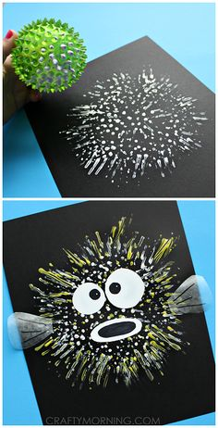[**Bouncy Ball Stamped Pufferfish**](https://www.pinterest.co.uk/pin/161637074103516057/)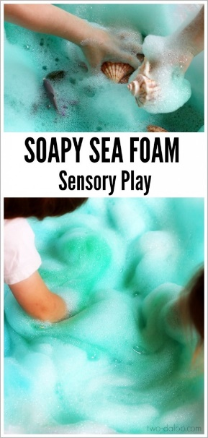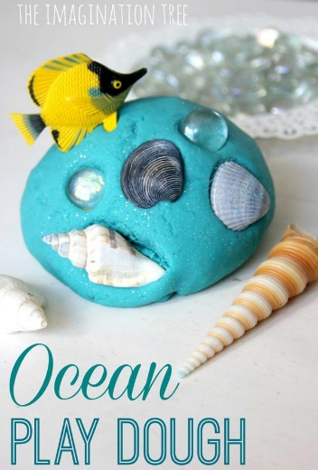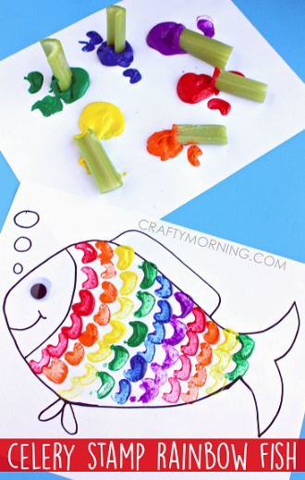

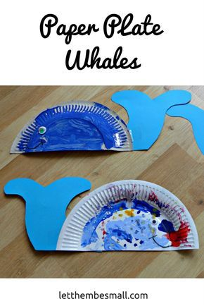

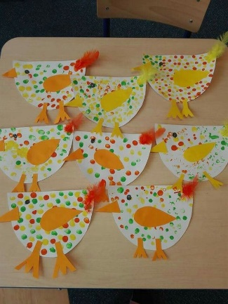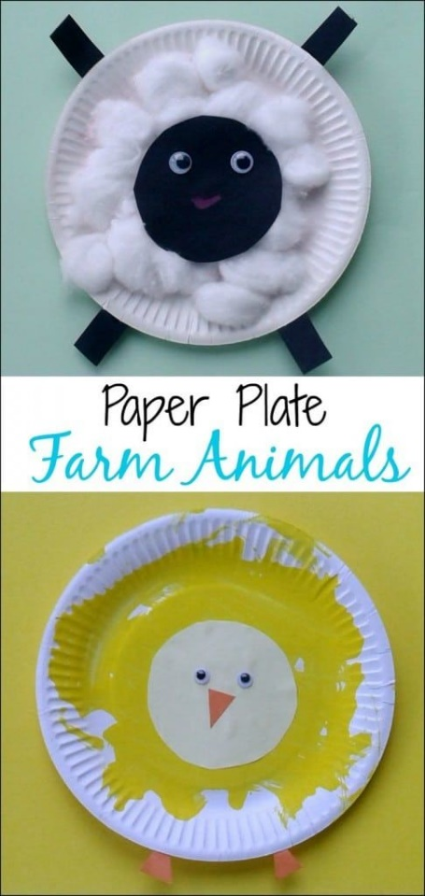**Easter Crafts**

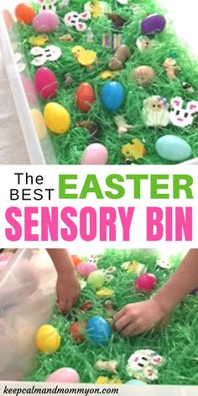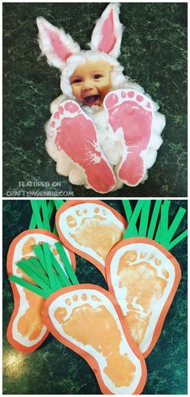

**Surprise bag:**

Intent: learning and understanding new words/ talk about the way items look, feel and sound.

Implement: put 3 or 4 sea animals or objects that feel or look different in a bag, let the child pull something out tell him/her what it is, how it looks, feels and smells.

.