Next step: - Place objects in, on and under on request.( CL, Understanding) ZC/YL

- Point to picture of common objects described by it use ( CL, Understanding)

(circle time/ Monday to Friday)

Rainbow song (Learning new words)

One to one reading (Listening and attention )

Choo choo train song

Rainbow roads (block play/small world play)

Card box vehicles role play

parachute game (Being willing to have a go)

Musical instruments (Playing and exploring)

Car wash water play (pllying cooperativey)

**C&L**

**PSED**

**Week 14/03 & 21/03/22**

**Vehicles and transportation**

**Venus**

**(** (Monday1) Traffic lights craft

(Tuesday 1) Go green/St Patrick day

(Wednesday 1) Monster trucks

(Thursday 1) paper plate boats/St Patrick day

(Monday 2) sponge painting cars

**(**Tuesday 2) Zooming pens

(Wednesday 2) Fire tracks foot print/ Mothers ‘day card (27th March 20222)

(Thursday 2) Track playdough

Junk modelling (Friday 1,2)

**PD**

**Go Green!**

Provide yellow, blue and white paint and see the shades of green your children can make!

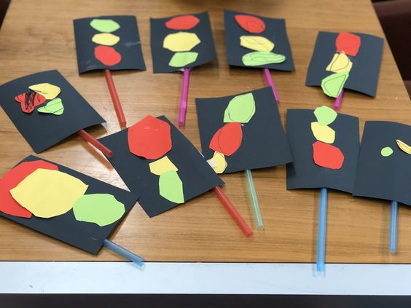**Traffic light craft**

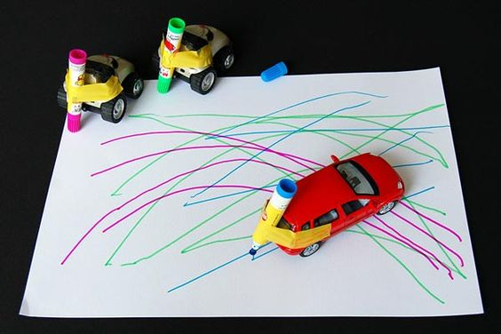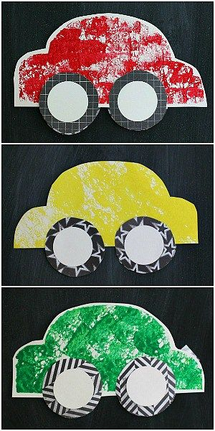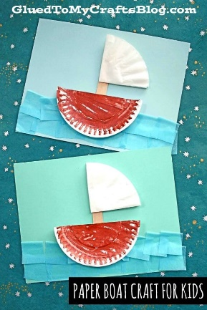

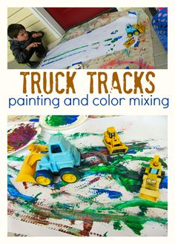

**Monster Trucks!** Driving the trucks through the paint onto the paper.

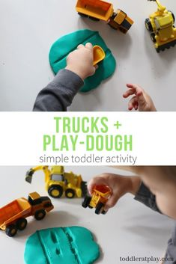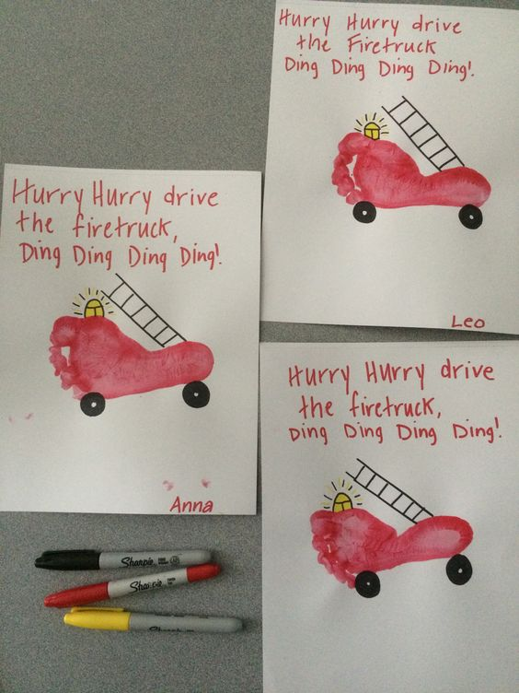

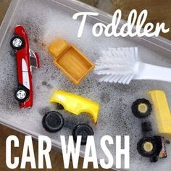

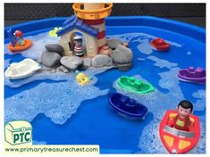

|  |  |  |
| --- | --- | --- |
| . Rainbow (St Patrick day)  sung to the tune of Twinke, Twinkle Little Star  See the rainbow way up high,  Spreading colours in the sky.  Red and orange, yellow too  Green and purple hug some blue.  Watch it quickly, it won't last.  Rainbows can disappear fast! |  |  |



