Child interest:

One, two, three the ball song

Muffin tray ball sorting (smooth, bumpy, squishy)

Where is Baby Mickey's Red Ball? (story book)

Musical instruments (Learning to listen)

The ball is going down the slide Ready, Steady, Go

(pushing balls down the slide)

Build a tower up,up,up (Blocks play)

Next step:

**C&L**

Ball name game! (Monday to Friday)

Ball pit (Monday to Friday)

Ball drop and post

Obstacle courses( playing and exploring;

be willing to have ago)

home corner play (cooking with pasta)

**PSED**

**Week**

**27th September and05/10/2021**

**Fun with balls**

Ball paintng, big time (Monday 1)

Transporting balls (Monday to Friday)

Balls floating on soapy water (water play) (Tuesday 1)

Playdough play; roll,roll and roll the dough (Wednesday 1)

Fill and pour balls !

Finger paint beach ball (Tuesday 2)

Dyed rice tuff spot (Wednesday 2)

Making marks (Hand printing on easel ) Thursday 1,2

Mark making with crayons (Friday 1,2)

**PD**

**Ball Painting--Big Time!**

Implement: Secure LARGE paper and balls (dodge balls, tennis balls, whatever!) and paint. Bowl or toss balls that have been dipped in paint onto the paper!

**Transporting Ball**

**Implement**: Provide trucks/balls that fit in the trucks. The children will figure out how to transport the balls to the different parts of the room!

**Ball Name Game**

**Intent:** small group games/ Circle Time is such a great time for children to learn the social skills of being together and form friendships.

**Implement:** Sit in a circle.  Name a child's name and roll the ball to that child.  Only that child should reach for the ball, then names a friend's name and rolls the ball to them.

**One, Two Three! (ball song)**

Here's a ball (make a small, ball shape with your fingers).

And here's a ball (make a ball shape using both hands).

And here is a great, BIG ball as you can see (make a huge ball shape using your arms)!

Let's count them together...Ready?

One, two, three (make each shape again as you count)!

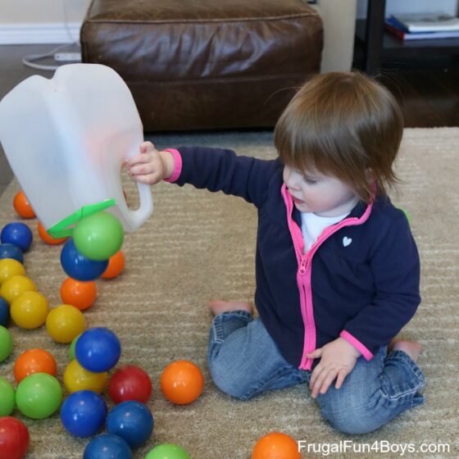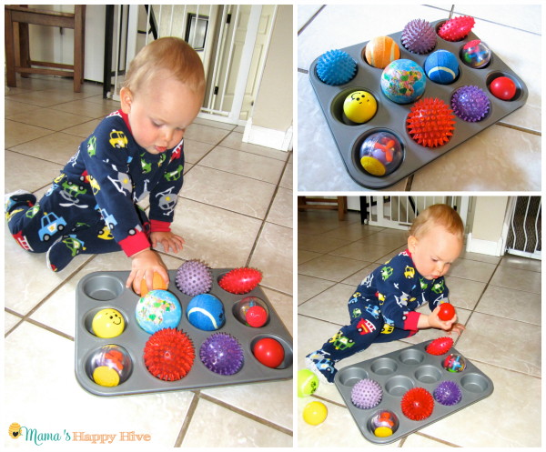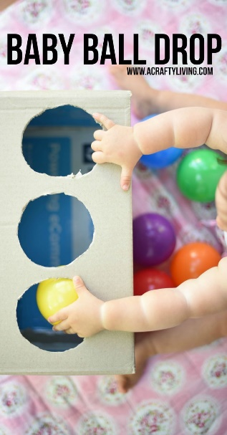Ball drop and post Muffin tray ball sorting Fill and pour balls

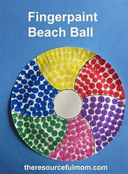

**Muffin tray ball sorting!**

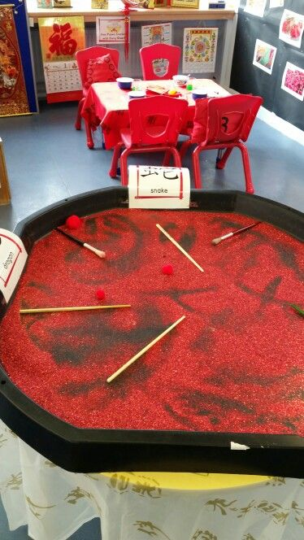**Intent:** Let the child play and sort balls of different texture and dyed rice tuff spot

size such as smooth, bumpy, squishy, koosh or foam to encourage sensory development.

**Obstacle Course (if child crawling e.g Jonas)**

**Implement:** For This Obstacle Course You Will Need:

* cushions and or pillows/soft steps
* [balls](https://www.amazon.com/KONIG-KIDS-BPA-Free-Textured-Multi-Shape/dp/B07BR72D7N/ref=sxin_7?ascsubtag=amzn1.osa.2dea0622-caef-438c-ac35-1efd91b4187c.ATVPDKIKX0DER.en_US&creativeASIN=B07BR72D7N&crid=34NJST86R0QXY&cv_ct_cx=infant+balls+toys&cv_ct_id=amzn1.osa.2dea0622-caef-438c-ac35-1efd91b4187c.ATVPDKIKX0DER.en_US&cv_ct_pg=search&cv_ct_wn=osp-single-source&dchild=1&keywords=infant+balls+toys&linkCode=oas&pd_rd_i=B07BR72D7N&pd_rd_r=96b341b0-6cbf-406c-b293-9ff507f56626&pd_rd_w=zAphC&pd_rd_wg=1OFFB&pf_rd_p=08a788f8-ae54-4b96-9e48-f1e694ec6c4f&pf_rd_r=ZPQXHT38RXFYC2JECVTM&qid=1596684251&sprefix=infant+balls%2Caps%2C174&sr=1-3-72d6bf18-a4db-4490-a794-9cd9552ac58d&tag=scripps-spellingbee-20) (small enough for child to lift)

**intent: create a physical challenge/ create a level of risk and children can learn by trial and error the quickest and easiest Way to go through the obstacle**

musical instruments (Learning to listen)

**implement:**

1 face the child with some musical instruments between you.

2.Play one gently.

3. describe the noises “Ding-a-ling-a-ling” or “That’s a good noise”

4.watch the child-which did they like best? Play it again.

5. Try different noise makers (bells, rattles, drums, shakers, saucepans, and wooden spoons)

6.Comment “Wow, that’s loud”, “That’s a nice noise”