Next step: - Place objects in, on and under on request.( CL, Understanding) ZC/YL

(circle time/ Monday to Friday)

We are going in Bear hunt story book!(Being involved and concentrating)

Where Bear ( ZC/JL)

(Listening and attention )

Bears pattern game

- Point to picture of common objects described by it use ( CL, Understanding)

**C&L**

Cave role play (Being willing to have a go)

Bear soup imaginary play (water tray)

Berry Fun (tasting new fiood)

Musical instruments (Playing and exploring)

What am I (JL/ TK)

**Week 15/11 & 22/11/21**

**Bears/**

**Venus Room**

**PSED**

Goopy Bear Hunt (Monday1)

Dirt paint mark making (Tuesday 1)

Fork painted bear craft (Wednesday 1)

Bring home the bears (Thursday 1)

Fuzzy bear (Monday 2)

**Bear collage (**Tuesday 2)

Brown playdough (Wednesday 2)

Coloured chalk Easel (Thursday 2)

Junk modelling (Friday 1,2)

**PD**

**Create a cave**

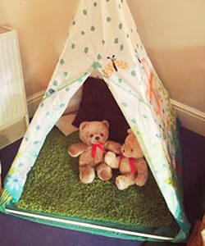Implement: Create a cave for the children to use as a role play area or a quiet area for them to read their own books. Heighten the excitement by creating it overnight and reveal it to the children in the morning. Provide some items to go on a bear hunt such as binoculars, a picnic basket, etc.

* Ask the children questions
  + Where did it come from?
  + What might be inside?
* Whatever approach you use to draw the children into the story, make it individual to those children in your setting
* Enjoy the time you have with these children in the magical world of stories, this will shine in your voice when you are telling the story
* Remember, you may have told this story over 100 times, but this could be the first time this child has heard it, make it memorable!

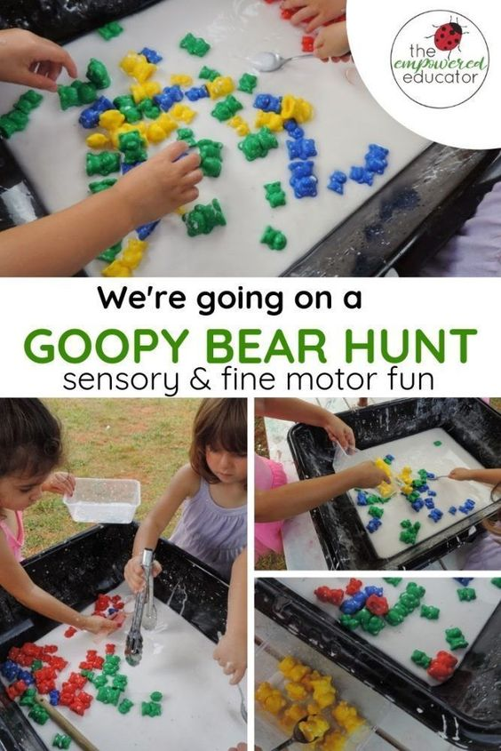

**We're going on a Goopy Bear Hunt.....**

**Intent** : Fine Motor Sensory Fun! - The Empowered Educator - a great way to expand on the great 'We're going on a bear hunt''' book with some messy and sensory play for toddlers and

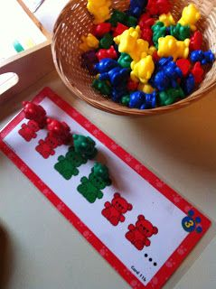**Bear patterns game..**

**Intent:** Understanding the concept of: Big, small, tiny

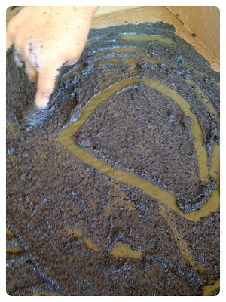

Dirt Paint (mark making)

Implement: Dirt Paint : 1 cup Flour. 1 cup Salt. 1 cup Water. A few tablespoons of Black tempera paint and coffee grounds With fingers as worms, children make marks in circles, straight lines, shapes.

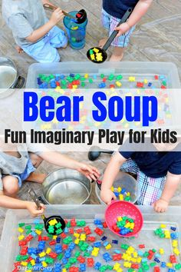

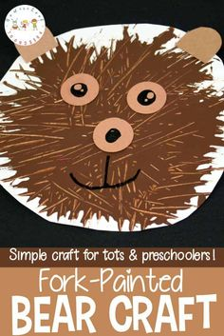

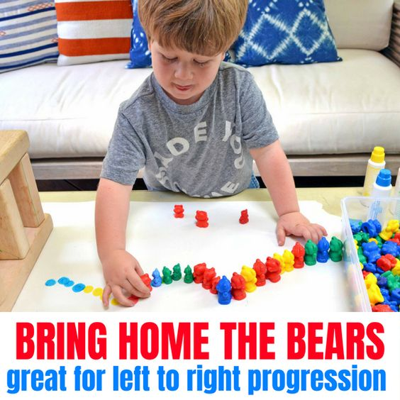

**Where Bear?**

Intent: Have a bear game to help your children learn spatial awareness and directionality! And prepositions.

Hold your bear**UP** to the sky.

Hold your bear **DOWN** near the ground.

Place your bear **UNDER** something in the room.

Place your bear **ON** something in the room.

Place your bear **NEXT TO** something in the room.

(You can choose the place in the room or let the children find a space!)

**Berry Fun!**

Bears eat berries and so do we! Provide different types of berries (check for allergies first!) in different bowls.

Have the children scoop a couple of spoonfuls of each into a bowl.

As they eat, ask questions Such as:

What colors are they? Are they large, small, medium? Which are larger, smaller?

How many of each type do you have? Do you like red or blue?

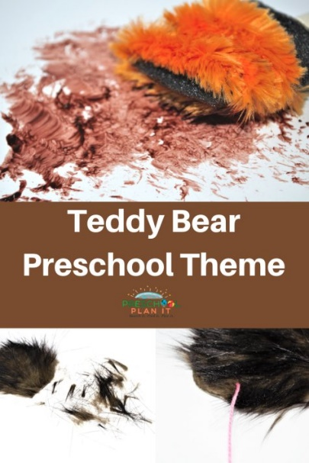Fuzzy Bears: Materials Needed: faux fur, scissors, glue, paint brushes, paper, googly eyes, paper

|  |  |
| --- | --- |
|  |  |



