Next steps:

Icy hand dancing

Tree climbing

Snowey pokey game

Window fog picture

How cold is it today? (circle time)

It’s Winter

One Winter day

The Mitten chant

.

**PSED**

**C&L**

Child interest: books/water play/Group games

Next step:

Local walk;Just take a walk!

Look for winter changes: no

more leaves on trees.

abandoned birds

' nests; snow.

ice; animal tracks!

Making orange Juice

Water play: pouring and transferring

Making snips on paper

Healthy and non-healthy food bingo

**Week**

**03/ 01/2022**

**10/01/2022**

**Winter/ Winter trees**

**Jupiter/ Neptune**

kk

Winter Icicles (Monday 1)

Winter storm (Tuesday 1)

Sand the icy road (Wednesday 1)

Ice catchers (Thursday 1)

(Friday 1,2) Free colouring and drawing

Winter tree Project (Monday 2)

Mitten craft (Tuesday 2)

Winter Hat Craft (Wednesday 2)

Winter Wonderland

Playdough (Thursday 2)

**KDW**

Winter snow ball counting

Trace and count

Broad stairs

Pink tower

3D solid shapes box

W letter box

Tracing winter sheet

January’s cold poem

Pink box series “o”

**Literacy**

**EAD**

**Winter Icicles**

Materials needed: aluminum foil, thinned paint, eye droppers.

Implement: Have children drip paint on the edge of the foil. Hold foil up and let paint drip down the foil. Continue with many colours. Let dry. Mount onto black paper. Shine flashlights to reflect the "ice"!

**Winter Storm**

**Implement:** Clip dark colours of construction paper onto the easel/ or individual paper .

Place warm water into cups and mix in several spoons of salt. Mix to melt salt.

Dip sidewalk chalk into water and draw!

The salt gives quite the sparkling effect when dried!

**Window Fog Pictures**

**Implement**: Wash the outside front glass door. Let the children "breathe" on the glass to see the fog and then draw pictures on it! Explain why this happens: the outside air is cold and the air in their mouths is warm and that makes fog!

Clean the door and let a few more children make fog! (For germ/ COVID 19 reasons! only allow a few children at a time do this.)

How Cold Is It Today

Provide thermometer for the children to look at. Discuss how they measure how cold it is, that the line goes up when it is warmer, etc.Place one outside to check the temperature. Record the temperature each day.Provide many cups of water at different temperatures for them to experiment to see what each type of water does to the thermometer.

**Sand the Icy Roads**

Materials Needed: Sheets of ice; play sand; ice; toy trucks and cars

**Implement**: In advance, freeze thin layers of water in shallow trays (like foil cookie sheets). Place sheets of ice in the water table and provide the children with cups of sand to put on the ice to sand the roads!

**Ice Catchers**

Materials Needed: plastic bowls, items from outside (twigs, leaves, rocks, etc.); a piece of ribbon for each child; water

Fill each bowl about half way with water.

Implement: Ask each child to guess if the item they are going to put in the water (twig, leaf, rock, etc.) will sink or float. Have them place it in. Where they right? Repeat for each item except for the ribbon.

Now, place the ribbon so that both ends are in the water and a "loop" is out.

Place bowls in the freeze overnight.

The next day, when you remove the ice from the bowls, there will be the ribbon loop sticking out of the frozen water so that you can go outside and hang it from a tree!

EXTENSION: Take guesses about what will happen, how long till they melt, etc.! If you can't get outside, be creative! See if you can hang them somehow in the classroom perhaps over the water table where it can drip while you watch!

**Icy Hand Dancing!**

Materials needed: A bowl of ice (do not let the children see them!); a metal tray; a CD player.

Tell the children you are going to drop something and ask if they can guess what it is. Drop an ice on a metal tray. Let them guess! Try a few more times. If they don't guess, give clues (It's cold. It's hard. etc.).

Have the children sit in a circle. Tell them they are going to pass the ice around the circle as the music plays. When you pause the music, they should freeze (HA- get it!) and the child with the ice cube holds it while you count to 1. Play music and repeat, next time count to 2. Next time ask, what number is next? We counted to 1 and then to 2? Continue as there is interest!

**Winter Snowball Counting**

Materials: Muffin baking pan; cotton balls; tongs or spoons; pre-cut circles to fit into tins with the numbers on them that you are working on with your children. Place a number circle in each compartment. Encourage the children to place the corresponding number of cotton balls into each circle, using the tongs.

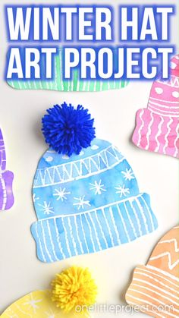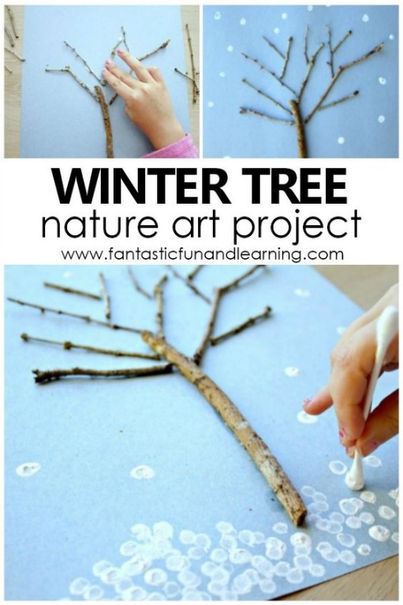 Winter tree project Mitten Crafts Winter Hat Art

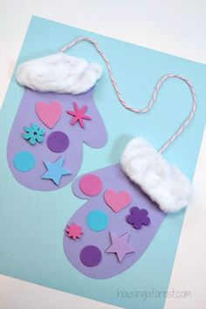

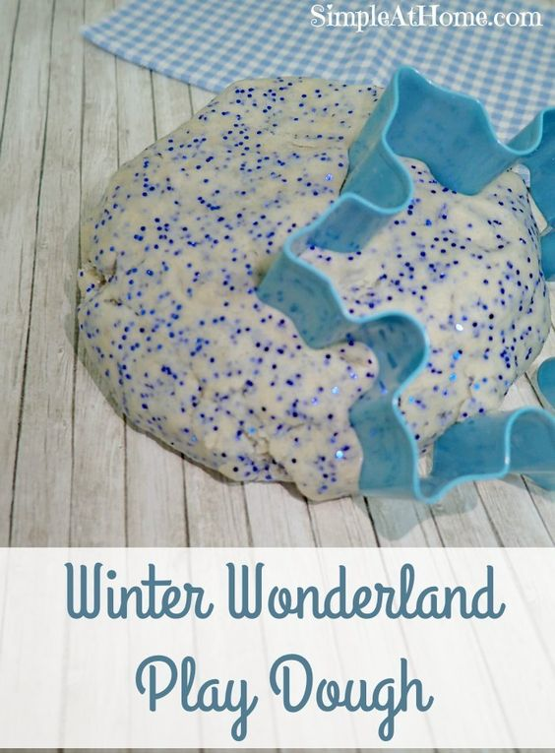

Winter Facts

Winter is the coldest season.

Snow falls in the Winter

Every snowflake has six sides.

The sun looks bigger in the Winter.

Trees stop growing in the Winter.

Plants stop growing in the Winter.

Nights are longer in the Winter.

Some animals hibernate in the Winter.

Winter comes before Spring.

A blizzard is a bad snowstorm.

|  |  |  |
| --- | --- | --- |
| January's Cold poem  January's a cold month- Shiver, shiver, shiver!  (wrap arms around self and shake)  Button up (pretend to button your coat)  Cover your ears (pretend to put on your hat)  Quiver, quiver, quiver |  |  |