Next step: - Place objects in, on and under on request.( CL, Understanding) ZC/YL

- Point to picture of common objects described by it use ( CL, Understanding)

(circle time/ Monday to Friday)

Oh McDonald had a Christmas tree song

!(Being involved and concentrating)

( ZC/JL)

One to one reading (Listening and attention )

**C&L**

(Being willing to have a go)

Warm winter scented sensory play (water tray)

Musical instruments (Playing and exploring)

What’s in the bag (JL/ TK)

**Week 29/11 & 06/12/21**

**Christmas**

**Venus Room**

**PSED**

Salt dough ornament (Monday1)

Paper plate Christmas tree (Tuesday 1)

Reindeer craft (Wednesday 1)

Ginger man playdough (Thursday 1)

Finger prints Christmas light (Monday 2)

**Christmas tree cards (**Tuesday 2)

Bauble sticking activity (Wednesday 2)

Coloured chalk Easel (Thursday 2)

Junk modelling (Friday 1,2)

**PD**

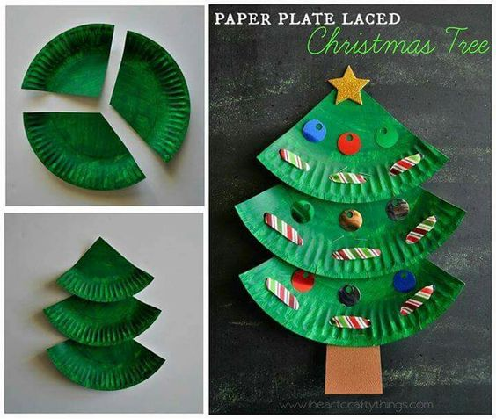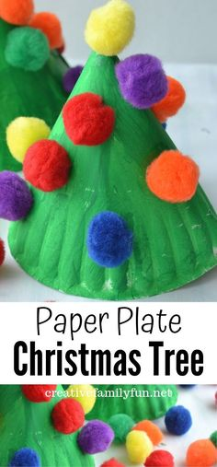

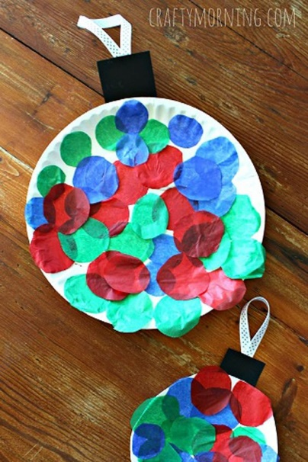Salt Dough ornament.



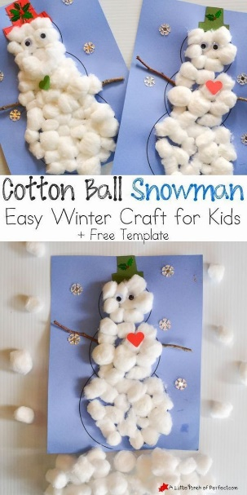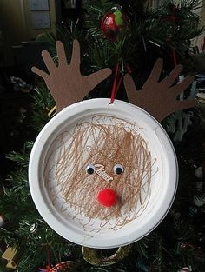

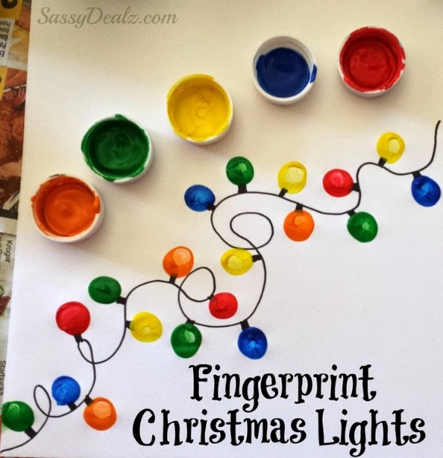

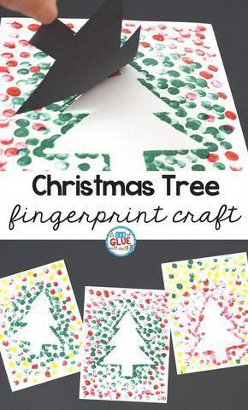

|  |
| --- |
| Old MacDonald (sung to Old MacDonald)  Old MacDonald had a Christmas tree--  Ho, ho, ho, ho, ho.  And on that tree he had some horns (blow horns)  Ho ho ho ho ho!  With a toot toot here and a toot toot there  Here a toot there a toot Everywhere a toot toot............  Other verses: lights---flash flash bells---ring ring birds---tweet tweet drums--boom boom stars---twinkle twinkle candy canes----yum yum |



